



National Return To Work Survey 2025
Analytical Report
Prepared for Safe Work Australia
Ref: 5059 | November 2025

Wallis acknowledges that we work upon the traditional lands of the Wurundjeri People and pay our respect to elders past, present and emerging. We extend that respect to all Aboriginal and Torres Strait Islander peoples. | Lotjpa Iyawa “Yarning as One”  Artwork by Luke and Siena Tieri bayadherra.com.au

Accreditations
ISO 27001: ISO 27001 is the highest standard for information security management systems, providing you with assurance that Wallis systems, processes and people are keeping your data safe.  ISO 20252: ISO 20252 is the international standard for market, opinion and social research, and ensures all stages of the research project are delivered to a quality that can be relied upon.  The Research Society Corporate member: The Research Society is Australia's largest research and insights community. Members have access to the latest industry knowledge, tools, quality assurances and professional standards.  ADIA Trust Mark Research Organisation: The Australian Data and Insights Association (ADIA) is the peak industry body for data, insights and research organisations in Australia. ADIA Trust Mark research organisations are compliant with the highest ethical, quality and privacy standards.  Australian Achiever Awards: The Australian Achiever Awards recognises the customer service excellence of Australian companies. Wallis has been awarded a high commendation every year since the inception of these awards in 1999.  Cyber security: Wallis is an acknowledged leader in data protection and privacy. Our system is regularly subjected to external penetration testing and we are a Privacy Awareness Week supporter – committed to sharing our knowledge with others. Wallis is also active member of the Australian Cyber Security Centre (ACSC) Partnership Program.  B Corporation: Wallis has been certified by B Lab Australia and New Zealand having shown that we meet high standards of social and environmental performance, transparency, and accountability. At Wallis, our approach to corporate social responsibility reflects our mission - to have a positive impact on society. | 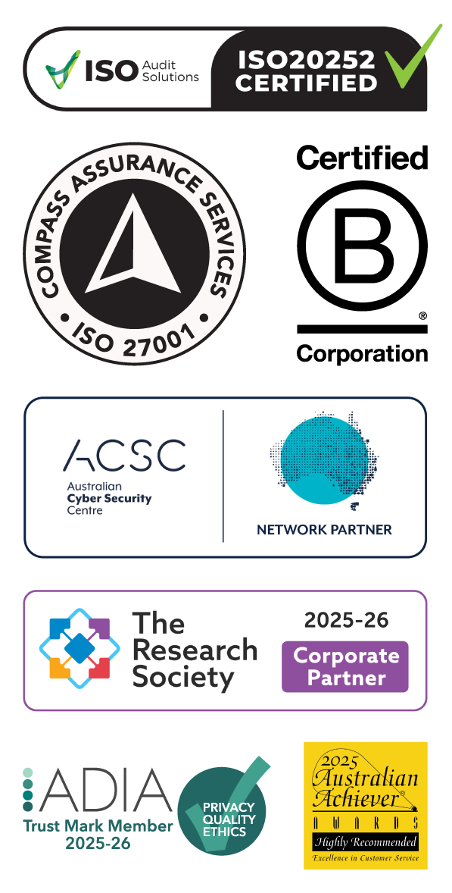

Table of Contents
Executive Summary i
Introduction ii
1 Return to Work Rates 2
1.1 Worker insights 3
1.2 Employer insights 10
2 Impact of Injury 14
2.1 Worker results 15
2.2 Employer results 25
3 Return to work planning 30
3.1 Worker results 31
3.2 Employer results 35
4 Returning to work 41
4.1 Worker results 42
4.2 Employer results 46
Appendix 1 – Methodology 53

List of Figures
Figure 1 Injury type 3
Figure 2 Return to Work Rate by National time series (% yes) 4
Figure 3 Current Return to Work Rate by National time series (% yes) 6
Figure 4 Reasons for not working (%) 7
Figure 5 Additional time off 8
Figure 6 Support needed to get back to work (%) 8
Figure 7 Employer offered RTW education or training 9
Figure 8 Injury type 10
Figure 9 Employer Return to Work Rate 11
Figure 10 Reason for not working (%) 12
Figure 11 Extent injury has negative impact on daily life (%) 15
Figure 12 Health and wellbeing rating (%) 16
Figure 13 Able to access medical treatment (%) 17
Figure 14 Main healthcare provider (%) 18
Figure 15 Areas main healthcare provider discussed (%) 19
Figure 16 Stress level when interacting with healthcare provider (%) 20
Figure 17 Contacted about injury prior to return to work 20
Figure 18 Employer helped manage injury/illness before lodged claim (%) 21
Figure 19 Received payment from employer 22
Figure 20 Awareness of employers’ policies, plans and procedures (%) 23
Figure 21 Returned to work by Awareness of employers’ policies, plans and procedures (% returned to work) 23
Figure 22 Negative impacts when considering submitting a compensation claim (% Agree) 24
Figure 23 Help and payments before and after lodgement (%) 25
Figure 24 Employer perception of the claim (%) 26
Figure 25 Contact with worker 28
Figure 26 Employer informed about treatment needs 28
Figure 27 Return to work plan 31
Figure 28 Return to work plan development (%) 32
Figure 29 Return to work plan monitoring 32
Figure 31 Has a return to work coordinator 33
Figure 32 Contact with return to work coordinator 33
Figure 33 Level of stress when dealing with coordinator (%) 34
Figure 34 Return to work plan (%) 35
Figure 35 Return to work plan format (%) 35
Figure 36 Employer perspective on return to work plan 36
Figure 37 Return to work plan changes (%) 36
Figure 38 How the plan was monitored (%) 37
Figure 39 Understanding of their role (% agree/strongly agree) 38
Figure 40 Training and support for the return to work coordinator role 38
Figure 41 Additional assistance for the return to work coordinator role (%) 39
Figure 42 Intention to continue working 42
Figure 43 Duties upon returning to work (%) 42
Figure 44 Hours worked upon returning to work (%) 43
Figure 45 Offered modified or alternative duties (%) 44
Figure 47 Why accepted modified or alternative duties (%) 44
Figure 46 Why accepted modified or alternative duties – Injury type comparisons (%) 45
Figure 48 Took additional time off work 45
Figure 49 Offered modified or alternative duties (%) 46
Figure 50 Offered any workplace accommodations (%) 47
Figure 51 Hours and duties upon returning to work (%) 48
Figure 52 Reason for not offering suitable employment (%) 49
Figure 53 Additional support in the return to work process (%) 50
Figure 54 Additional support from the insurer (%) 51
Figure 55 Additional support from the regulator (%) 52

List of Tables
Table 1 2025 Return to Work Rate by Jurisdiction (% yes) 4
Table 2 2025 Current Return to Work Rate by Jurisdiction (% yes) 6
Table 3 Employer provided worker with information 27

Executive Summary
The 2025 National Return to Work Survey collected data from injured workers and employers.
The survey gathers information on the impact of workplace injuries and illness including workers’ compensation, return to work planning and return to work experiences.
Return to work overview
Since 2014, the national Return to Work Rate has been trending downward and decreased significantly in 2025 (88.9%) compared to 2021 (91.6%).
Injured workers with serious injuries, and those with psychological injuries, report getting less return to work support compared to workers with less severe injuries and/or physical injuries.
Workers with a psychological injury need a larger range of supports, and the Return to Work Rate is lower among workers with a psychological injury.
Employers who offer return to work education and training have higher Return to Work Rates.
Impact of injury
According to workers, important factors linked to better return to work outcomes were access to medical treatment or services, being contacted by their employer before returning to work, being helped by their employer to manage their injury or illness before lodging a claim, and receiving payments before lodging a claim.
Injured workers whose injury had more significant negative impacts, and those with a psychological injury, were less likely to receive these supports, and have lower Return to Work Rates.
Employers reported that helping their injured worker manage their injury or illness before they lodged their claim resulted in a greater likelihood of the worker returning to work. Employers from larger organisations had higher rates of providing their injured worker information about workplace health and safety, the compensation process and returning to work.
Return to work planning
When preparing for an injured worker to return to work, the data shows that having a return to work plan in place improves Return to Work Rates. Further, return to work plans that consider the medical advice that the injured worker received when developing the plan improve outcomes.
Elements such as having the plan in writing, having someone monitor the plan, and making changes to the plan, do not appear to be linked to better return to work outcomes.
Employers also reported that simply having a return to work plan in place is a key contributor to successful return to work outcomes.
Returning to work
The majority of injured workers who have returned to work intend to continue working. There are better outcomes, including self-reported general health, and a greater intention to remain working, for injured workers who were offered modified or alternative duties to get them back to work.
Employers reported that offering modified or alternative duties that are accepted by an injured worker are more likely to result in the injured worker returning to work.

Introduction
Project background and objectives
Safe Work Australia’s biennial National Return to Work (NRTW) survey is a key contributor to the evidence base for workers’ compensation policy and practice. This survey provides key indicators that inform the effectiveness of the National Return to Work Strategy 2020-2030. The Strategy’s vision is to ‘minimise the impact of work-related injury and illness and enable workers to have a timely, safe and durable return to work’.
'Return to work' is about helping workers to get back to work or to stay at work while they recover from work-related injury or illness. It is a complex process in which factors at the individual, organisational and system levels interact. A positive return to work involves all systems working well together.
The overall aims of the NRTW survey are to gain a better understanding of:
- The return to work outcomes and experiences of workers, injured or made unwell by their work, receiving workers' compensation throughout Australia, and
- The return to work process and experience from the perspective of employers.
Methodology
The design of the NRTW survey program was reviewed in 2022, with resulting enhancements implemented in 2025. New elements include streamlined online delivery and, for the first time, an employer cohort. Historically, only injured workers had been covered in the survey.
The 2025 iteration of the NRTW survey was conducted by Wallis Social Research. It used a dual-mode survey; respondents could complete the survey either by telephone (CATI) or online (CAWI). Fieldwork was conducted from 31 March 2025 to 18 July 2025.
Survey length
For Workers, the average survey length was 28 minutes for CATI and 21 minutes for CAWI.
For Employers, the average survey length was 26 minutes for CATI and 18 minutes for CAWI.
Sample size
The survey collected data from 4,143 injured workers and 754 employers, across all nine work health and safety jurisdictions - New South Wales, Victoria, Queensland, South Australia, Western Australia, Tasmania, Northern Territory, Australian Capital Territory and Comcare.
Eligibility criteria
The sample consisted of injured workers who had made a workers’ compensation claim, or employers of workers with these claims, who:
- had at least one day away from work due to their workplace injury or illness,
- had a workers’ compensation claim in the 24 month period from 1 July 2022 to 30 June 2024,
- had either an open or closed workers’ compensation claim, and
- worked in either premium-paying (including own businesses) or self-insured organisations.
Several screening questions were included in the survey to confirm that workers and employers were in scope. If they were not in scope they were excluded from participating in the survey.
Statistical significance
Differences between results described using terms such as ‘higher’, ‘lower’ and ‘significant’ means the differences are statistically significant. A statistically significant difference means an effect is unlikely to have occurred by chance.

This section presents an overview of key return to work measures from the perspective of injured workers, and of employers of injured workers.
01
Section
Return to Work Rates

Return to Work Rates
Key findings

Workers:
- Since 2014, the national Return to Work Rate has been trending downward, and decreased significantly in 2025 (88.9%) compared to 2021 (91.6%).
- The national Current Return to Work Rate has trended downward since 2016 (83.5%) and is significantly lower in 2025 (78.8%) compared to 2021 (81.3%).
- The Return to Work Rate and Current Return to Work Rate were lower among those with psychological injury and those who indicated that their injury had a significant or severe negative impact on their daily life.
- Workers with a psychological injury were more likely to indicate that their injury had a significant or severe negative impact on their daily life (36.8%) compared to those with a physical injury (20.7%). Further, workers with a psychological injury need a larger range of supports to get back to work than those with a physical injury.
- Injured workers who were offered education or training from their employer in relation to returning to work were more likely to have returned to work, compared to those who were not offered it.

Employers:
- The Return to Work Rate reported by employers in 2025 (70.8%) is lower than that reported by workers (88.9%). Similar to that reported by workers, the rate reported by employers for those with psychological injuries is lower than that for those with physical injuries.

Worker insights

Injury types
Nine in ten (90.4%) injured workers with a workers’ compensation claim were classified as primarily having a physical injury, and one in ten (9.6%) had a psychological injury (see Figure 1). The proportion of workers with a psychological injury has more than doubled since 2021 (4.1%).
The type of work-related injury or illness experienced by workers can vary across worker cohorts and labour market characteristics.
For example, 78.9% injured workers were in service industries and 21.1% were in production industries.
- Injured workers in production industries were much more likely to have a physical injury (97.7%) compared to injured workers in service industries (88.4%).
- Injured workers in production industries were less likely to have a psychological injury than those in service industries (2.3% and 11.6% respectively).
Further, workers aged 35 and over were more likely to have had a psychological injury (11.2%) compared to those aged under 35 years old (4.3%).
Compared to previous years, in 2025, a higher proportion of injured workers were women (47.9% - a marked increase since 2021 [37.7%]), and a higher proportion of injured workers were aged 55 and over (36.7%, another notable increase, from 25.8% in 2021).
Work-related injuries and illnesses affect workers, their families and the community around them. One-quarter (22.3%) of injured workers reported that their workplace injury has had a significant or severe negative impact on their daily life, whilst three-quarters (75.5%) indicated that their workplace injury has had a moderate or lesser negative impact. Workers with a psychological injury were more likely to report that it had a significant or severe negative impact (36.8%) compared to those with a physical injury (20.7%).
Figure 1 Injury type
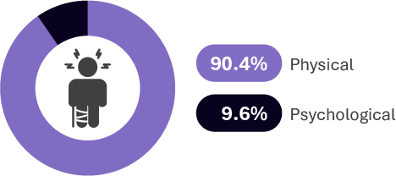
Injury type from sample
Base: All 2025 workers n=4,143

Return to Work Rate
The Return to Work Rate is the proportion of injured workers surveyed who reported having returned to work at any time since their work-related injury or illness.
The national Return to Work Rate was 88.9% in 2025. Since 2014, the rate has been trending downward and decreased significantly in 2025 (88.9%) compared to 2021 (91.6%).
Figure 2 Return to Work Rate by National time series (% yes)
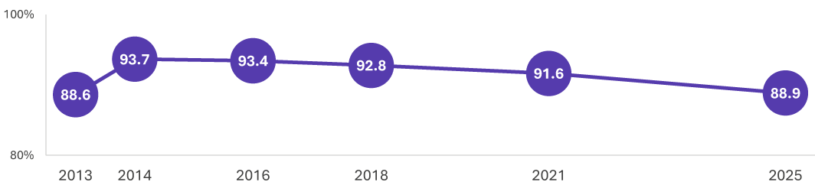
RTW1. Have you returned to work at any time since your work-related injury or illness?
Base: All workers (2013 n=4,698; 2014 n=4,679; 2016 n=5,124; 2018 n=4,602; 2021 n=4,588; 2025 n=4,143)
Table 1 2025 Return to Work Rate by Jurisdiction (% yes)
NSW | VIC | QLD | SA | WA | TAS | ACT | NT | Comcare
87.2% | 84.2% | 91.7% | 89.2% | 93.4% | 90.6% | 91.6% | 86.5% | 92.0%
RTW1. Have you returned to work at any time since your work-related injury or illness?
Base: All workers (NSW n=987; VIC n=723; QLD n=595; SA n=435; WA n=573; TAS n=224; ACT n=200; NT n=206; Comcare n=200)

Key insights from the data
Binary logistic regression of the Return to Work Rate, based on characteristics of the way the injury was managed and the demographics of the injured workers, identified the following characteristics as related to higher return to work outcomes, independently of each other:
- having a physical injury,
- having a return to work plan in place,
- the employer managed the injury before claim,
- injured workers who were not Aboriginal and / or Torres Strait Islander,
- injured workers with a university education,
- injured workers aged between 18-34.
After accounting for these characteristics, additional characteristics such as gender, were not significantly associated with different Return to Work rates.
The purpose of the regression analysis was to account for related characteristics such as age, education and industry. The regression analysis determines which of these had the strongest association with Return to Work rate, independent of other characteristics.
Some of the characteristics identified (above) as relating to higher return to work outcomes were also identified in Monash University’s Barrier and Enablers to Return to Work: Literature Review. These include higher education, age and return to work planning.
In 2025, the Return to Work Rate was lower amongst injured workers:
- with psychological injuries (76.5%) compared to those with physical injuries (90.2%)
- whose injury has had a significant or severe impact on their daily life (68.5%) compared to those where the impact was moderate or less (95.2%)
- who work in the Transport, postal and warehousing industry (83.8%)
- in businesses with less than 200 employees (87.0%) compared to those in businesses with 200 or more employees (91.0%)
- who identified as Aboriginal and/or Torres Strait Islander background (81.2%)
- without a university education (87.6%) compared to those with a university education (93.1%)
- aged 55 and over (85.5%) compared to those aged under 35 (92.6%)

Current Return to Work Rate
The Current Return to Work Rate is the proportion of injured workers surveyed who reported having returned to work at any time since their work-related injury or illness and were in a paid job at the time of interview.
The national Current Return to Work Rate was 78.8% in 2025 (see Figure 3). Similar to the trend with the national Return to Work Rate, the national Current Return to Work Rate has trended downward since 2016 (83.5%) and is significantly lower compared to 2021 (81.3%).
Similar to the Return to Work Rate, in 2025 injured workers with psychological injuries (67.9%), workers whose injury had a significant or severe impact on their daily life (52.3%), those in businesses with less than 200 employees (76.0%), those with Aboriginal and/or Torres Strait Islander background (70.9%), and those aged 55 and over (71.1%) had lower Current Return to Work Rates.
Figure 3 Current Return to Work Rate by National time series (% yes)
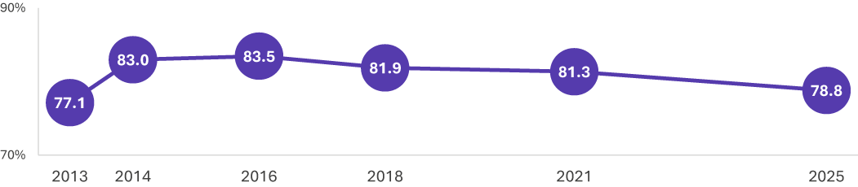
RTW1. Have you returned to work at any time since your work-related injury or illness? RTW2. Are you currently working in a paid job?
Base: All workers (2013 n=4,698; 2014 n=4,679; 2016 n=5,124; 2018 n=4,602; 2021 n=4,588; 2025 n=4,143)
Table 2 2025 Current Return to Work Rate by Jurisdiction (% yes)
NSW | VIC | QLD | SA | WA | TAS | ACT | NT | Comcare
77.9% | 71.5% | 82.9% | 76.9% | 81.3% | 75.0% | 82.9% | 78.7% | 80.0%
RTW1. Have you returned to work at any time since your work-related injury or illness? RTW2. Are you currently working in a paid job?
Base: All workers (NSW n=987; VIC n=723; QLD n=595; SA n=435; WA n=573; TAS n=224; ACT n=200; NT n=206; Comcare n=200)
Injured workers whose injury has had a significant or severe negative impact were more likely to not be currently working due to their work-related injury or illness (54.3%) than workers whose injury had a moderate or lesser impact (14.1%).
Injured workers who are not currently working are more likely to be those:
- whose injury has had a significant or severe negative impact on their daily life (43.5% not currently working) compared to workers whose injury had a moderate or lesser impact (10.9%).
- who work in organisations with less than 200 employees (21.5%) compared to those in larger organisations (14.7%).

Reason for not working
Among those not currently working, the predominant reason for not working (Figure 4) was due to a work-related injury or illness (35.7%), followed by retirement (11.5%) and a suitable job not being available (9.1%).
Injured workers with a psychological injury were more likely to not be working due to a work-related injury or illness (45.9%) and a mental health concern such as depression or anxiety (14.5%) compared to those with a physical injury (33.8% and 3.8% respectively).
Work-related injuries and illnesses can have different effects on workers across the life course. For instance, injured workers aged 55 and over were the most likely to not be currently working because they retired (21.2%), whilst injured workers aged under 35 were the most likely to not be working because they are studying (10.9%). Injured workers aged 35 to 54 were the most likely to not be working because of their work-related injury or illness (48.4%).
Figure 4 Reasons for not working (%)
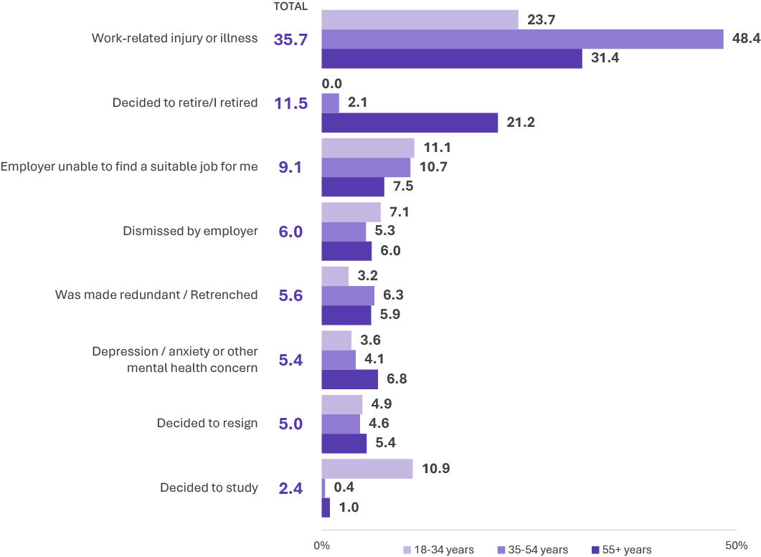
RTW4. What is the main reason you are not currently working?
Base: Not currently working n=815

Needed additional time off
More than one fifth (21.4%) of injured workers who are currently working had needed additional time off due to their work-related injury or illness.
Figure 5 Additional time off

RTW8. Since you first returned to work, have you had to have any additional time off because of your work-related injury or illness?
Base: Currently working n=3,301

Support needed to get back to work
Among injured workers who have not returned to work, the main type of support they need to get back to work is greater understanding and/or communication from their workplace.
Workers with a psychological injury are more likely to need a greater range of supports including understanding and communication from their workplace, assistance finding suitable work, and getting access to education and training for a different position, than those with a physical injury.
Workers whose injury has had a significant or severe negative impact on their daily life are more likely to need greater support from healthcare services (36.1%) than workers whose injury had a moderate or lesser impact (23.6%).
Figure 6 Support needed to get back to work (%)
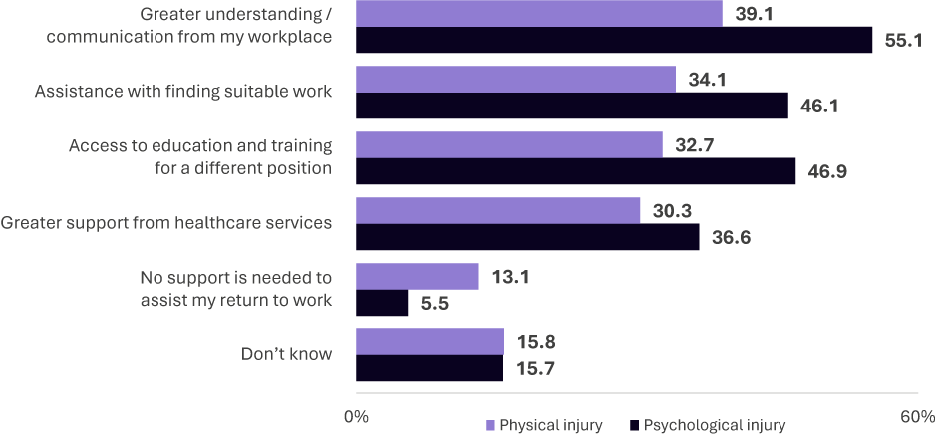
RTW16. In your opinion, which of the following supports could be provided to assist you in the return to work process?
Base: Has not returned to work n=459

Employer offered RTW education or training
One in six (16.5%) injured workers were offered education or training from their employer in relation to returning to work. Injured workers who were offered this support were more likely to have returned to work (94.4%) compared to those who were not offered it (88.1%).
Notably, injured workers with a physical injury were more likely to be offered this education and training (17.4%) compared to those with a psychological injury (7.7%). Workers whose injury has had a moderate or lesser impact on their daily life were also more likely to have been offered education and training (18.7%) compared to workers whose injury had a significant or severe negative impact (8.3%).
Figure 7 Employer offered RTW education or training

EMP15_W. Did your employer offer any education or training in relation to your return to work, either for your current job or for moving to a different job?
Base: All respondents n=4,143

Employer insights

Injury types
According to employer responses , about four in five employers (82.6%) had a worker with a physical injury or illness only, while 6.4% had a psychological injury or illness only. About one in ten (9.7%) were classified as having both a physical and psychological injury or illness (see Figure 8).
Employers in production industries were more likely to have a worker with a physical injury or illness only (86.3%) compared with employers in service industries (79.7%). Employers in services industry were more likely to have a worker with a psychological injury only (8.8%) compared with employers in production industries (3.3%).
Employers of micro (90.4%) and small (87.5%) sized businesses were also more likely to have a worker with a physical injury only compared to medium (78.9%) and large (74.3%) sized businesses. Psychological injuries were more likely in large (14.3% psychological injury only) and medium (10.5%) sized businesses compared to small (2.6%) and micro (0.9%) sized businesses.
Figure 8 Injury type
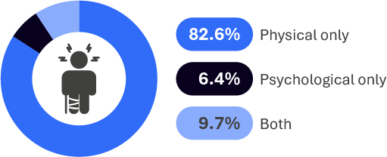
RTW12. Broadly, what category does your worker’s injury, illness or disease fall under?
Base: All employers n=754
Note: Don’t know, prefer not to say, disease responses not shown (all <1%)

Employer Return to Work Rate
The national Return to Work Rate, as reported by employers, was 70.8% in 2025 (see Figure 9), which is lower than the rate reported by workers (88.9%). For accuracy of recall, employers with more than one workplace injury were asked to report on their most recent injured worker who made a claim. This biases the employer Return to Work Rate downwards due to workers captured through the employer survey possibly having less time to return to work compared with workers who responded to the worker survey. Other possible reasons the employer Return to Work Rate is lower include different levels of recall of return to work between workers and employers, scope definitions applied to each survey, and non-response bias for both workers and employers.
In 2025, the employer Return to Work Rate was lower amongst those with workers who had a psychological injury or illness (37.2%) compared to those with a physical injury or illness (75.0%). Although these results are lower when compared to those reported in the worker survey, the pattern, whereby the rate is lower amongst those with a psychological injury/illness, is similar.
The Return to Work Rate was higher for micro sized businesses (82.0%) compared to small (66.7%), medium (69.3%) and large (71.6%) sized businesses.
Figure 9 Employer Return to Work Rate

RTW1. Has your worker returned to your workplace at any time since their work-related injury or illness?
Base: All employers n=754

Reason for not working
According to employers, the predominant reason for their injured worker to not be working was due to the worker’s injury or illness (41.0%), followed by 13.9% who said it was because the worker decided to resign (see Figure 10).
Other reasons included ‘our workplace was unable to find a suitable job for them’ (8.3%), ‘fraudulent claim’ (6.7%), and ‘they didn’t want to return to work’ (5.2%).
Figure 10 Reason for not working (%)
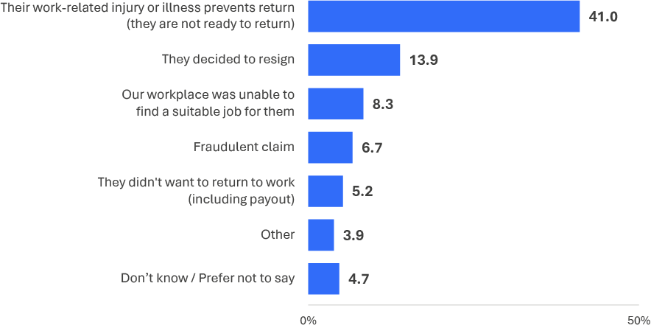
RTW4. What is the main reason you think your worker has not returned to your workplace?
Base: Worker not returned to work n=255
Note: ‘Fraudulent claim’ and ‘They didn’t want to return to work’ were captured as free text using the ‘Other’ response option and coded during data processing. ‘Fraudulent claim’ responses do not necessarily reflect that a determination was made on the legitimacy of a claim.

This section reports on the impact of workplace injuries on workers and employers.
02
Section
Impact of injury

Impact of Injury

Key findings

Workers:
- Access to medical treatment or services is linked to better Return to Work Rates as workers who agreed that they were able to access the treatment / services they needed were more likely to have returned to work compared to those who disagreed. Injured workers whose injury had a significant or severe impact were more likely to state that their medical treatment or services were not approved.
- One in five (20.0%) workers with a psychological injury did not agree that they were able to access the medical services and treatment they needed. They were more likely to report that it took too long to get help and that there is limited healthcare provider availability compared to those with a physical injury.
- Workers with physical injuries who are aged 35 and over need more support with health and wellbeing than those aged under 35 years old.
- Injured workers whose injury has had more significant negative impacts, and those with psychological injuries, are getting less support from their employer, including being less likely to be contacted by their employer before returning to work, be helped by their employer to manage their injury or illness before lodging a claim, and receive payments before lodging a claim.
- Compared to previous years, in 2025 a lower proportion of workers reported that they were helped by their employer to manage their injury or illness before lodging their claim.

Employers:
- Similar to the findings from injured workers, employers who reported helping their injured worker manage their injury or illness before they lodged their claim resulted in a greater likelihood of the worker returning to work.
- In contrast to the finding from injured workers, employers who reported offering payments either before or after lodging their claim did not result in a better return to work outcome.
- Employers were less likely to be informed about the treatment needs of workers with psychological injuries than those with physical injuries.
- Employers were less likely to have encouraged workers with psychological injuries to put in a claim, and less likely to think these workers were being truthful about their injury or illness, compared to workers with physical injuries.
- Employers from larger organisations have higher rates of providing their injured worker with information about workplace health and safety, the compensation process and returning to work.
- Employers with workers who have a physical injury are more likely to contact their worker within three days after their injury or illness, compared to employers with workers who have a psychological injury.

Worker results

Overall impact
Around one quarter (22.3%) of injured workers reported that their work-related injury or illness has a significant or severe negative impact on their daily life. More injured workers with a psychological injury (36.8%) reported a significant or severe impact compared to those with a physical injury (20.7%).
Injured workers whose injury had a significant/severe impact are less likely to have returned to work (68.5%) compared to workers whose injury has a lesser impact (95.2%). When these workers do return to work, they are more likely to return to less hours (67.0%) compared to workers whose injury had a lesser impact (38.9%).
Figure 11 Extent injury has negative impact on daily life (%)
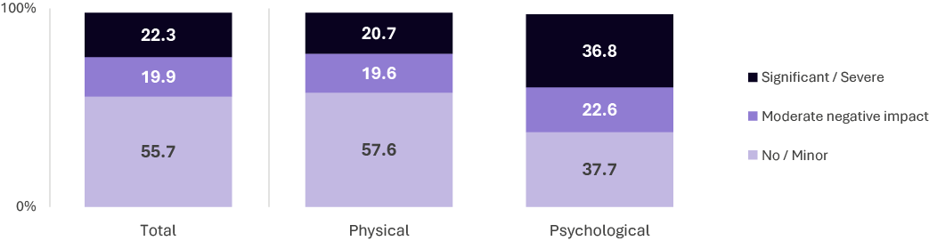
PP6. To what extent does your work-related injury or illness have a negative impact on your daily life now?
Base: All workers n=4,143

Health and wellbeing
A third (35.4%) of injured workers reported being in poor or fair health at the time of the survey (see Figure 12). More injured workers with psychological injuries (49.1%) reported being in poor or fair health compared to those with physical injuries (33.9%).
Amongst workers with physical injuries, those aged 35 and above were more likely to report being in poor to fair health (36.1%) compared to those aged under 35 years old (26.8%), whereas for workers with a psychological injury, there were no significant differences in health and wellbeing between age groups.
Figure 12 Health and wellbeing rating (%)
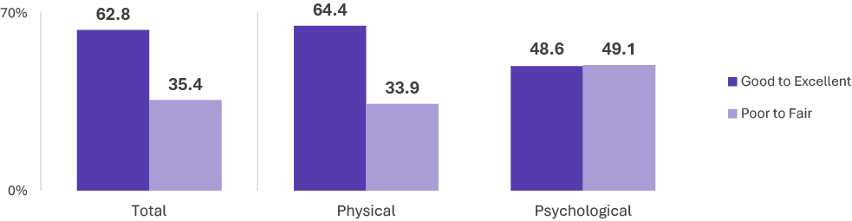
PP1. In general, how would you say your health and wellbeing is now?
Base: All workers n=4,143

Access to medical treatment and services
Over eight in ten (83.4%) injured workers agreed or strongly agreed that they were able to access the medical treatment or services that they needed for their work-related injury or illness (Figure 13). Workers who agreed that they were able to access these treatment / services were more likely to have returned to work (90.5%) compared to those who disagreed (80.1%).
Injured workers whose injury has had a significant or severe impact were less likely to agree that they were able to get this access (67.2%) compared to workers whose injury had a moderate or lesser impact (88.6%).
Four in five (80.0%) workers with a psychological injury agreed that they were able to access the medical services and treatment they needed. However, workers with a psychological injury who disagreed that they were able to get access to treatment or services were more likely to respond that it took too long to get help (51.2%) and that there is limited healthcare provider availability (32.6%) compared to those with a physical injury (37.3% and 18.5% respectively).
Figure 13 Able to access medical treatment (%)
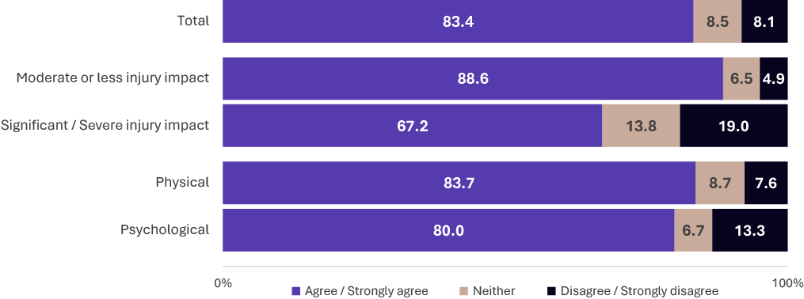
HL1. To what extent do you agree or disagree that you were able to access the medical treatment or services that you needed for your work-related injury or illness?
Base: All workers n=4,089
Note: Refused responses excluded from base (<2%)

Main healthcare provider
The main healthcare provider used by injured workers was their GP (60.3%). Workers with a psychological injury were more likely to mainly use a GP (70.0%) than those with a physical injury (59.3%), and they were also more likely to mainly use a psychologist or psychiatrist. On the other hand, workers with a physical injury were more likely to mainly use a physiotherapist or other medical specialist (see Figure 14).
Figure 14 Main healthcare provider (%)
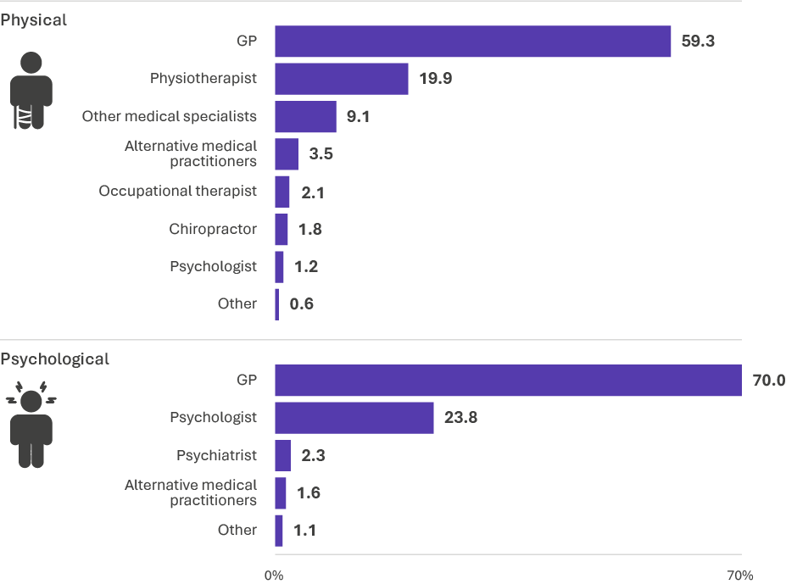
HL2b. Who is your main healthcare provider?
Base: Has a healthcare provider (Physical n=3,490; Psychological n=590)
Notes: Don’t know/refused results not shown (<2.2%); Healthcare providers with less than <1% of responses combined into ‘other’; ‘Alternative medical practitioners’ was captured as free text using the ‘other’ response option and coded during data processing.

Areas discussed with main healthcare provider
Injured workers whose main healthcare provider discussed areas related to returning to work and recovery activities were more likely to return to work. Discussing the date on which the injured worker was likely to return to work was the topic most closely linked to returning to work: 81.5% of those who returned to work had discussed the topic compared to 39.3% who did not return to work.
Physiotherapists were the most likely to regularly discuss progress for returning to work (92.7%) and to recommend activity as part of an injured workers’ recovery (95.1%). Occupational therapists (93.6%) and physiotherapists (91.8%) were the most likely to discuss the types of activities that the injured worker could do.
Figure 15 Areas main healthcare provider discussed (%)
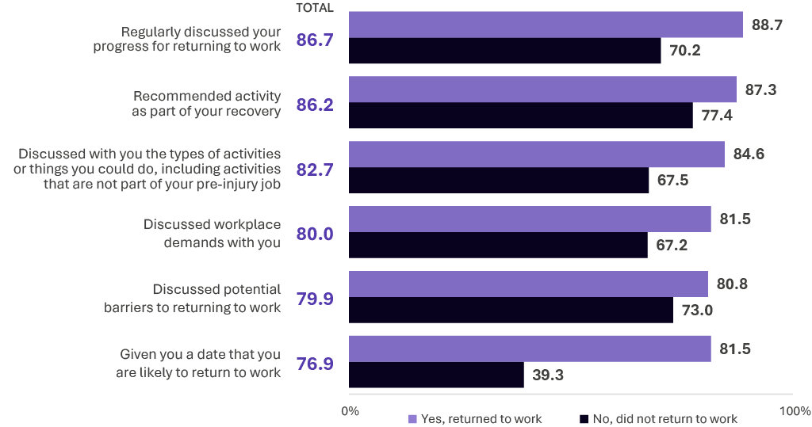
HL3b. Did your <main healthcare provider> discuss any of the following with you?
Base: Has a main healthcare provider (n=3,999)

Stress level when interacting with healthcare provider
Injured workers with a psychological injury were more likely to be extremely or quite stressed (31.8%) during their interactions with their healthcare provider compared to those with a physical injury (15.2%). This was also the case for workers whose injury had a significant or severe impact (38.8%) compared to workers whose injury had a moderate or lesser impact (10.2%).
Notably, women were more likely to find interactions with their healthcare provider to be stressful (19.5%) than men (14.2%).
Figure 16 Stress level when interacting with healthcare provider (%)
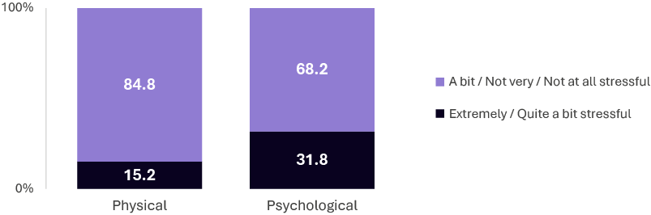
HL4a. Thinking about all the healthcare providers you have seen, to what extent have your interactions with your healthcare provider(s) been stressful?
Base: Has a healthcare provider (n=4,093)
Note: don’t know & refused responses excluded from base (<1.5%)

Contacted by workplace prior to return to work
Two-thirds (66.6%) of injured workers were contacted by their workplace prior to returning to work. Workers with a psychological injury (38.4%) and workers whose injury had a significant or severe impact (49.0%) were less likely to be contacted compared to those with a physical injury (69.2%) and workers whose injury had a moderate or lesser impact (70.4%).
Workers with a physical injury who were contacted were much more likely to be contacted earlier within 3 days (75.7%) compared to those a psychological injury (46.1%).
Figure 17 Contacted about injury prior to return to work

EMP8. Did your supervisor or someone else from your workplace contact you about recovering from your work-related injury or illness prior to your return to work?
Base: Returned to work (n=3,654)

Employer helped manage injury/illness before lodged claim
Nearly half (48.3%) of injured workers were helped by their employer to manage their injury or illness before lodging their claim. Compared to previous years, in 2025 a lower proportion of workers reported that they were helped by their employer to manage their injury or illness before lodging their claim, decreasing since 2021 (51.1%).
Injured workers who had returned to work were more likely to have been helped (51.0%) compared to those who had not returned to work (27.2%).
Workers with a psychological injury, and workers whose injury had a significant or severe impact, were less likely to be helped compared to those with a physical injury and workers whose injury had a moderate or lesser impact (see Figure 18). Among those with a physical injury, women were less likely to be helped (49.3%) compared to men (54.8%).
Figure 18 Employer helped manage injury/illness before lodged claim (%)
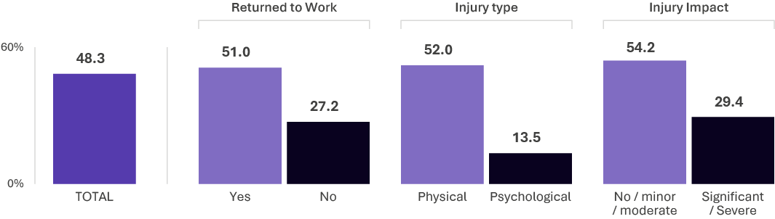
EMP10. Did your employer help you manage your injury or illness before you lodged your workers’ compensation claim?
Base: All workers n=4,143

Lodging a claim
Most elements of submitting a compensation claim and receiving payments are correlated with positive return-to-work outcomes.
One in seven (14.5%) injured workers received payments from their employer before lodging a claim and one-quarter (24.8%) received payments after lodging a claim but before the claim had been accepted (Figure 19).
Return to Work Rates were higher amongst injured workers who received payments from their employer before (93.3%) and/or after (91.8%) lodging a compensation claim, compared to those who had not received them (88.3% and 87.7% respectively).
Women were less likely to have received a payment before lodging a compensation claim (11.4%) than men (17.3%).
Statistical analysis indicates that the effect of payments on Return to Work Rates is marginally higher when they are made before lodging a claim than after.
Figure 19 Received payment from employer
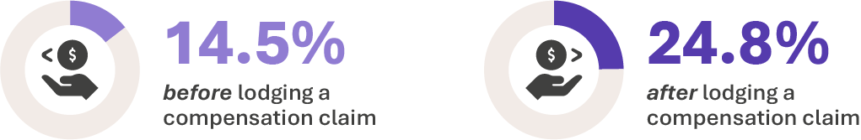
EMP14a. Did you receive any payments for treatment from your employer before you lodged your workers’ compensation claim? EMP14b. Did you receive any payments for treatment from your employer after lodging the claim but before it had been accepted by <jurisdiction>?
Base: All workers n=4,143

Awareness of employers’ policies, plans and procedures
Less than two thirds (62.8%) of injured workers were aware of, or had been provided with, their employers’ work, health and safety policies or procedures. Only around half of injured workers were aware of, or had been provided with, their employers’ policies on return to work (51.4%), or the workers’ compensation claims process (49.0%). Well less than half (44.2%) were aware of information about recovery after a workplace illness or injury (see Figure 20).
Return to Work Rates were higher amongst injured workers who were aware of, or had been provided with, this information (see Figure 21). For example, 94.0% of those who were aware of information about returning to work were more likely to return to work compared to those who were not aware (83.7%).
Figure 20 Awareness of employers’ policies, plans and procedures (%)
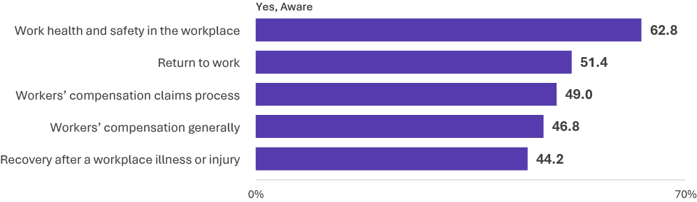
EMP16. Are you aware of, or have you been provided with, any information regarding your employer’s relevant policies, plans and procedures for any of the following?
Base: All workers n=4,143
Figure 21 Returned to work by Awareness of employers’ policies, plans and procedures (% returned to work)
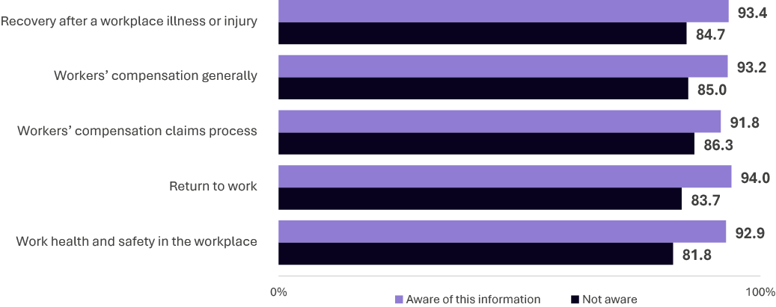
EMP16. Are you aware of, or have you been provided with, any information regarding your employer’s relevant policies, plans and procedures for any of the following?
Base: Workers who had returned to work n=3,654: Workers who had not returned to work n=459

Negative impacts when considering submitting a compensation claim
Concerns about the negative impacts of submitting a claim are correlated with lower Return to Work Rates. For example, over two in five (41.0%) injured workers who had not returned to work agreed that they thought they would be treated poorly by people at work, compared with 26.1% who had returned to work (see Figure 22).
Workers with psychological injuries were more likely to agree with all four statements relating to the negative impacts of submitting a claim compared to those with a physical injury. For example, 64.5% of those with a psychological injury agreed that they felt their supervisor thought they were exaggerating or faking their injury compared with 23.1% of those with a physical injury.
Figure 22 Negative impacts when considering submitting a compensation claim (% Agree)
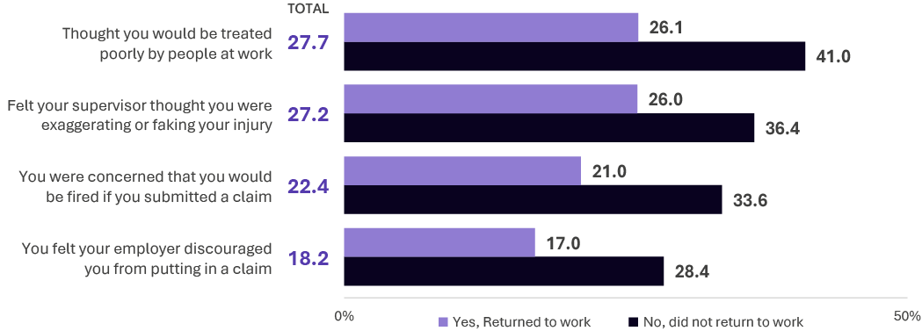
EMP11. Thinking back to when you were considering putting in a workers’ compensation claim, to what extent do you agree or disagree with the following?
Base: All respondents n=4,143

Employer results

Helped with injury/claim
Seven in ten (68.1%) employers said they helped their worker manage their work-related injury or illness before they lodged their claim (see Figure 23).
About two in five (37.4%) employers said they offered payments for treatments to their worker prior to them lodging a claim. Fewer employers (34.5%) offered payments before the claim was accepted but after it was lodged.
Employers were more likely to say their worker returned to work when the employer helped the worker manage their injury or illness before they lodged their claim (74.3%). A lower proportion of injured workers (62.2%) returned to work if the employer did not help the worker manage their claim before it was lodged.
Despite being a return to work indicator for workers’ results, according to employer responses there was not a significant difference between the Return to Work Rate of workers who were, and those who were not, offered payments from their employer before (71.9% versus 70.2%) or after (71.1% versus 70.5%) lodging their claim.
Figure 23 Help and payments before and after lodgement (%)
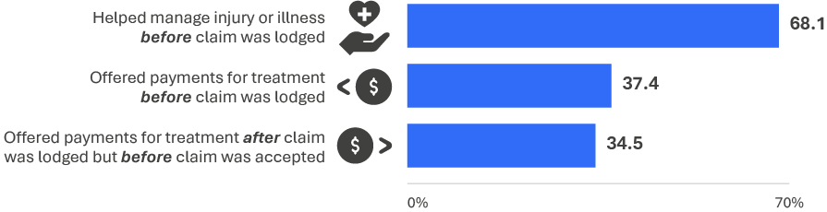
EMP10. Did you help your worker manage their injury or illness before they lodged their workers’ compensation claim? EMP14a. Did you offer any payments for treatment to your worker prior to them making a claim? EMP14b. Did you offer any payments for treatment to your worker after they had made a claim but before the claim had been accepted?
Base: All employers n=754

Four in five (82.0%) employers agreed that their worker was ‘not treated poorly by people in their immediate working group’ (see Figure 24).
However, employers were less likely to agree that ‘they (injured workers) were being accurate and truthful about their injury or illness’ (65.5%) and ‘you (the employer) encouraged them to put in a claim’ (62.4%).
Agreement for ‘you encouraged them to put in a claim’ and ‘they were being accurate and truthful about their injury or illness’ were both significantly lower for employers who had workers with a psychological injury or illness (24.3% and 35.9% respectively) compared to those with a physical injury or illness (70.8% and 64.6% respectively).
Employers who believed the worker was being truthful about their injury or illness reported a higher Return to Work Rate (79.1%) than employers who did not agree the worker was being truthful (44.7%).
Figure 24 Employer perception of the claim (%)
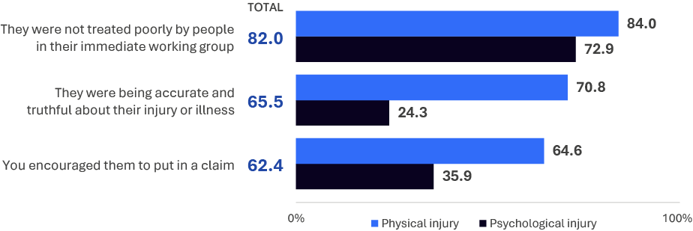
EMP11. To what extent do you agree or disagree with the following?
Base: All employers n=754
Almost four in five (78.6%) employers said they provide their workers with general information about work health and safety during the course of their employment, and half (48.1%) said they provided their worker with information about work health and safety following their incident or injury (see Table 3).
Employers from large (66.7%) and medium (52.6%) sized businesses were more likely to say they provided their worker with work health and safety information following their incident or injury compared to small (40.4%) and micro (41.4%) sized businesses.
Just over half (52.2%) of employers said they provide their workers with general information about workers’ compensation during the course of their employment. Employers who have had more than 3 claims in the last 24 months (65.1%) were more likely to say they provide their workers with general information about workers’ compensation compared to employers who have only had one claim (47.0%).
Almost three in five (57.6%) employers said they provided their worker with information about workers’ compensation following their incident or injury. Employers who have had more than 3 claims in the last 24 months (73.8%) were more likely to say they provided their worker with information about workers’ compensation following their incident or injury compared to employers who have only had one claim (50.9%).

Table 3 Employer provided worker with information
 | Total | Micro  (1-4) | Small  (5-19) | Medium  (20-199) | Large  (200+) | 1  claim | 2  claims | 3  claims | >3  claims
Health and safety
Yes, as we provide general information about work health and safety to all workers during  the course of their employment | 78.6% | 68.3% | 80.1% | 81.8% | 72.4% | 74.7% | 79.8% | 81.5% | 84.3%
Yes, we specifically provided work health  and safety information to the worker  following their incident or injury | 48.1% | 41.4% | 40.4% | 52.6% | 66.7% | 40.5% | 51.8% | 40.2% | 63.3%
Compensation and RTW
Yes, as we provide general information  about workers’ compensation to all workers during the course of their employment | 52.2% | 42.0% | 49.6% | 54.7% | 65.1% | 47.0% | 50.1% | 48.5% | 65.1%
Yes, we specifically provided workers’ compensation information to the worker following their incident or injury | 57.6% | 49.5% | 51.4% | 61.2% | 79.0% | 50.9% | 55.0% | 53.7% | 73.8%
Yes, we provide general information to  support workers’ return to work | 46.9% | 34.8% | 43.4% | 52.4% | 55.3% | 37.0% | 52.7% | 51.7% | 60.8%
EMP16a. Did you provide the worker with any information regarding work health and safety? EMP6b. Did you provide the worker with any information regarding workers’ compensation?
All employers n=754

Contact with worker
Nine in ten employers (92.1%) said they contacted their worker since their work-related injury or illness. Of these employers, 89.8% said that the first contact occurred within 3 days of their work-related injury or illness, and 92.9% said that this contact was maintained with the worker (see Figure 25).
Employers who contacted the worker about their work injury or illness reported a higher Return to Work Rate (74.0%) than those who did not contact their worker (35.6%).
Similarly, the Return to Work Rate was higher among employers who maintained contact with the worker since their work injury or illness (77.8%) than employers who did not maintain contact (19.3%).
Employers who had contacted workers with a physical injury or illness were more likely to have done so within 0 to 3 days after the injury or illness (91.8%) compared to those with a psychological injury or illness (74.1%).
Figure 25 Contact with worker
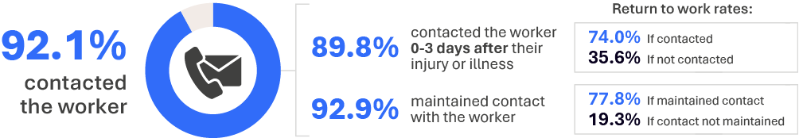
EMP8. Have you or someone else from your workplace contacted the worker since their injury or illness?
Base: All employers n=754
EMP9a. How many days after the worker’s work-related injury or illness occurred were they first contacted by you or someone from your workplace? EMP9b. Have you or someone else from your workplace stayed in regular contact with the worker since their injury or illness?
Base: Contacted the worker n=699
A majority (66.1%) of employers agreed that they were sufficiently informed about the treatment needs and medical condition of their worker (see Figure 26).
Employers who had workers with a physical injury or illness (70.1%) were more likely to say they were sufficiently informed about the treatment needs and medical condition of their worker compared to those with a psychological injury or illness (36.6%).
Further, importantly, employers who reported that they were sufficiently informed about the treatment needs and medical condition of their worker reported a higher Return to Work Rate (77.5%) than employers who were not sufficiently informed (44.0%).
Figure 26 Employer informed about treatment needs
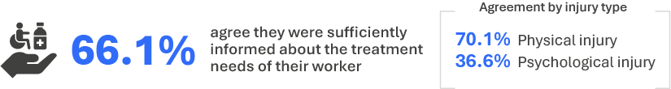
WC2. To what extent do you agree or disagree that you were sufficiently informed about the treatment needs and medical condition of the injured or unwell worker so that you could adequately support and assist them?
Base: All employers n=754
This section reports on the elements of return to work planning which contribute to positive outcomes for injured workers.
03
Section
Return to work planning

Return to work planning
Key findings

Workers:
- Injured workers with a return to work plan are more likely to have returned to work at any time, and to be currently working. This is consistent with previous research that found strong evidence that return to work planning has a positive impact on return to work outcomes.
- The proportion of injured workers with a return to work plan has remained steady since 2016.
- Having a plan results in better return to work outcomes. For those with a plan, considering the medical advice further improves return to work outcomes. Regardless of injury type, elements such as having the plan in writing, having someone monitor the plan and making changes to the plan, do not appear to be linked to better return to work outcomes, according to the data in this survey.
- Having a return to work coordinator is linked to better return to work outcomes, although having contact with a coordinator is not always linked to better outcomes. It is important that this contact is managed appropriately as having a stressful interaction can lessen the benefits of interacting with the coordinator.
- Injured workers with a psychological injury, and workers whose injury had a significant or severe impact on their daily life, were less likely to have a return to work plan.

Employers:
- Similar to workers, employers reported that injured workers who had a return to work plan were more likely to have returned to work at any time. Simply having a return to work plan was more of a contributor to returning to work than factors such as updating the plan and having it in writing. Having the plan in writing is not correlated with an increased Return to Work Rate. Being able to update the plan has a low effect on returning to work.
- Employers were more likely to have a return to work plan in place with workers who had a physical injury. Where a return to work plan had been established, it was more likely to be in writing for workers with a psychological injury compared with workers with a physical injury.
- Employers from large businesses are more likely to agree that they receive enough training to act as a return to work coordinator than employers from small/micro businesses. However, employers from small/micro businesses are more likely to say they do not need additional assistance compared to employers from large businesses.

Worker results

Had a return to work plan
Three in five (61.8%) injured workers had a plan in place to get back to work. Injured workers with a plan were more likely to have returned to work at any time (94.0%) and to be currently working (89.5%) compared to those without a plan (81.7% at any time, 69.4% currently working).
A similar proportion of injured workers had a plan in 2025 (61.8%) compared to 2021 (64.8%), 2018 (62.9%) and 2016 (63.6%), after increasing from 2014 (50.2%).
Workers with a physical injury were much more likely to have a return to work plan (64.0%) than those with a psychological injury (40.9%). Workers whose injury had a moderate or lesser negative impact on their daily life were also more likely to have a return to work plan (65.8%) than workers whose injury had a significant or severe impact (50.3%).
Figure 27 Return to work plan

EMP1. Did you have a plan in place to get back to work?
Base: All workers n=4,143

Return to work plan development
Injured workers were asked to assess their return to work plan using four statements. Seven in ten (69.1%) injured workers agreed they ‘found the return to work plan helpful’ and eight in ten (78.2%) agreed with the statement ‘I felt the return to work plan considered the medical advice I received’.

Injured workers with a psychological injury, and workers whose injury had a significant or severe negative impact, were less likely to agree with each of these statements compared to workers whose injury was physical and workers whose injury had a moderate or lesser negative impact. In particular, workers whose injury had a significant or severe negative impact had low agreement with ‘I found the return to work plan helpful’ (46.5%) and ‘I was involved in the development of the return to work plan’ (52.2%).
Figure 28 Return to work plan development (%)
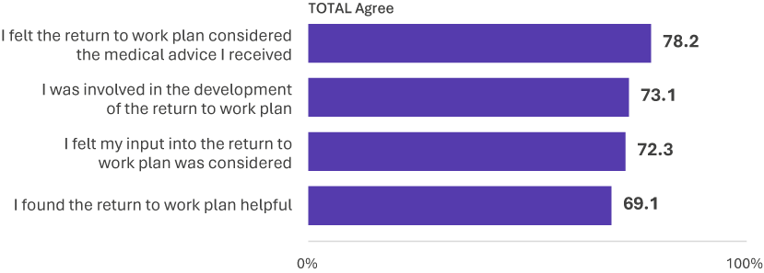
EMP3. Do you agree or disagree with the following statements about your return to work plan?
Base: Had a return to work plan n=2,615
Over six in ten (62.4%) injured workers who had a return to work plan indicated that someone within their workplace monitored the progress and effectiveness of the plan. There was not a strong link between having someone monitor the plan and better return to work outcomes - the Return to Work Rate is similar for those who had their plan monitored (95.4%) compared to those who did not have the plan monitored (93.5%).
Figure 29 Return to work plan monitoring

EMP12a. Did an individual within your workplace monitor the progress and effectiveness of your return to work plan?
Base: Had a return to work plan n=2,615

Return to work coordinator
Seven in ten (70.5%) injured workers reported having a return to work coordinator. Injured workers whose injury has a significant or severe negative impact on their daily life were less likely to have a coordinator (63.8%) compared to workers whose injury had a moderate or lesser impact (73.5%).
Injured workers who had a coordinator from within their workplace were more likely to have returned to work (94.2%) compared to those who had an external coordinator (87.5%). Injured workers without a coordinator were the least likely to return to work (83.9%).
Figure 30 Has a return to work coordinator
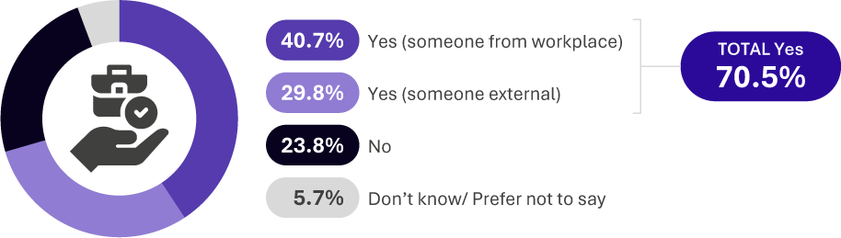
EMP4. Do you have a designated person to coordinate your return to work process?
Base: All workers n=4,143
Among injured workers who had a return to work coordinator, 77.2% had been in contact with their coordinator since their injury or illness. Men were more likely to have had contact with their coordinator (79.7%) compared to women (74.9%).
Injured workers whose injury has a significant or severe negative impact on their daily life were more likely to have had contact with the coordinator (82.4%) compared to workers whose injury had a moderate or lesser impact (75.9%). However, having contact with the coordinator does not appear to result in better return to work outcomes. For example, amongst injured workers whose injury had a significant or severe negative impact, those who had had contact with their coordinator were less likely to have returned to work (71.7%) compared to those who did not have contact (84.8%).
Figure 31 Contact with return to work coordinator

EMP5. Has this person been in contact with you since your injury or illness?
Base: Has a return to work coordinator n=2,915
One in six (16.1%) injured workers found their interaction with the return to work coordinator to be quite stressful or extremely stressful. Injured workers whose injury had a significant or severe negative impact on their daily life were more likely to have found this interaction stressful (34.1%) than workers whose injury had a moderate or lesser impact (11.1%). Injured workers who found their interaction with their coordinator to be not very, or not at all, stressful were more likely to have returned to work at any time (92.6%) compared to those who found it quite or extremely stressful (80.2%).
Figure 32 Level of stress when dealing with coordinator (%)
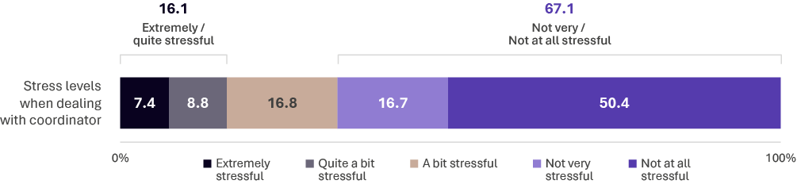
EMP6a. Thinking about all your dealings with this person, to what extent have your interactions been stressful?
Base: Has had contact with return to work coordinator n=2,265
Note: don’t know & refused responses excluded from base (<2%)

Employer results

Had a return to work plan
Four in five (78.7%) employers said the injured worker had a plan in place to get back to work. Of those workers with a plan, three quarters of employers (75.5%) said this plan was in writing (see Figure 34). Although these proportions are higher than those reported by injured workers, this could be because some injured workers were not aware of their plan or that it was in writing.
Employers whose worker had a physical injury or illness (80.3%) were more likely to say their worker had a plan in place compared to those with a psychological injury or illness (60.5%). However, return to work plans were more likely to be in writing for workers with a psychological injury or illness (94.6%) compared to those with a physical injury or illness (73.7%).
Return to work plans in writing were more likely for large (84.2%) and medium (83.8%) sized businesses compared to small (67.7%) and micro (63.6%) sized businesses, as well as for employers with more than 3 claims in the last 24 months (81.6%) compared to those with one claim (68.3%).
Employers were more than twice as likely to say their worker returned to work when the employer said there was a plan in place to get back to work for the worker (80.4%) than when there was not a plan in place (33.9%).
Figure 33 Return to work plan (%)

EMP1. Did / does your worker have a plan in place to get back to work?
Base: All employers n=754
Figure 34 Return to work plan format (%)
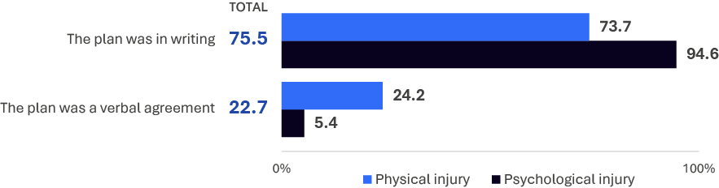
EMP2. Was / is this return to work plan in writing or a verbal agreement?
Base: Had a return to work plan n=593

Return to work plan development
Most employers (84.2%) said that the worker was involved in the development of the return to work plan and 70.6% said the plan was helpful.
Employers who agreed that the return to work plan was helpful reported a higher Return to Work Rate (84.5%) compared with employers who did not agree that it was helpful (59.6%).
Figure 35 Employer perspective on return to work plan

EMP3. To what extent do you agree or disagree with the following statements about your worker’s return to work plan?
Base: Had a return to work plan n=593
Two in five employers said that changes to the return to work plan were needed and that they were able to make them (42.3%), or that no changes were needed (43.5%). Only one in ten (9.3%) said that changes were needed but they were not able to make them.
This is important because when the employer said changes were able to be made to the return to work plan, employers reported a much higher Return to Work Rate (86.7%) than when changes were not able to be made (66.3%).
Figure 36 Return to work plan changes (%)
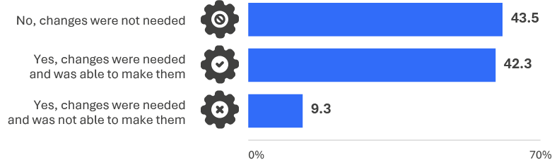
EMP13a. Have you been able to make changes to the worker’s return to work plan, if you needed them?
Base: Had a return to work plan n=593

According to employers, the top three ways that their injured worker’s return to work plan was monitored was through regular communication with the manager/supervisor (53.4%), medical practitioner/GP (45.4%), and insurer (40.4%) (Figure 37).
Employers with workers who had a psychological injury or illness were more likely to say the return to work plan was monitored through regular communication with the manager/supervisor (78.0%) compared to those with a physical injury or illness (51.8%). This was also true for employers of large (76.0%) and medium (61.0%) sized businesses compared to small (46.9%) and micro (32.2%) sized businesses.
Employers of large (61.1%) and medium (45.8%) sized businesses were more likely to say the return to work plan was monitored through regular communication with the RTW coordinator compared to small (26.0%) and micro (18.5%) sized businesses. This was also true for employers with more than 3 claims in the last 24 months (52.4%) compared to one claim (23.2%).
Figure 37 How the plan was monitored (%)
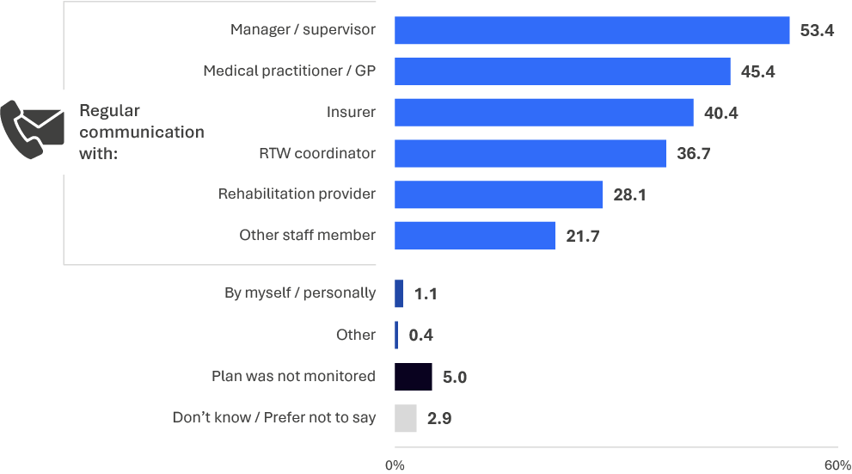
EMP12b. How was / is their plan monitored?
Base: Had a return to work plan n=593
Note: ‘By myself / personally’ was captured as free text using the ‘other’ response option and coded during data processing.

Return to work coordinator
Employers play an important role in helping injured workers return to work.
When it came to employers understanding their role (Figure 38), most employers agreed they understood ‘your duty of care to your worker’ (95.8%), ‘return to work’ (91.0%) and ‘incident notification’ (90.7%).
Employers from large sized businesses were more likely to understand their role compared to micro sized businesses, including ‘your workplace’s return to work program’ (96.9%, compared to 71.9%), ‘the claims process’ (96.0%, compared to 79.1%), ‘obligations around provision of information’ (94.7%, compared to 73.6%) and ‘workplace accommodations’ (91.3%, compared to 64.2%).
Employers who were a return to work coordinator reported a similar Return to Work Rate (72.3%) to employers who were not (71.6%). Employers who said they understand their role in their worker’s recovery reported a much higher Return to Work Rate (73.4%), roughly double that for those who did not understand their role in the worker’s recovery (37.3%). Similarly, the reported Return to Work Rate was far higher when employers understood their role in the worker returning to work (72.3%) than when employers do not understand their role in the worker returning to work (29.2%).
Figure 38 Understanding of their role (% agree/strongly agree)
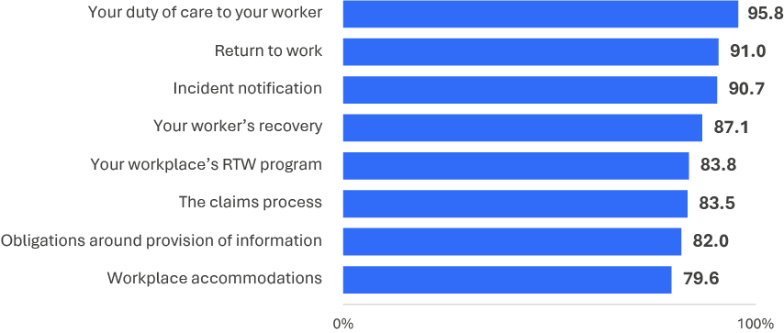
MAN1. To what extent do you agree or disagree that you have a good understanding of your role in each the following?
Base: All employers n=754
Three in five (58.3%) employers agreed that they receive enough training and support to act in the return to work coordinator role. Agreement was higher for employers of large (74.7%) and medium (67.5%) sized businesses compared to small (49.5%) and micro (44.8%) sized businesses.
Figure 39 Training and support for the return to work coordinator role
MAN2a. To what extent do you agree or disagree that you receive enough training and support to act in the RTW Coordinator (or equivalent) role within your workplace?
Base: All employers n=754
Key insights from the data
The extent to which training and support was related to employers’ understanding of their role was investigated using analysis of variance (ANOVA) between the two areas – questions about training and support for the return to work coordinator role and employers’ understanding of their role.
All areas of understanding of the role had a significant association with training i.e. positive outcomes for training were associated with increased understanding of all aspects of the role. The aspect of the role where understanding was most strongly associated with increased training was ‘Your workplace’s return to work program’ (coefficient 0.34). The aspects where understanding was least associated with training were ‘duty of care to your worker’ and ‘incident notification’ (coefficients 0.16 and 0.15), which nevertheless shows a statistically significant positive association with training.
‘Greater assistance from insurers’ (31.5%) was employers’ top suggestion for additional assistance that could be provided to be successful return to work coordinators. A quarter (24.4%) of employers said they did not need any additional assistance (see Figure 40).
Employers with workers who had a psychological injury or illness (47.2%) were almost twice as likely to say they needed ‘further information about legislation/regulation’ than those with a physical injury or illness (24.8%).
Figure 40 Additional assistance for the return to work coordinator role (%)
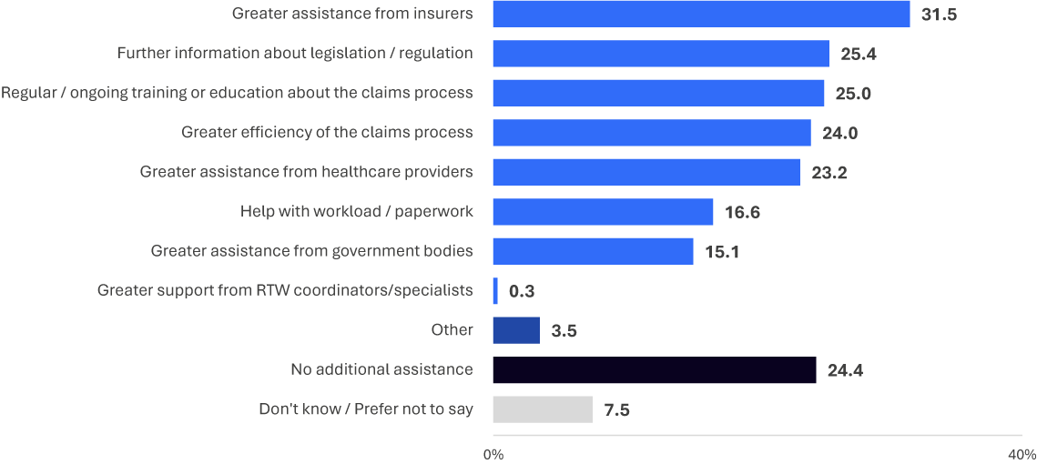
MAN2b. What additional assistance could be provided to you to be successful in the RTW Coordinator (or equivalent) role?
Base: All employers n=754
Note: ‘Greater support from RTW coordinators/specialists’ was captured as free text using the ‘other’ response option and coded during data processing.
This section reports on the experience of returning to work from the perspective of injured workers, and from employers who have experience with injured workers.
04
Section
Returning to work

Returning to work
Key findings

Workers:
- Among all injured workers who have returned to work since their workplace injury or illness, most (87.5%) intend to continue working.
- Whilst this intention is lower among workers whose injury has had a significant or severe negative impact, the majority of these injured workers (75.2%) also intend to continue working.
- Workers with psychological injuries were less likely than those with physical injuries to be offered modified or alternative duties. This is despite those with psychological injuries who have returned to work being more likely to return to completely different duties compared to those with physical injuries. Those with a psychological injury were more likely to indicate they accepted those duties because they meant they could move to a different location compared to those with a physical injury.
- There are better return to work outcomes, including self-reported general health, and a greater intention to remain working, for injured workers who were offered modified or alternative duties to get them back to work.

Employers:
- Employers offering modified or alternative duties that are accepted by an injured worker are more likely to result in the injured worker returning to work. Employers indicated that those with a physical injury were more likely to accept the modified or alternative duties that were offered than those with a psychological injury.
- Employers indicated that injured workers with psychological injuries were more likely to return to different duties compared to those with physical injuries. The unavailability of suitable duties and/or hours was the main barrier reported by employers to offering suitable employment.
- Employers responded that the main areas that they need support in assisting their worker return to work are with investigation into the validity of claims, greater communication with employers, support from healthcare providers, support with transition to work and help with the claims process.
- In terms of support from insurers, the main areas highlighted by employers were more responsive, timely and clear communication, more investigation of the injured worker, and more detail about the claims process.
- The assistance employers would like from the workers’ compensation regulator were updates on policy and legislative changes, consultation with employers, training on policy and procedure, more frequent communication, and help with claims issues.

Worker results

Intention to remain working
The majority (87.5%) of injured workers who have returned to work intend to continue working. The intention to remain working is higher amongst those who are currently working (91.4%) than those who are not currently working (55.9%). This intention is similar across sub-groups except among workers whose injury has had a significant or severe negative impact on their daily life (75.2%), where those workers intention is lower than workers whose injury had a moderate or lesser impact (90.8%).
Figure 41 Intention to continue working

JP11. Do you intend to remain working (whether it be at the same, or a different workplace, as pre-injury or illness)?
Base: Return to work and/or currently working n=3,753

Duties upon returning to work
Nearly two-thirds (64.7%) of injured workers who returned to work returned to the same duties as before their injury/illness. One in five (18.4%) returned to slightly different duties and 15.2% returned to completely different duties.
Injured workers with a psychological injury were more likely to return to completely different duties (29.2%) compared to those with a physical injury (13.9%). Injured workers whose injury has a significant or severe negative impact on their daily life were more likely to return to completely different duties (34.2%) compared to workers whose injury has a moderate or lesser impact (11.1%).
Figure 42 Duties upon returning to work (%)
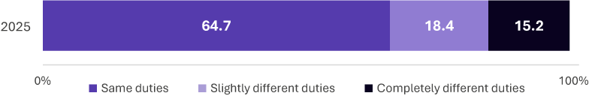
RTW7. Have/did you returned back to the same duties or completely different duties to what you were doing at the time of your work-related injury or illness?
Base: Has returned to work n=3,654

Hours worked upon returning to work
Providing workers with workplace accommodations such as modified duties and hours results in positive return to work outcomes by reducing the amount of time an injured worker spends away from work.
Over half of injured workers said they returned to the same hours as before their workplace injury (53.4%) (Figure 43).
Workers with psychological injuries, and women, were less likely to return to the same hours, regardless of the severity of their injury.
Workers with a psychological injury were less likely to return to the same hours if their injury had a significant or severe impact (16.2%), or if it had a moderate or lesser impact (53.9%), compared to those with a physical injury (29.9% and 59.0% respectively).
Women were less likely to return to the same hours if their injury had a significant or severe impact (22.6%) or if it had a moderate or lesser (54.3%) compared to men (35.2% and 62.6% respectively).
Figure 43 Hours worked upon returning to work (%)
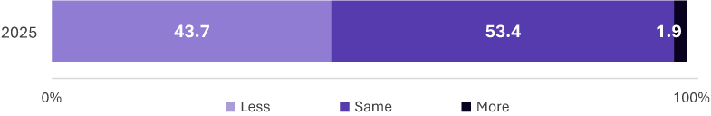
RTW6. When you first came back to work, were the hours you returned to the same, more, or less than what you were doing at the time of your work-related injury or illness?
Base: Has returned to work n=3,654
Note: Numbers don’t add to 100% as ‘don’t know / refused’ not shown

Duties upon returning to work
Nearly half (46.0%) of injured workers reported that their workplace offered modified or alternative duties to help them get back to work (Figure 44). A similar proportion (43.0%) reported that that they were not offered modified or alternative duties.
Workers with a psychological injury were less likely to report being offered modified or alternative duties (26.1%) compared to those with a physical injury (48.1%). The same is true for workers whose injury has a significant or severe negative impact (34.1%) compared with those whose injury has a moderate or lesser negative impact (50.0%).
Of the injured workers who have returned to work, those who were offered modified or alternative duties were more likely to intend to remain working (90.9%) compared with those who were not offered modified or alternative duties (85.0%). Likewise, returned workers who were offered modified or alternative duties had better self-reported general health (69.6% reported ‘good’ health or better) compared to those who were not offered modified or alternative duties (58.1%).
Figure 44 Offered modified or alternative duties (%)
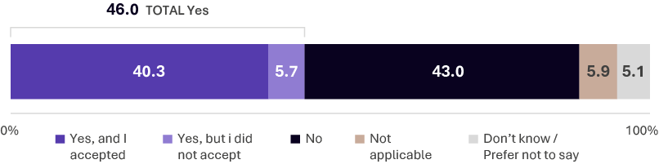
JP5. Since the time of your injury or illness, has your workplace offered you modified or alternative duties to help you get back to work?
Base: All workers n=4,143
The main reason for accepting modified or alternative duties was because those duties matched the injured worker’s physical and/or psychological capabilities (63.0%).
Figure 45 Why accepted modified or alternative duties (%)
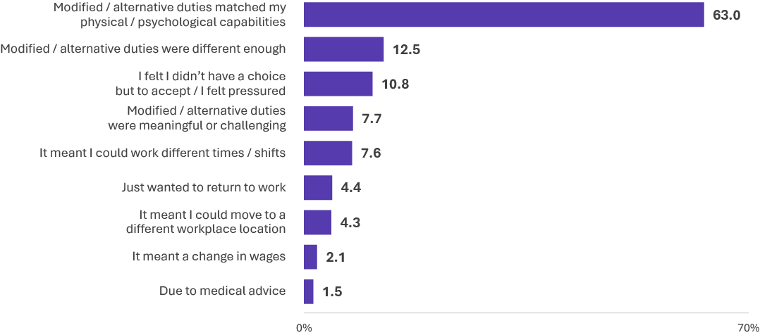
JP13. Why did you accept the offer for modified or alternative duties?
Base: Accepted modified/alternative duties n=1,708
Note: ‘Just wanted to return to work’ and ‘Due to medical advice’ were captured as free text using an ‘other’ response option and coded during data processing.

Workers with a psychological injury were more likely to indicate they accepted those duties because did not have a choice, or felt pressured, to accept them (22.0%), and they meant they could move to a different location (22.3%), compared to those with a physical injury (10.2% and 3.5% respectively).
Figure 46 Why accepted modified or alternative duties – Injury type comparisons (%)
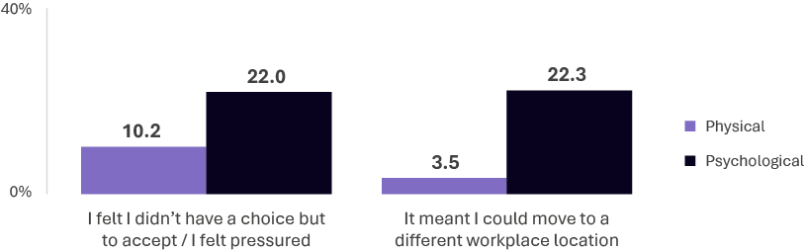
JP13. Why did you accept the offer for modified or alternative duties?
Base: Accepted modified/alternative duties n=1,708
Among those who are currently working, over one-fifth (21.4%) had to take additional time off since they first returned to work because of their work-related injury or illness. Workers whose injury has had a significant or severe negative impact on their daily life were much more likely to have taken additional time off (53.3%) compared to workers whose injury had a moderate or lesser impact (15.6%).
Figure 47 Took additional time off work
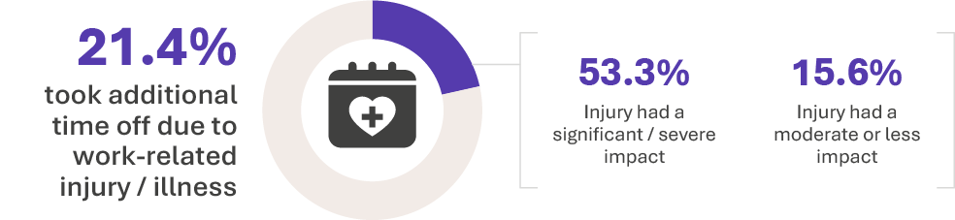
RTW8. Since you first returned to work, have you had to have any additional time off because of your work-related injury or illness?
Base: Currently working n=3,301

Employer results

Offered alternative working arrangements
Three in five (58.4%) employers said they offered their worker modified or alternative duties and that they were accepted. One in nine (11.5%) said they offered their worker modified or alternative duties, but they were not accepted (see Figure 48).
Employers with workers who had a physical injury (60.8%) were more likely to say they offered their worker modified or alternative duties that were accepted compared to those with a psychological injury (35.3%). Employers of workers with a psychological injury were more likely to say that they offered modified or alternative duties that were not accepted (26.8%) compared with employers with workers with a physical injury (9.5%).
Figure 48 Offered modified or alternative duties (%)
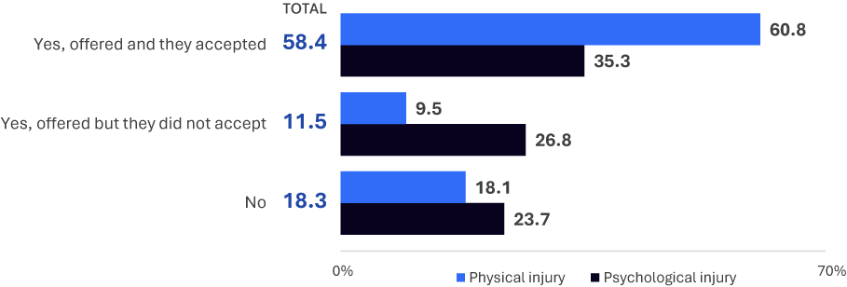
JP5. Since the time of your worker’s injury or illness, have you offered them modified or alternative duties in order to help them get back to work? Did the worker accept these modified or alterative duties?
Base: All employers n=754

A third (34.7%) of employers said they offered their worker any workplace accommodations and that they were accepted. One in ten (10.7%) said they offered their worker any workplace accommodations, but they were not accepted (Figure 49).
Employers were more likely to say their worker returned to work (91.4%) when accommodations were offered and accepted compared to employers who said accommodations were not offered (37.9%).
Figure 49 Offered any workplace accommodations (%)
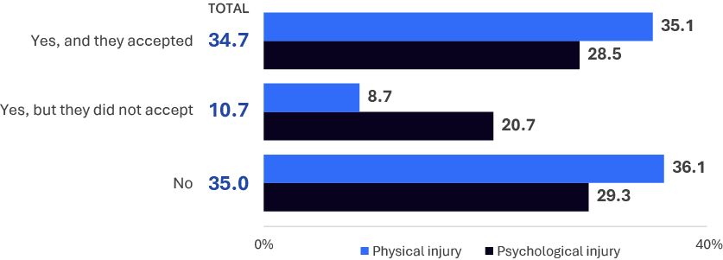
JP8. Since the time of your worker’s injury or illness, have any workplace accommodations been offered to the worker in order to help them get back to work?
Base: All employers n=754

Half of employers said that the hours their worker returned to were either the same (48.4%) or less (50.8%) than the hours they worked before their work-related injury or illness. Employers with injured workers who had a psychological injury or illness (77.0%) were more likely than injured workers with a physical injury or illness (49.0%) to say that the hours the worker returned to were less (see Figure 50).
A quarter (24.9%) of employers said that their injured worker returned to the same duties. Three quarters (74.8%) said the injured worker had slightly (60.3%) or completely (14.5%) different duties. Employers whose workers who had a physical injury were much more likely to say their worker returned to the same duties (26.4%) compared to those with a psychological injury (5.3%).
Figure 50 Hours and duties upon returning to work (%)
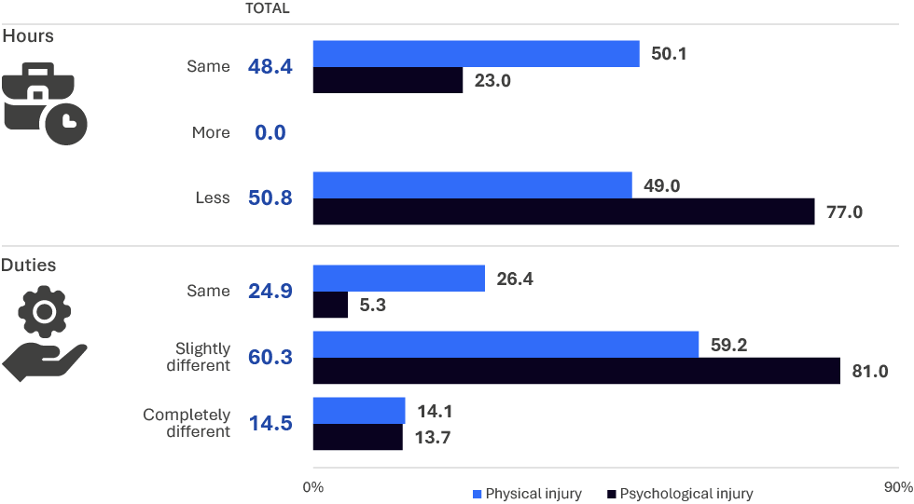
RTW6. When your worker first came back to work, were the hours they returned to the same, more, or less than what they were doing at the time of their work-related injury or illness? RTW7. When your worker first came back to work, were the duties they returned to the same, slightly different, or completely different to what they were doing at the time of their work-related injury or illness?
Base: Worker returned to work n=537

Of the 7.1% of employers who were unable to find and offer suitable employment for their worker, about two in five (37.2%) said it was because they ‘do not have suitable duties/hours’ (see Figure 51). ‘Finding the worker suitable work/duties’ was also identified by employers as a barrier in preparing for, responding to, and managing their worker’s return to work (30.7%).
Figure 51 Reason for not offering suitable employment (%)
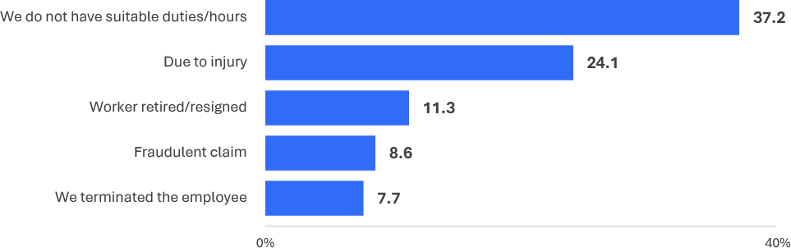
EMP7a. Why were you unable to find and offer suitable employment for your worker in your workplace or another organisation?
Base: Unable to offer suitable employment n=56
Note: Responses were captured as free text and coded during data processing. ‘Fraudulent claim’ responses do not necessarily reflect that a determination was made on the legitimacy of a claim.

Additional return to work support
Three in ten employers said that ‘more investigation into validity of the claim’ (29.1%) and ‘greater communication with employers’ (28.7%) would assist them in their worker’s return to work. A quarter (27.4%) said that ‘no additional support is needed’ (see Figure 52).
Employers with workers who had a psychological injury or illness were more likely to suggest ‘more investigation into validity of the claim’ (49.7%) compared to those with a physical injury or illness (26.6%).
Figure 52 Additional support in the return to work process (%)
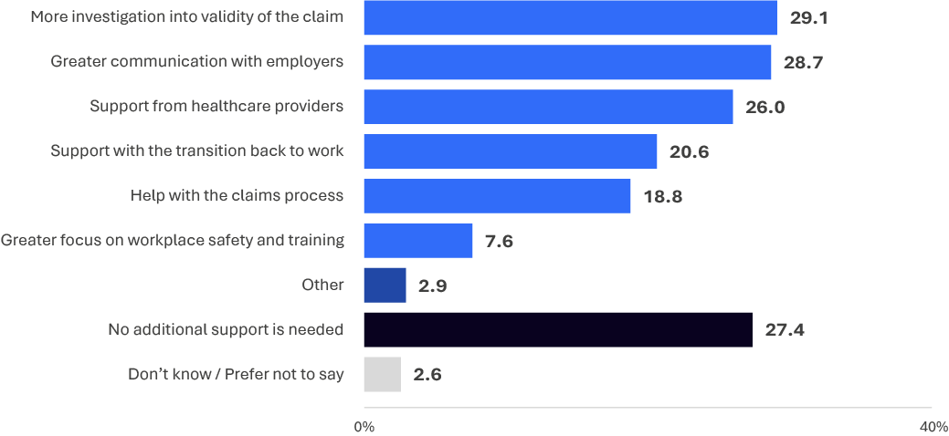
RTW11. In your opinion, what support could be provided to you as an employer to assist your workers in the return to work process?
Base: All employers n=754

Half (48.9%) of employers identified greater communication as something insurers could do to provide additional assistance, including ‘more responsive/timely communication and updates’ (38.0%), ‘clearer communication’ (29.6%) and ‘more ways to contact the insurer’ (14.7% - see Figure 53).
Employers with workers who had a psychological injury or illness were more likely to suggest ‘more investigation of the injured worker’ (49.4%) compared to those with a physical injury or illness (27.7%).
Figure 53 Additional support from the insurer (%)
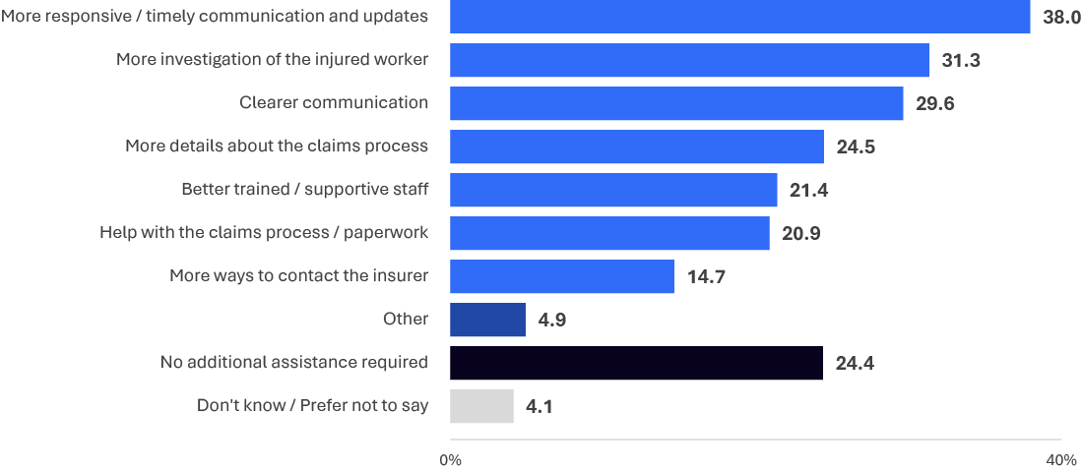
WC9b. What additional assistance could be provided to you by your insurer?
Base: All employers n=754

Nearly half (48.2%) of employers identified greater communication as something regulators could do to provide additional assistance, including ‘updates on policy / legislative changes’ (26.7%), ‘consultation with employers’ (24.4%), ‘frequent communication with employers’ (23.8%) and ‘easier ways to contact the regulator’ (15.3% - see Figure 54).
Employers with workers who had a psychological injury or illness were more likely to say ‘updates on policy/legislative changes’ (40.6%) compared to those with a physical injury or illness (25.3%).
Employers with more than 3 claims in the last 24 months were more likely to say ‘training/education on policy and procedure’ (33.0%) compared to those with one claim (20.8%).
Figure 54 Additional support from the regulator (%)
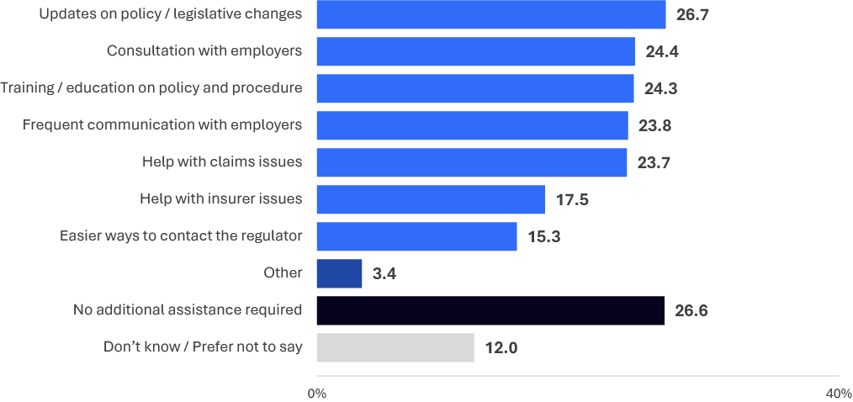
WC10. What additional assistance could be provided to you by your workers’ compensation regulator?
Base: All employers n=754

Appendix 1 – Methodology
01
Appendix
Methodology

Methodology
Overview
The 2025 iteration of the NRTW survey was conducted by Wallis Social Research. It used a dual-mode survey for each of workers and employers; respondents could complete the survey either by telephone (CATI) or online (CAWI).
Sampling process
A two-step sampling process was implemented for both workers and employers to ensure minimal handling of identifiable data to protect privacy:
- Step 1: Supply a de-identified ‘population file’
- Sept 2: Supply an identified ‘sample file’
Once the records from the de-identified population were selected in accordance with the sampling plan, Wallis sent the IDs of those records to the jurisdictions to append the additional details necessary to contact them for the survey. This formed the identified ‘sample file’.
Sample design
The sample consisted of injured workers who had made a workers’ compensation claim, or employers of workers with these claims, who:
- had at least one day away from work due to their workplace injury or illness,
- had a workers’ compensation claim in the 24 month period from 1 July 2022 to 30 June 2024,
- had either an open or closed workers’ compensation claim, and
- worked in either premium-paying (including own businesses) or self-insured organisations.
Several screening questions were included in the survey to confirm that workers and employers were in scope. If they were not in scope they were excluded from participating in the survey.
Ethics approval
Ethics approval was obtained for the NRTW survey from Bellberry on 16 January 2025 as there was a risk of triggering distress among the vulnerable injured worker audience.
Revised ethics approval was obtained from Bellberry on 21 May 2025 to account for changes made to the survey materials to improve response rates.
Questionnaire design
In collaboration with SWA, Wallis refined the 2023 iteration of the questionnaire with the focus being to minimise survey length. Wallis conducted multivariate analysis on the 2023 Pilot survey data to identify correlated variables; this was done for both the injured worker and employer cohorts. The analyses undertaken identified variables answered similarly by respondents, as well as those with a weak relationship to key performance measures.
Once the final questionnaire was approved, the two questionnaires were programmed into Wallis’ survey system (Forsta). Several rounds of testing were undertaken by both Wallis and SWA to ensure that skips were working as intended to account for a variety of potential respondent situations, and that the look and feel of the surveys was optimized for clear and engaging delivery.
Respondent contact
The primary approach invitation to participate in the survey was issued via email; SMS-based versions were issued to those where a valid email address was not available. Reminders were issued to those who had not yet completed the survey using a combination of email and SMS over the fieldwork period. Approaches by CATI served the dual purpose as invitations to complete the survey via phone on the spot or at an agreed time, and also as a reminder of the survey completion options.
Data collection
The survey was then piloted across both modes (CATI and CAWI) and cohorts from 31 March 2025 to 11 April 2025 and revised as needed in collaboration with SWA prior to going to full launch.
The main fieldwork was conducted from 16 April 2025 to 18 July 2025.
The survey collected data from 4,143 injured workers and 754 employers, across all nine work health and safety jurisdictions - New South Wales, Victoria, Queensland, South Australia, Western Australia, Tasmania, Northern Territory, Australian Capital Territory and Comcare.
For Workers, the average survey length was 28 minutes for CATI (n=1,047) and 21 minutes for CAWI (n=3,096).
For Employers, the average survey length was 26 minutes for CATI (n=193) and 18 minutes for CAWI (n=561).
For Employers, the injury type of the injured worker was determined by a survey question. For Workers, the injury type of the respondent was provided in the administrative (sample) data and asked in a survey question (SR13). The administrative data was dichotomous whereby 90.4% of injured workers had a physical injury and 9.6% had a psychological injury. At SR13, 67.6% reported having a physical injury, 10.3% a psychological injury, and 20.3% both a physical and psychological injury.
Weighting
Data were weighted to the population files supplied by the jurisdictions. The data weighting was used to represent all injured workers / employers. Injured workers’ weighting is based on jurisdiction and injury type – physical or psychological as defined in the population files supplied by the jurisdictions. Employers’ weighting is based on jurisdiction and business size as specified in the population file.

Service industries are Accommodation and Food Services, Administrative and Support Services, Arts and Recreational Services, Education and Training, Financial and Insurance Services, Health Care and Social Assistance, Information Media and Telecommunications, Public Administration and Safety, Professional, Scientific and Technical Services, Rental, Hiring and Real Estate Services, Retail Trade, Transport, Postal & Warehousing, and Wholesale Trade. Production industries are Agriculture, Forestry and Fishing, Construction, Electricity, Gas, Water and Waste Services, Manufacturing, and Mining.
‘Moderate impact’ is grouped with ‘minor impact’ and ‘no impact’ throughout this report as the experiences, including the Return to Work Rate, of injured workers whose injury had a moderate impact is similar to workers whose injury had a minor impact or no impact, whereas workers whose injury had a significant or severe impact had similar experiences.
https://bridges.monash.edu/articles/report/Barriers_and_Enablers_to_Return_to_Work_Literature_Review/23682051?file=41559180
It is not known whether this mental health concern is a result of the injured workers workplace injury, or additional to that injury.
For each employer, only the worker who made the most recent workers’ compensation claim in the reference period is captured in this data. Note that employers may have had other workers who have made claims, prior to their most recent. They are not included in these statistics.
Business size definitions: Micro - 1 to 4 employees, Small - 5 to 19 employees; Medium - 20 to 199 employees; Large - 200+ employees
https://bridges.monash.edu/articles/report/Barriers_and_Enablers_to_Return_to_Work_Literature_Review/23682051?file=41559180
ANOVA coefficients can be interpreted as a correlation coefficient where 1 is a perfect positive correlation and 0 is no correlation.
MAN3c. What barriers, if any, do you experience in effectively preparing for, responding to, and managing injured workers in their return to work? Base: All employers n=754
‘Greater communication’ is a net of ‘more responsive / timely communication and updates’, ‘clear communication’ and ‘more ways to contact the insurer’
‘Greater communication’ is a net of ‘updates on policy / legislative changes’, ‘frequent communication with employers’, ‘consultation with employers’ and ‘easier ways to contact the regulator’.

