
National Return to Work Survey
Key findings factsheet
Prepared for Safe Work Australia
Ref: 5059 | September 2025

Introduction

Project background and objectives
Safe Work Australia’s biennial National Return to Work (NRTW) survey is a key contributor to the evidence base for workers’ compensation policy and practice.
This survey provides key indicators that inform the effectiveness of the National Return to Work Strategy 2020-2030. The Strategy’s vision is to ‘minimise the impact of work-related injury and illness and enable workers to have a timely, safe and durable return to work’.
‘Return to work’ is about helping workers to get back to work or to stay at work while they recover from work-related injury or illness. It is a complex process in which factors at the individual, organisational and system levels interact. A positive return to work involves all systems working well together.
The overall aims of the NRTW survey are to gain a better understanding of:
- The return to work outcomes and experiences of workers, injured or made unwell by their work, receiving workers' compensation throughout Australia, and
- The return to work process and experience from the perspective of employers.

The design of the NRTW survey program was reviewed in 2022, with resulting enhancements implemented in 2025. New elements include streamlined online delivery and, for the first time, an employer cohort. Historically, only injured workers had been covered in the survey.
The 2025 iteration of the NRTW survey was conducted by Wallis Social Research and involved a dual-mode survey; respondents could complete the survey either by telephone (via a computer assisted telephone interview - CATI) or online. Fieldwork was conducted from 31 March 2025 to 18 July 2025.
This factsheet reports key findings related to return to work experiences, at a national level.
A detailed analytical survey report is also available, with a focus on the drivers that contribute to successful return to work outcomes.

Worker Survey

Return to Work Rate (% yes)
The Return to Work Rate is the proportion of injured workers surveyed who reported having returned to work at any time since their work-related injury or illness.
The national Return to Work Rate was 88.9% in 2025. Since 2014, the rate has been trending downward, and decreased significantly between 2025 (88.9%) and 2021 (91.6%). In 2025, the Return to Work Rate was significantly higher for workers with physical injuries (90.2%) compared to psychological injuries (76.5%).
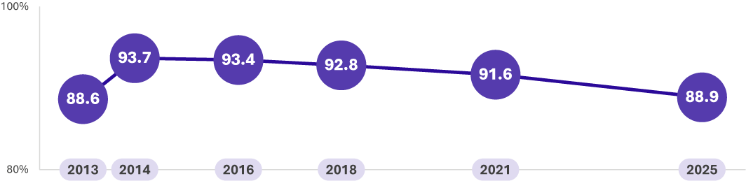
Safe Work Australia, National Return to Work Survey

Current Return to Work Rate (% yes)
The Current Return to Work Rate is the proportion of injured workers surveyed who reported having returned to work at any time since their work-related injury or illness, and were in a paid job at the time of interview.
The national Current Return to Work Rate was 78.8% in 2025. Similar to the trend with the national Return to Work Rate, the national Current Return to Work Rate has trended downward since 2016 (83.5%) and is significantly lower in 2025 (78.8%) compared to 2021 (81.3%).
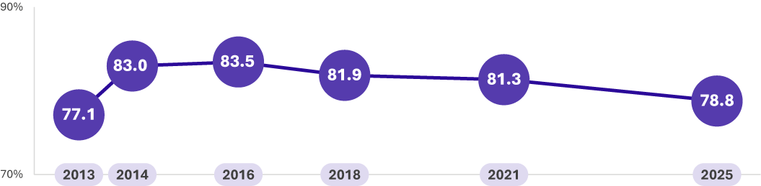
Safe Work Australia, National Return to Work Survey

Proportion of injured workers who had a return to work plan (%)
Developing a return to work plan in collaboration with an injured or ill worker is one of the best ways to support their recovery. Research shows that return to work plans are linked with better self-reported return to work outcomes, and that workers have poorer health outcomes if they are away from work for a long time. A plan helps them return to good work, or to stay at work, while they recover.
The 2025 survey results show that 61.8% of workers had a return to work plan; this has remained relatively consistent since 2016 (63.6%). Significantly more workers said they ‘don’t know’, or refused to answer, if they had a return to work plan in place in 2025 (8.3%), compared to previous years.
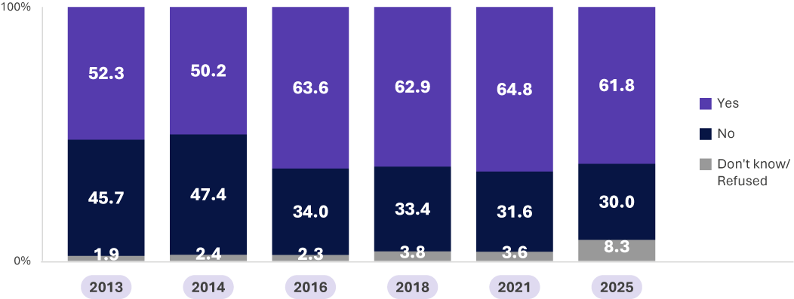

Safe Work Australia, National Return to Work Survey

Experience of returning to work

Self-assessed health rating (% good or better)
In 2025, 62.8% of workers said their health was good or better (Good: 28.7%; Very good: 19.4%; Excellent: 14.8%). There has been a downward trend in positive self-assessed health ratings since 2016, when 77.6% of workers said their health was good or better.
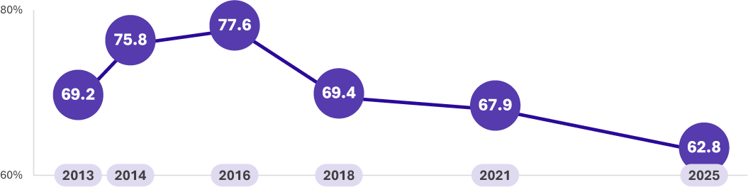

Safe Work Australia, National Return to Work Survey

Hours worked upon returning to work (%)
Providing workers with workplace accommodations such as modified duties and hours has been shown to result in positive return to work outcomes by reducing the amount of time an injured worker spends away from work.
In 2025, over half of workers said they returned to the same hours as before their workplace injury (53.4%), a significant decrease since 2021 (58.1%). Under half of workers said they returned to less hours (43.7%), a significant increase since 2021 (38.9%).
Only 1.9% of injured workers said they returned to more hours.
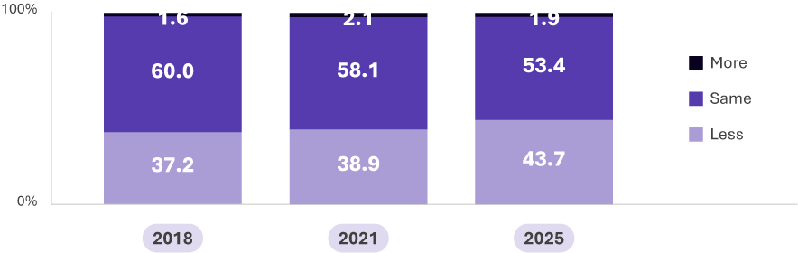

Safe Work Australia, National Return to Work Survey
Note: Numbers don’t add to 100% as ‘don’t know / refused’ not shown

Duties upon returning to work (%)
In 2025, a majority (64.7%) of workers said they returned to the same duties as before their workplace injury. Less than one in five workers said they returned to slightly different duties (18.4%) and completely different duties (15.2%).
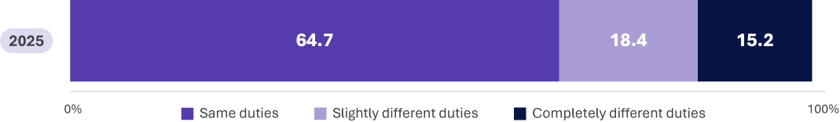
Safe Work Australia, National Return to Work Survey
Note: Numbers don’t add to 100% as ‘don’t know / refused’ not shown

Employer support attributes (% agree)
In 2025, injured workers were asked to provide their level of agreement on six attributes about their employer.
A majority of injured workers agreed that their employer treated them fairly during (61.1%) and after (60.6%) the claims process, and over half (55.2%) agreed that their employer did what they could to support them.
Under half of injured workers agreed that their employer provided enough information (47.5%), helped with their recovery (47.1%), and made an effort to find suitable employment for them (42.7%).
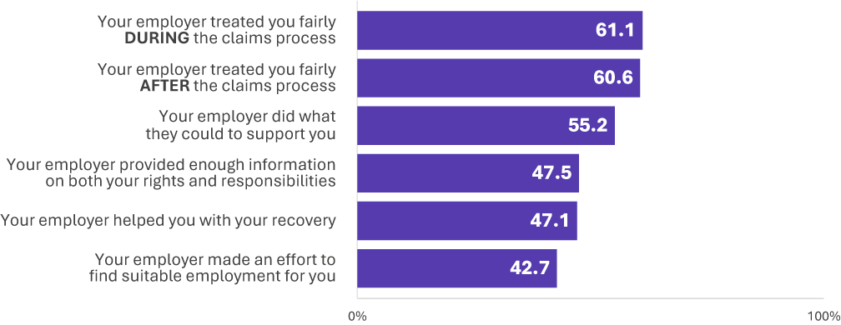
Safe Work Australia, National Return to Work Survey

Employer Survey

Return to work planning (% agree)
Nearly eight in ten (78.7%) employers reported that their injured worker had a return to work plan, higher than the proportion reported by workers in 2025 (61.8%). Among those employers, 84.2% said the worker was involved in the development of the plan, and 70.6% said that the return to work plan was helpful.
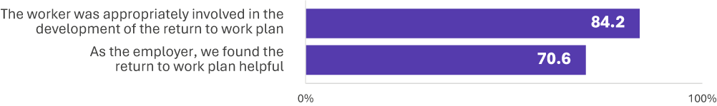
Safe Work Australia, National Return to Work Survey

Barriers to managing the return to work process (%)
The top three barriers for employers in managing the return to work process include ‘Finding the worker suitable work/duties’ (30.7%), ‘Communication with healthcare providers’ (27.1%), and ‘Injured workers being uncooperative’ (26.6%).
About one-fifth of employers said that there were no barriers (22.4%).
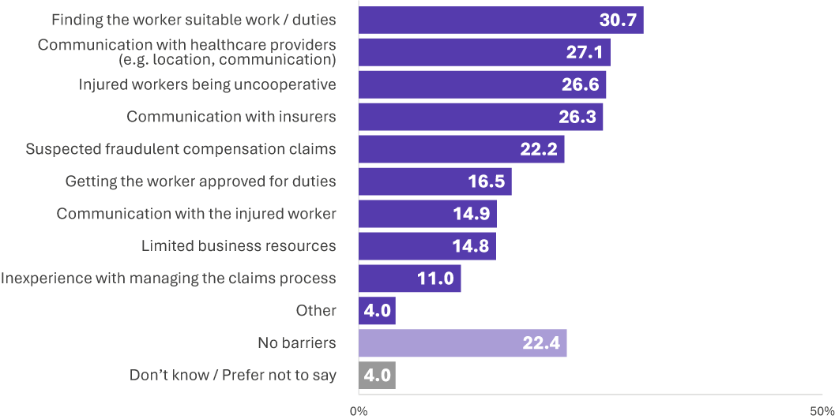
Safe Work Australia, National Return to Work Survey

The term ‘significance’ means statistical significance. A statistically significant difference means an effect is unlikely to have occurred by chance.

