**Safe Work Australia**

# **Workers’ Compensation Injury Frequency Calculator (WCIFR) Dashboard User Guide**

March 2025

**This guide shows how to use the Safe Work Australia Workers’ Compensation Injury Frequency Calculator (WCIFR) dashboard with the new Microsoft Power BI user experience.   
  
This dashboard allows you to interact with and explore industry benchmarking information from Safe Work Australia’s workers’ compensation dataset.**

The dashboard

The illustration above shows the home page of the dashboard.

1. **Compare WCIFR by Industry** to see how your organisation’s WCIFR compares to industry benchmarks. See the [Australian and New Zealand Standard Industrial Classification](https://www.abs.gov.au/statistics/classifications/australian-and-new-zealand-standard-industrial-classification-anzsic/latest-release) for information on the industry coding structure.
2. **Compare by occupation** to see how your organisation’s WCIFR compares to occupation benchmarks. This may be of interest for specific occupations in your organisation with high injury rates or those with higher hazard exposure. See the [Australian and New Zealand Standard Classification of Occupations](https://www.abs.gov.au/statistics/classifications/anzsco-australian-and-new-zealand-standard-classification-occupations/latest-release) for information on the occupational coding structure.
3. **Explore WCIFR** has further breakdowns on benchmark data by Industry, Occupation, Severity (claims count, cost and time lost), and Injury type (mechanism and nature of injury)
4. More information about how to interpret and use the data.
5. Page navigation bar

General page navigation

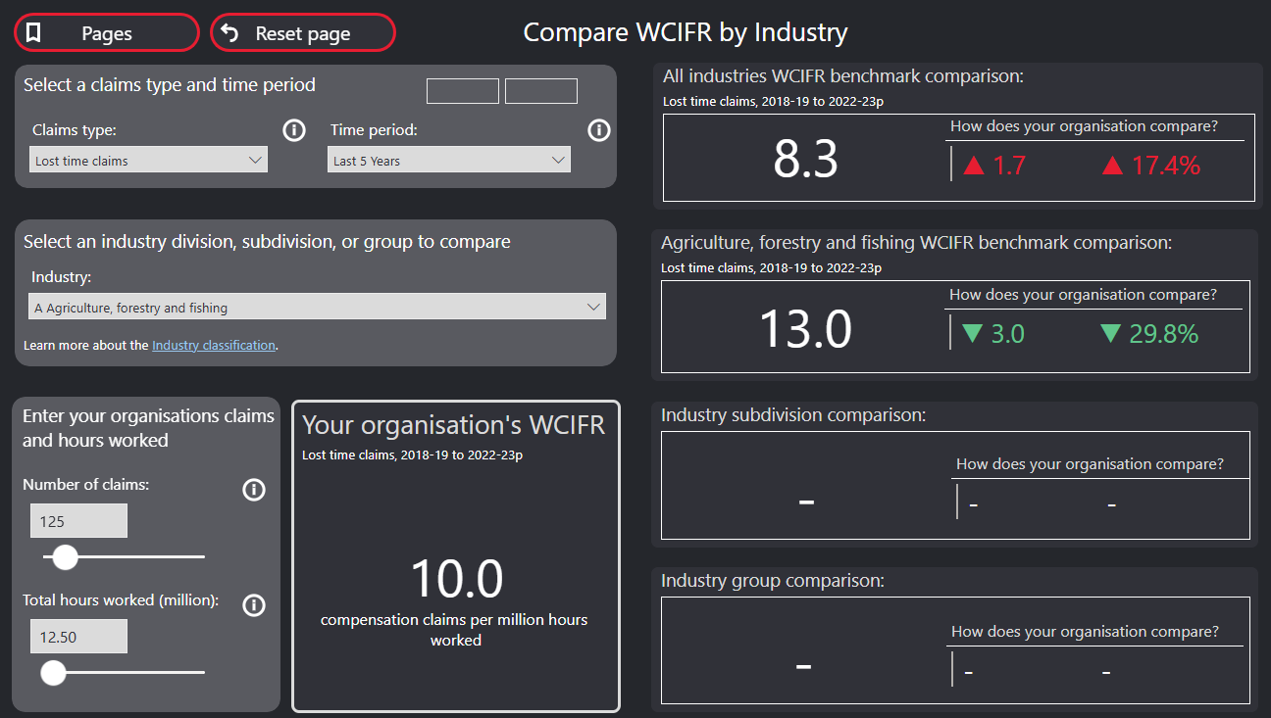

1. **Pages**  
   Shows a drop-down list of all pages in this dashboard.
2. **Reset page**  
   Resets all inputs and filters on the page.
3. **Claims type**Choose a Claims type from the dropdown menu. The default Claims type is ‘Lost time claims’. Hover over the ‘i’ icon for more information about the selected Claims type.
4. **Time period**   
   Choose a Time period from the dropdown menu. The default is ‘Last 3 years’, but small and medium enterprises should select ‘Last 5 years’ or longer. Select a different period using the ‘Custom’ option. Selecting the ‘Custom’ option will allow you to enter years using the text boxes (4a). Hover over the ‘i’ icon for more information about Time periods.

Compare by industry and occupation pages

The pages ‘Compare by industry’ and ‘Compare by occupation’ are used in a similar way.

1. **Select industry or occupation**Select an industry or occupation to compare your organisation against the relevant specific benchmark. See the [Australian and New Zealand Standard Industrial Classification](https://www.abs.gov.au/statistics/classifications/australian-and-new-zealand-standard-industrial-classification-anzsic/latest-release) (for Industry) and [Australian and New Zealand Standard Classification of Occupations](https://www.abs.gov.au/statistics/classifications/anzsco-australian-and-new-zealand-standard-classification-occupations/latest-release) (for Occupation) for information on the coding structures used and to search for your industry or occupation under these classifications.      
   Options in the menu have a chevron that expands to show more detailed options.

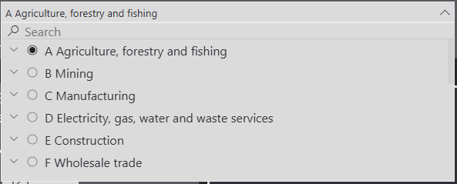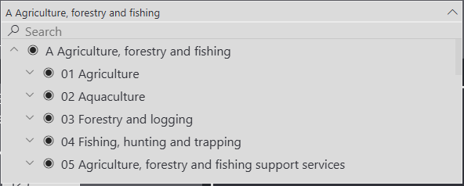

1. **Number of claims and Total hours worked (million)**   
   Enter your organisation’s claims and total hours worked. Note if you have less than 0.25 Total hours worked (million) (i.e., less than 250,000 hours worked), then a longer time period is needed. Hover over the ‘i’ icons for more information.
2. **Your organisation’s WCIFR**  
   Based on the information entered in (2), the dashboard will calculate the WCIFR for your organisation.
3. **All industries/occupations benchmark comparison**  
   The number at the top is the WCIFR across all industries or occupations. The two numbers in red or green are how your organisation compares in number and percent difference of WCIFR.
4. **Industry or occupation benchmarks**  
   Industry or occupation specific benchmarks will display based on the selection in (1). Selecting an industry or occupation at a lower level of detail will display more benchmark numbers. The lowermost number is the most detailed industry or occupation selected. The ABS has more information on the classification hierarchy for [industry](https://www.abs.gov.au/statistics/classifications/australian-and-new-zealand-standard-industrial-classification-anzsic/2006-revision-2-0/numbering-system-and-titles) and [occupation](https://www.abs.gov.au/statistics/classifications/anzsco-australian-and-new-zealand-standard-classification-occupations/2022/classification-structure).   
   The two numbers in red or green are how your organisation compares in number and percent difference of WCIFR to the industry or occupation specific benchmarks.

Explore WCIFR page

Explore WCIFR data in more detail by selecting the buttons (1).

**Explore by Industry** and **Explore by Occupation** present time series WCIFR data by industry or occupation in the chart on the left. Select an occupation or industry from the bar chart on the right to see trends for that industry. Right click on a bar and select ‘Drill down’, or select the  icon in the top right of the chart to look at more detailed industries or occupations.



**Hint:** try holding the Ctrl or command key down when selecting filters or data in a chart to make multiple selections.

**Explore by Severity** presents claims by time lost and compensation paid. You can select your industry or occupation to explore the data.

**Explore by Injury type** presents claims by Nature and Mechanism of injury. See the [Type of Occurrence Classifications System (TOOCS) catalogue page](https://data.safeworkaustralia.gov.au/about-our-datasets/type-occurrence-classification-system-toocs-3rd-edition) for further information on Nature and Mechanism coding structures. You can select your industry or occupation to explore the data.

Feedback

We are working to improve your experience with the interactive data website. Please provide us with your feedback or suggestions by clicking on [Contact us](https://data.safeworkaustralia.gov.au/about/contact-us).