Disclaimer

Safe Work Australia is an Australian Government statutory agency established in 2009. Safe Work Australia includes Members from the Commonwealth, and each state and territory, Members representing the interests of workers and Members representing the interests of employers.

Safe Work Australia works with the Commonwealth, state and territory governments to improve work health and safety and workers’ compensation arrangements. Safe Work Australia is a national policy body, not a regulator of work health and safety. The Commonwealth, states and territories have responsibility for regulating and enforcing work health and safety laws in their jurisdiction.

**ISSN 2209-9158**

Creative Commons

With the exception of the Safe Work Australia logo, this copyright work is licensed under a Creative Commons Attribution 4.0 International licence. To view a copy of this licence, visit creativecommons.org/licenses. In essence, you are free to copy, communicate and adapt the work, even commercially, as long as you attribute the work to Safe Work Australia and abide by the other licence terms.

Contact information

Safe Work Australia | <mailto:info@swa.gov.au> | www.swa.gov.au

Comparative Performance Monitoring (CPM) 25th edition indicators

The CPM comprises of 5 sections that measure Work Health and Safety and Workers’ Compensation performance. The bolded indicators are included in this section.

**Work Health and Safety Performance**

* **Incidence rates of serious injury and disease claims by jurisdiction**
* **Frequency rates of serious injury claims by jurisdiction**
* **Incidence rates of long term (12 weeks or more compensation) injury and disease claims by jurisdiction**
* **Frequency rates of long term (12 weeks or more compensation) injury and disease claims by jurisdiction**
* **Self-insured claims: number and proportion of serious claims by jurisdiction**
* **Serious claims: Percentage involving selected periods of compensation**
* **Traumatic injury worker fatalities: number and rate of incidents not on a public road, by state of death**
* **Compensated fatalities involving occupational diseases by jurisdiction**
* **Proportion of serious claims by mechanism of incident**
* **Incidence rates of serious claims by industry**

**Work Health and Safety Compliance and Enforcement Activities**

* Work health and safety intervention activity by jurisdiction
* Work health and safety inspectorate activity by jurisdiction
* Work health and safety notices and enforceable undertakings by jurisdiction
* Work health and safety legal proceedings and fines by jurisdiction

**Workers’ Compensation Premiums**

* Standardised average premium rates (including insured and self-insured sectors) by jurisdiction
* Australian average premium rates by industry

**Workers’ Compensation Funding Ratios**

* Standardised ratio of assets to net outstanding claim liabilities for centrally funded schemes
* Standardised ratio of assets to net outstanding claim liabilities for privately underwritten schemes

**Workers’ Compensation Disputes**

* Proportion of claims with dispute
* Percentage of disputes resolved within selected time periods (cumulative)

Contents

Foreword 7

1. Serious claims 8

1.1 Incidence rate 8

Incidence rates of serious injury and disease claims by jurisdiction 8

1.2 Frequency rate 9

Frequency rate of serious injury claims by jurisdiction 9

1.3 Long term incidence and frequency rates 10

Incidence rates of long term (12 weeks or more compensation) injury and disease claims by jurisdiction 10

Frequency rate of long term (12 weeks or more compensation) injury and disease claims by jurisdiction 10

1.4 Self-insured serious claims 11

Self-insured claims: number of serious claims by jurisdiction 11

Self-insured claims as a proportion of serious claims by jurisdiction (%) 11

2. Duration of absence 12

Serious claims: Percentage involving selected periods of compensation (%), 2020–21 12

3. Work-related fatalities 13

3.1 Work-related traumatic injury fatalities 13

Traumatic injury worker fatalities: number of incidents not on a public road, by state of death 13

Traumatic injury fatalities: incidence rate per 100,000 workers for incidents not on a public road, by state of death 13

3.2 Work-related disease fatalities 14

Compensated fatalities involving occupational diseases by jurisdiction 14

4. Claims by mechanism of incident 15

Proportion of serious claims by mechanism of incident, Australia total 15

4.1 Claims by mechanism of incident and jurisdiction 15

Proportion of serious claims involving Body stressing by jurisdiction 16

Proportion of serious claims involving Falls, trips and slips of a person by jurisdiction 16

Proportion of serious claims involving Being hit by moving objects by jurisdiction 17

Proportion of serious claims involving Hitting objects with a part of the body by jurisdiction 17

Proportion of serious claims involving Mental stress by jurisdiction 18

Proportion of serious claims involving Other mechanisms by jurisdiction 18

Proportion of serious claims involving Vehicle incidents and other mechanisms by jurisdiction 19

Proportion of serious claims involving Heat, electricity and other environmental factors by jurisdiction 19

5. Claims by industry 20

Frequency rates of serious claims by industry 20

5.1 Claims by industry and jurisdiction 21

Frequency rates of serious claims for Agriculture, forestry and fishing by jurisdiction 21

Frequency rates of serious claims for Mining by jurisdiction 22

Frequency rates of serious claims for Manufacturing by jurisdiction 22

Frequency rates of serious claims for Electricity, gas, water and waste services by jurisdiction 23

Frequency rates of serious claims for Construction by jurisdiction 23

Frequency rates of serious claims for Wholesale trade by jurisdiction 24

Frequency rates of serious claims for Retail trade by jurisdiction 24

Frequency rates of serious claims for Accommodation and food services by jurisdiction 25

Frequency rates of serious claims for Transport, postal and warehousing by jurisdiction 25

Frequency rates of serious claims for Information media and telecommunications by jurisdiction 26

Frequency rates of serious claims for Financial and insurance services by jurisdiction 26

Frequency rates of serious claims for Rental, hiring and real estate services by jurisdiction 27

Frequency rates of serious claims for Professional, scientific and technical services by jurisdiction 27

Frequency rates of serious claims for Administrative and support services by jurisdiction 28

Frequency rates of serious claims for Public administration and safety by jurisdiction 28

Frequency rates of serious claims for Education and training by jurisdiction 29

Frequency rates of serious claims for Health care and social assistance by jurisdiction 29

Frequency rates of serious claims for Arts and recreation services by jurisdiction 30

Frequency rates of serious claims for Other services by jurisdiction

Appendix 1 - Further information 31

Glossary 31

Time series and adjustment of scheme data 32

Foreword

This is the 25th edition of the Comparative Performance Monitoring (CPM) report which provides trend analyses about work health and safety (WHS) and workers’ compensation schemes operating in Australia and New Zealand.

This report has been compiled and coordinated by Safe Work Australia with assistance from representatives of all WHS and workers’ compensation authorities in Australia and New Zealand. Through a partnership of governments, employers and employees, Safe Work Australia leads the development of national policy to improve WHS and workers’ compensation arrangements across Australia.

The report is presented in the following sections:

* *Work health and safety performance* – provides an overview of WHS performance across Australia and New Zealand through analysing trends in serious claim rates and work-related fatalities across jurisdictions (this section).
* *Work health and safety compliance and enforcement activities* – includes a jurisdictional comparison of workplace interventions, inspectorate activity, safety notices, enforceable undertakings, legal proceedings and fines.
* *Workers’ compensation premiums -* includes a national and jurisdictional overview of the standardised average premium rates by industry in the past 5 years.
* *Workers’ compensation funding ratios –* compares the differences in scheme funding arrangements.
* *Workers’ compensation disputes* – includes information about disputes against an insurer’s decision or decisions relating to compensation.

Previous editions of the CPM report also included data on Workers’ Compensation expenditure (under the *Workers’ compensation funding – assets, liabilities and expenditure* section) and scenarios that illustrated the differences in entitlement levels across jurisdictions (under the *Entitlements under workers’ compensation* section). This information will be moved to the [*Comparison of workers’ compensation arrangements in Australia and New Zealand*](https://www.safeworkaustralia.gov.au/workers-compensation/comparing-workers-compensation-australia)which provides information biennially about workers’ compensation arrangements and the differences between schemes in Australia and New Zealand.

*About the data*

Data in this publication may differ from jurisdictional annual reports due to the use of different definitions and the application of adjustment factors to aid in the comparability of data.

The CPM does not currently include information or data from other industry-specific regulators that have responsibilities with respect to WHS and workers’ compensation. These include national industry-based regulators with compliance and enforcement roles such as the National Heavy Vehicle Regulator, the National Rail Safety Regulator and the National Offshore Petroleum Safety and Environmental Management Authority, and other agencies with responsibility for industry‑specific compensation claims. Further information on these regulators can be found on their respective websites.

In this report ‘Australian Government’ (Aus Gov) is used for indicators relating to WHS and workers’ compensation matters under the Australian Government jurisdiction, while ‘Comcare’ is used for the indicators relating to premium rates.

Australian Government employees working in each jurisdiction have been included in Australian Government figures rather than state or territory results. Australian Capital Territory Public Service employees are covered by the Comcare scheme but operate under the WHS provisions of the Australian Capital Territory. These employees and their claims have been combined with the Australian Capital Territory private sector employees for reporting outcomes in this section.

In September 2023, Safe Work Australia implemented improvements to the estimates of the working population used to calculate injury rates from the National Dataset for Compensation Based Statistics (NDS). As a result of these changes, a break in series occurs for work-related injury frequency and incidence rates using the NDS from 2021-22 onwards. Safe Work Australia advises caution when interpreting time series changes for rates calculated from the NDS spanning the period before and after this change.

1. Serious claims

Workers’ compensation data is one way to measure WHS performance as it provides an indication of people’s experiences with work-related injuries or illnesses. However, the data only covers those eligible for workers’ compensation and under‑reports the incidence of work-related disease. While there are some limitations, the data still provide a good indication of WHS trends.

The data presented in this section relates to accepted serious workers’ compensation claims lodged in each financial year (2016-17 to 2021-22p). Serious claims are claims relating to work-related injury or disease that result in a total absence from work of one working week or more. Data for 2021–22 is preliminary (denoted by ‘p’) and subject to revision in future years as claims are finalised.

Comparisons of preliminary and non-preliminary data should be made with caution. Non‑preliminary data are more likely to have been finalised and are generally more accurate than preliminary data. In this section, comparisons over time have been made with the latest financial year excluded.

Detailed denominator data is not available for Seacare and New Zealand have not made a National Dataset for Compensation Based Statistics (NDS) data submission. Therefore, incidence and frequency rates have not been calculated for Seacare and New Zealand.

Incidence rate

The incidence rate is expressed as the number of serious workers' compensation claims per 1,000 employees.

### Incidence rates of serious injury and disease claims by jurisdiction (previously indicator 1)

ACT – includes workers’ compensation scheme data from the ACT government sector and ACT private sector.

Frequency rate

The frequency rate is expressed as the number of serious workers' compensation claims per 1,000 employees.

Compared with an incidence rate, a frequency rate is a more precise and accurate measure of work health and safety because it reflects the number of injuries and diseases per hour worked. It is important to account for the number of hours worked because there are significant differences in the number of hours worked by different groups of employees and employees at different points in time.

### Frequency rate of serious injury claims by jurisdiction (previously indicator 2)

ACT – includes workers’ compensation scheme data from the ACT government sector and ACT private sector.

1.3 Long term incidence and frequency rates

Serious claims have been classed as long term if the claimant receives compensation for 12 or more weeks.

### Incidence rates of long term (12 weeks or more compensation) injury and disease claims by jurisdiction (previously indicator )

ACT – includes workers’ compensation scheme data from the ACT government sector and ACT private sector.

### Frequency rate of long term (12 weeks or more compensation) injury and disease claims by jurisdiction (previously indicator )

ACT – includes workers’ compensation scheme data from the ACT government sector and ACT private sector.

1.4 Self-insured serious claims

Self-insurers are employers who are allowed to manage and pay for their employees’ claims for work-related injuries and disease, rather than paying premiums to insurers to take on these responsibilities. This measures the number of self-insured serious claims accepted by workers' compensation schemes.

### Self-insured claims: number of serious claims by jurisdiction (previously indicator a)

|  |  |  |  |  |  |  |  |  |  |  |
| --- | --- | --- | --- | --- | --- | --- | --- | --- | --- | --- |
| **Year** | **NSW** | **VIC** | **QLD** | **SA** | **WA** | **TAS (a)** | **NT** | **ACT (b)** | **Aus Gov** | **Australian Total (c)** |
| **2016-17** | 2,171 | 1,302 | 1,688 | 2,300 | 927 | 634 | 214 | 358 | 1,162 | 10,756 |
| **2017-18** | 2,285 | 1,515 | 1,831 | 2,109 | 869 | 609 | 213 | 296 | 1,273 | 11,000 |
| **2018-19** | 2,232 | 1,716 | 1,739 | 2,388 | 832 | 730 | 265 | 284 | 1,398 | 11,584 |
| **2019-20** | 2,310 | 1,631 | 1,745 | 2,337 | 798 | 733 | 264 | 313 | 1,466 | 11,597 |
| **2020-21** | 2,579 | 1,243 | 1,870 | 2,585 | 953 | 730 | 198 | 416 | 1,634 | 12,208 |
| **2021-22p** | 4,118 | 1,086 | 1,810 | 1,953 | 893 | 792 | 152 | 330 | 1,652 | 12,786 |

### Self-insured claims as a proportion of serious claims by jurisdiction (%) (previously indicator 5b)

|  |  |  |  |  |  |  |  |  |  |  |
| --- | --- | --- | --- | --- | --- | --- | --- | --- | --- | --- |
| **Year** | **NSW** | **VIC** | **QLD** | **SA** | **WA** | **TAS (a)** | **NT** | **ACT (b)** | **Aus Gov** | **Australian Total (c)** |
| **2016-17** | 6.2% | 7.2% | 6.5% | 36.7% | 8.1% | 22.9% | 15.7% | 20.2% | 65.5% | 10.3% |
| **2017-18** | 6.3% | 8.1% | 6.8% | 33.5% | 7.4% | 22.4% | 16.5% | 16.6% | 68.7% | 10.2% |
| **2018-19** | 5.7% | 8.7% | 6.0% | 35.1% | 7.1% | 22.2% | 21.1% | 16.4% | 73.6% | 10.1% |
| **2019-20** | 5.3% | 8.2% | 6.0% | 34.5% | 6.9% | 22.7% | 23.1% | 18.1% | 74.2% | 9.7% |
| **2020-21** | 5.4% | 6.1% | 5.7% | 36.8% | 7.5% | 21.2% | 18.5% | 22.9% | 76.8% | 9.5% |
| **2021-22p** | 8.0% | 5.5% | 5.8% | 32.6% | 7.6% | 23.2% | 20.5% | 22.0% | 83.8% | 10.0% |

(a) Tasmanian self-insured claims also include state government agencies

(b) Australian Capital Territory self-insured claims include data from both the Australian Capital Territory Government sector and Australian Capital Territory Private sector.

(c) The Australian total excludes Seacare self-insured claims.

1. Duration of absence

The duration of absence associated with serious claims provides an indication of the severity of injuries and diseases occurring in Australia. This measure shows the variation in the percentage of claims involving selected periods of compensation across the jurisdictions. Data are based on claims lodged in 2020–21, which is the most recent year that finalised data is available for this indicator.

### Serious claims: Percentage involving selected periods of compensation (%), 2020–21 (previously indicator )

|  |  |  |  |  |  |
| --- | --- | --- | --- | --- | --- |
| **Jurisdiction** | **less than 6 weeks** | **6 weeks or more** | **12 weeks or more** | **26 weeks or more** | **52 weeks or more** |
| **NSW** | 50.5% | 49.5% | 34.4% | 21.3% | 13.0% |
| **VIC** | 17.8% | 82.2% | 64.5% | 45.7% | 30.5% |
| **QLD** | 47.6% | 52.4% | 34.7% | 18.5% | 8.1% |
| **SA** | 42.6% | 57.4% | 39.8% | 22.4% | 10.7% |
| **WA** | 36.8% | 63.2% | 46.5% | 28.6% | 14.8% |
| **TAS** | 55.3% | 44.7% | 27.8% | 13.7% | 6.8% |
| **NT** | 45.9% | 54.1% | 34.2% | 16.8% | 5.7% |
| **ACT** | 42.3% | 57.7% | 38.1% | 18.5% | 7.1% |
| **Aus Gov** | 44.8% | 55.2% | 38.4% | 22.8% | 11.5% |
| **Seacare** | 18.4% | 81.6% | 56.6% | 32.9% | 17.1% |
| **Australian total** | **42.7%** | **57.3%** | **40.6%** | **25.0%** | **14.2%** |

ACT – includes workers’ compensation scheme data from the ACT government sector and ACT private sector.

1. Work-related fatalities

Work-related traumatic injury fatalities

*About Traumatic Injury Fatalities*

Data presented in this section are sourced from the Work-related Traumatic Injury Fatality (TIF) data collection. This collection sources information from workers’ compensation data, fatality notifications to the various WHS authorities and information in the National Coronial Information System (NCIS).

Information presented is based on the location where the fatality occurred. It does not include fatal work-related incidents occurring on a public road. While the model WHS safety laws apply many jurisdictions separately count fatalities at a physical workplace from those that occur on public roads.

It should be noted that traumatic injury fatality data can be volatile year-on-year. In particular, a single incident resulting in multiple deaths can significantly impact the data in a given year, potentially masking the progress of jurisdictions in reducing or eliminating work‑related traumatic injury fatalities in other areas. Further information about the TIF collection and a detailed analysis of the data can be found on the [Safe Work Australia](https://www.safeworkaustralia.gov.au/collection/work-related-traumatic-injury-fatalities) website.

### Traumatic injury worker fatalities: number of incidents not on a public road, by state of death (previously indicator a)

|  |  |  |  |  |  |  |
| --- | --- | --- | --- | --- | --- | --- |
| **State of death** | **2017-18** | **2018-19** | **2019-20** | **2020-21** | **2021-22** | **5 yr Average** |
| **New South Wales** | 39 | 31 | 44 | 33 | 26 | **35** |
| **Queensland** | 29 | 39 | 30 | 18 | 28 | **29** |
| **Victoria** | 24 | 26 | 31 | 20 | 32 | **27** |
| **Western Australia** | 13 | 12 | 16 | 16 | 18 | **15** |
| **South Australia** | 8 | 6 | 4 | 10 | 9 | **7** |
| **Northern Territory** | 5 | 4 | 6 | 4 | 3 | **4** |
| **Tasmania** | 3 | 2 | 7 | 2 | 5 | **4** |
| **Australian Capital Territory** | 0 | 1 | 2 | 0 | 1 | **1** |
| **Australian total** | **121** | **121** | **140** | **103** | **122** | **121** |

ACT – covers workers who were fatally injured in the Australian Capital Territory.

### Traumatic injury fatalities: incidence rate per 100,000 workers for incidents not on a public road, by state of death (previously indicator 7b)

|  |  |  |  |  |  |  |
| --- | --- | --- | --- | --- | --- | --- |
| **State of death** | **2017-18** | **2018-19** | **2019-20** | **2020-21** | **2021-22** | **5 yr Average** |
| **New South Wales** | 1.0 | 0.8 | 1.1 | 0.8 | 0.6 | **0.9** |
| **Queensland** | 1.2 | 1.6 | 1.2 | 0.7 | 1.0 | **1.1** |
| **Victoria** | 0.7 | 0.8 | 0.9 | 0.6 | 0.9 | **0.8** |
| **Western Australia** | 1.0 | 0.9 | 1.2 | 1.1 | 1.2 | **1.1** |
| **South Australia** | 0.9 | 0.7 | 0.5 | 1.1 | 1.0 | **0.9** |
| **Northern Territory** | 3.6 | 3.0 | 4.5 | 3.0 | 2.2 | **3.3** |
| **Tasmania** | 1.2 | 0.8 | 2.6 | 0.7 | 1.8 | **1.4** |
| **Australian Capital Territory** | 0.0 | 0.4 | 0.8 | 0.0 | 0.4 | **0.3** |
| **Australian total** | **1.0** | **0.9** | **1.1** | **0.8** | **0.9** | **0.9** |

ACT – covers workers who were fatally injured in the Australian Capital Territory.

Work-related disease fatalities

Workers’ compensation data contains some information on disease-related fatalities, but this data is known to understate the number of fatalities from work-related diseases. It can be difficult to associate a disease that becomes evident later in life after exposure to a chemical or substance that occurred many years earlier while at work. Some occupational diseases such as asbestosis and mesothelioma are also compensated through separate mechanisms, while many other diseases go unreported and/or uncompensated.

### Compensated fatalities involving occupational diseases by jurisdiction (previously indicator )

|  |  |  |  |  |  |  |  |
| --- | --- | --- | --- | --- | --- | --- | --- |
| **Jurisdiction** | **2016-17** | **2017-18** | **2018-19** | **2019-20** | **2020-21** | **2021-22p** | **5yr Average(a)** |
| **Victoria** | 25 | 19 | 22 | 43 | 23 | 21 | **26** |
| **Australian Government** | 29 | 27 | 13 | 5 | 20 | 7 | **19** |
| **New South Wales** | 11 | 13 | 21 | 15 | 9 | 10 | **14** |
| **Queensland (b)** | 13 | 19 | 20 | 12 | 8 | 5 | **14** |
| **South Australia** | 5 | 8 | 6 | 4 | 4 | 1 | **5** |
| **Western Australia** | 5 | 4 | 5 | 3 | 3 | 1 | **4** |
| **Tasmania** | 0 | 4 | 2 | 2 | 0 | 1 | **2** |
| **Australian Capital Territory** | 1 | 0 | 1 | 0 | 2 | 1 | **1** |
| **Northern Territory** | 0 | 1 | 1 | 0 | 0 | 0 | **<1** |
| **Seacare** | 0 | 1 | 0 | 0 | 0 | 0 | **<1** |
| **Australian total** | **89** | **96** | **91** | **84** | **69** | **47** | **86** |

(a) The five-year average includes compensated fatalities between 2016–17 to 2020–21.

(b) The majority of compensated fatalities for occupational diseases in Queensland and the Australian Government are due to mesothelioma or asbestosis. Queensland compensates more of these fatalities through its scheme than is the case in other jurisdictions where compensation is more often sought through separate mechanisms including common law.

(c) The Australian Capital Territory includes workers’ compensation scheme data from the government sector and private sector.

1. Claims by mechanism of incident

Claim patterns can be analysed using the Type of Occurrence Classification System (TOOCS), which contains a series of codes providing information on the cause of the incident and the type of injury or disease. Coding for the mechanism of incident is intended to identify the overall action, exposure or event that best describes the circumstances that resulted in the most serious injury or disease. More information on TOOCS can be found on the [Safe Work Australia](https://www.safeworkaustralia.gov.au/resources-and-publications/guidance-materials/type-occurrence-classification-system-toocs-3rd-edition-may-2008) website.

The Agency also provides further information on the claims by mechanism of incident on the [Workers’ compensation](https://data.safeworkaustralia.gov.au/interactive-data/topic/workers-compensation) data dashboard, published on the [Safe Work Australia data website](https://data.safeworkaustralia.gov.au/).

### Proportion of serious claims by mechanism of incident, Australia total (previously indicator 10)

* 'Other mechanisms' includes Biological factors, Chemicals and other substances, Sound and pressure, and Mechanisms not coded.

Claims by mechanism of incident and jurisdiction

This section presents a comparison of the proportion of serious claims across the Australian jurisdictions for each of the different mechanism of incident groups.

Due to the differences in the total number of serious claims across jurisdictions, proportions are a better measure for direct comparison between jurisdictions. The industry and occupation composition of each jurisdiction can influence the proportion of claims due to different mechanisms. This may explain some of the differences between jurisdictions.

# Body stressing

### Proportion of serious claims involving Body stressing by jurisdiction (previously indicator 10a)

ACT – includes workers’ compensation scheme data from the ACT government sector and ACT private sector.

# Falls, trips and slips of a person

### Proportion of serious claims involving Falls, trips and slips of a person by jurisdiction (previously Indicator 10b)

ACT – includes workers’ compensation scheme data from the ACT government sector and ACT private sector.

# Being hit by moving objects

### Proportion of serious claims involving Being hit by moving objects by jurisdiction (previously indicator 10c)

ACT – includes workers’ compensation scheme data from the ACT government sector and ACT private sector.

# Hitting objects with a part of the body

### Proportion of serious claims involving Hitting objects with a part of the body by jurisdiction (previously indicator 10d)

Seacare - some values have been suppressed as the annual workers' compensation claim counts are too low to be reported (less than 5)

ACT – includes workers’ compensation scheme data from the ACT government sector and ACT private sector.

# Mental stress

### Proportion of serious claims involving Mental stress by jurisdiction (previously indicator 10e)

Seacare - some values for Seacare have been suppressed as the annual workers' compensation claim counts are too low to be reported (less than 5)

ACT – includes workers’ compensation scheme data from the ACT government sector and ACT private sector.

# Other mechanisms

‘Other mechanisms’ include Biological factors, Chemicals and other substances, Sound and pressure, and Mechanisms not coded. More information on the categories can be found in the TOOCS on the [Safe Work Australia](https://www.safeworkaustralia.gov.au/resources-and-publications/guidance-materials/type-occurrence-classification-system-toocs-3rd-edition-may-2008) website.

### Proportion of serious claims involving Other mechanisms by jurisdiction (previously indicator 10f)

The ‘Other mechanisms’ should be interpreted with caution.  In 2021-22p there was a significant spike in COVID-19 serious claims as compared to the previous year (up by more than 9,100 claims). Some jurisdictions established presumptive rights for employees of prescribed occupations who contracted COVID-19. The occupations covered by these arrangements differed across jurisdictions. More information about the claims for COVID-19 are available in the [Key Work Health and Safety Statistics Australia, 2023.](https://data.safeworkaustralia.gov.au/insights/key-whs-stats-2023)

SA - recorded a substantial increase in the proportion of serious claims due to these mechanisms in 2017–18. These substantial changes in proportions can be related to the fluctuations in the number of serious claims coded to “Unspecified mechanisms of incident” in these years and may therefore reflect issues with coding rather than significant increases or decreases in serious claims related to the specific issues noted above.

Seacare - some values for Seacare have been suppressed as the annual workers' compensation claim counts are too low to be reported (less than 5).

ACT – includes workers’ compensation scheme data from the ACT government sector and ACT private sector.

# Vehicle incidents and other

### Proportion of serious claims involving Vehicle incidents and other mechanisms by jurisdiction (previously indicator 10g)

Seacare - some values for Seacare have been suppressed as the annual workers' compensation claim counts are too low to be reported (less than 5).

ACT – includes workers’ compensation scheme data from the ACT government sector and ACT private sector.

# Heat, electricity and other environmental factors

### Proportion of serious claims involving Heat, electricity and other environmental factors by jurisdiction (previously indicator 10h)

n.p.

n.p.

n.p.

n.p.

n.p.

n.p.

n.p.

Values for 2018-19 the Australian Government and values for Seacare have been suppressed as the annual workers' compensation claim counts are too low to be reported (less than 5).

ACT – includes workers’ compensation scheme data from the ACT government sector and ACT private sector.

1. Claims by industry

Frequency rates have been used in this section to express the number of serious claims per million hours worked in each industry.

There are significant differences in the number of hours worked by different groups of employees and employees at different points in time. A frequency rate accounts for these differences and allows more accurate comparisons between jurisdictions and industries.

### Frequency rates of serious claims by industry (previously indicator 11)

A Agriculture, forestry and fishing

O Public administration and safety

E Construction

R Arts and recreation services

C Manufacturing

I Transport, postal and warehousing

Q Health care and social assistance

F Wholesale trade

H Accommodation and food services

B Mining

G Retail trade

D Electricity, gas, water and waste services

S Other services

P Education and training

N Administrative and support services

L Rental, hiring and real estate services

J Information media and telecommunications

M Professional, scientific and technical services

K Financial and insurance services

Safe Work Australia implemented improvements to the estimates of the working population used to calculate 2021-22 frequency rates. This can explain some of the large changes in frequency rates between 2020-21 and 2021-22p (such as in the Administrative and support services industry and the Public administration and safety industry). See https://data.safeworkaustralia.gov.au/sites/default/files/2023-09/Denominator%20Impact%20Analysis.DOCX for more information.

Claims by industry and jurisdiction

This section presents a comparison of the frequency rates of serious claims across the Australian jurisdictions for each of the 19 industries. Not all jurisdictions are included under each industry, as some industries will not be relevant for certain jurisdictions, particularly Comcare (Australian Government).

Detailed denominator data is not available for Seacare and New Zealand have not made a National Dataset for Compensation Based Statistics (NDS) data submission. Therefore, incidence and frequency rates have not been calculated for Seacare and New Zealand.

*Caution should be used when interpreting these results*

Frequency rates in some industries at the jurisdictional level can be volatile and should be treated with caution. As the number of employees used in calculating frequency rates are estimated from survey samples, readers should be aware that the relative standard errors for estimating the number of employees will be higher with smaller sample sizes.

To assist interpretation, rates have been suppressed when:

* There are less than five workers’ compensation claims contributing to the calculation of a rate.
* The estimated total hours worked per year contributing to the calculation of a rate is less than the equivalent hours of 1,000 full time staff.
* The Relative Standard Error (RSE) associated with employment estimates contributing to the calculation of a rate is greater than 50%.

# Agriculture, forestry and fishing

### Frequency rates of serious claims for Agriculture, forestry and fishing by jurisdiction (previously indicator 11a)

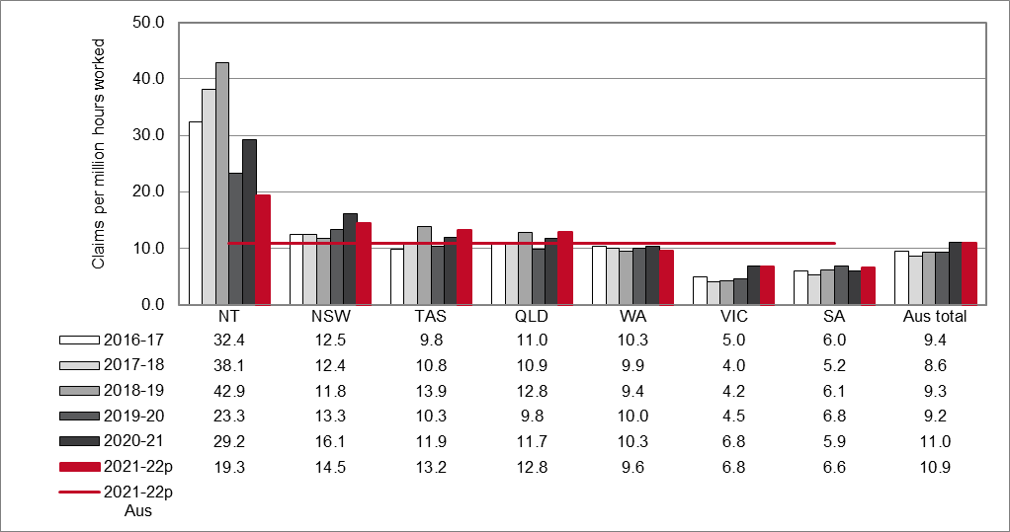

ACT - Values for the Australian Capital Territory have been suppressed.

# Mining

### Frequency rates of serious claims for Mining by jurisdiction (previously indicator 11b)

ACT - Values for the Australian Capital Territory have been suppressed.

# Manufacturing

### Frequency rates of serious claims for Manufacturing by jurisdiction (previously indicator 11c)

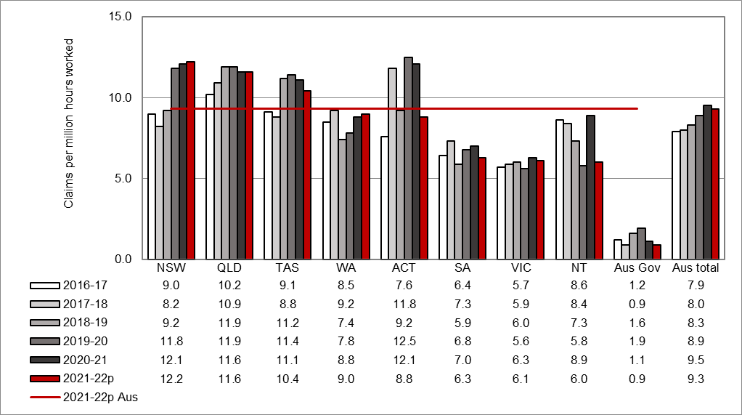

ACT – includes workers’ compensation scheme data from the ACT government sector and ACT private sector.

# Electricity, gas, water and waste services

### Frequency rates of serious claims for Electricity, gas, water and waste services by jurisdiction (previously indicator 11)

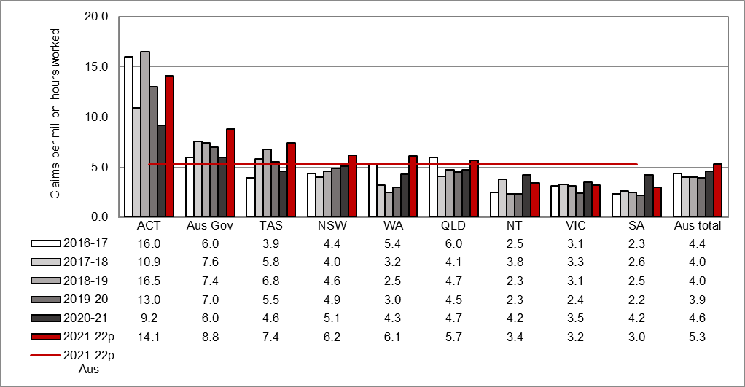

ACT – includes workers’ compensation scheme data from the ACT government sector and ACT private sector.

# Construction

### Frequency rates of serious claims for Construction by jurisdiction (previously indicator 11e)

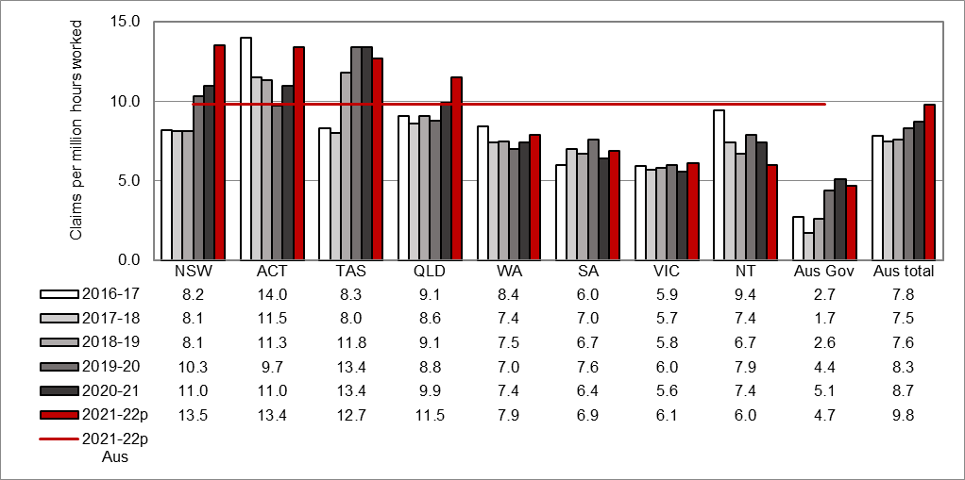

ACT – includes workers’ compensation scheme data from the ACT government sector and ACT private sector.

# Wholesale trade

### Frequency rates of serious claims for Wholesale trade by jurisdiction (previously indicator 11f)

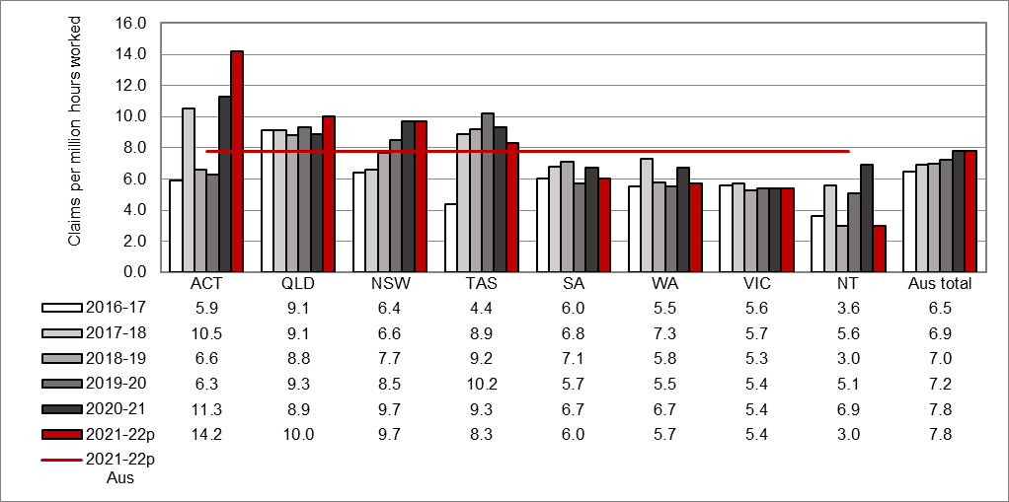

ACT – includes workers’ compensation scheme data from the ACT government sector and ACT private sector.

# Retail trade

### Frequency rates of serious claims for Retail trade by jurisdiction (previously indicator 11g)

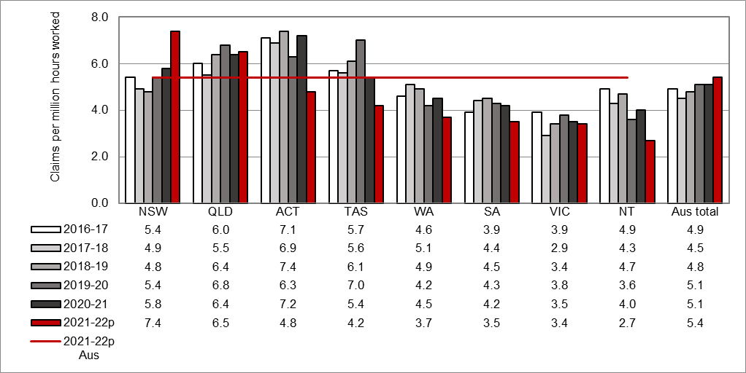

ACT – includes workers’ compensation scheme data from the ACT government sector and ACT private sector.

# Accommodation and food services

### Frequency rates of serious claims for Accommodation and food services by jurisdiction (previously indicator 11h)

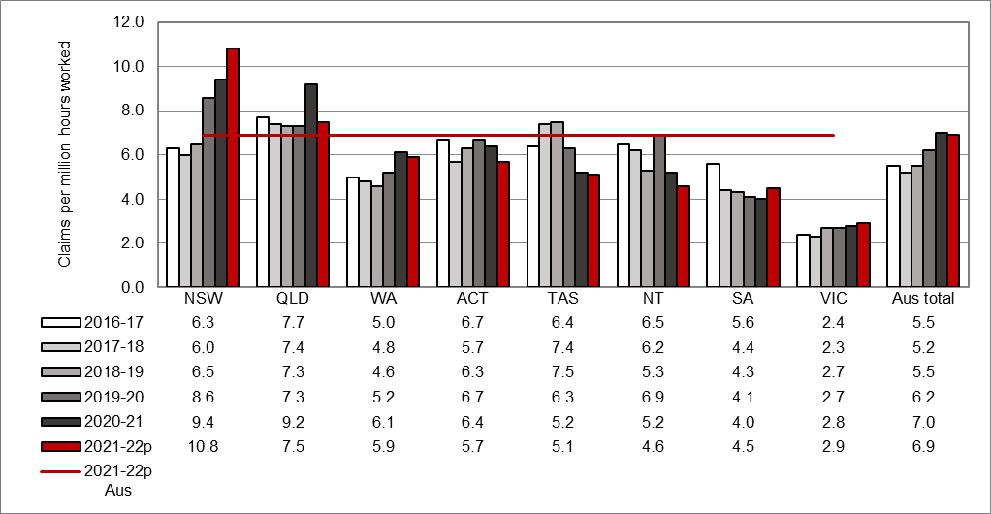

ACT – includes workers’ compensation scheme data from the ACT government sector and ACT private sector.

# Transport, postal and warehousing

### Frequency rates of serious claims for Transport, postal and warehousing by jurisdiction (previously indicator 11i)

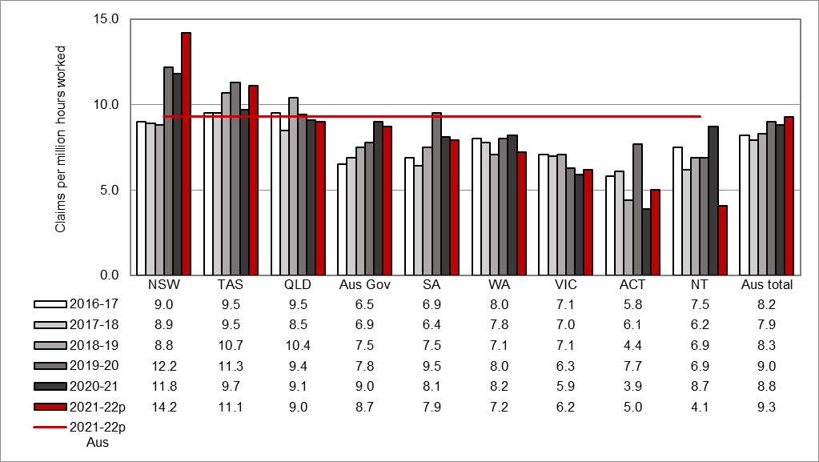

ACT – includes workers’ compensation scheme data from the ACT government sector and ACT private sector.

# Information media and telecommunications

### Frequency rates of serious claims for Information media and telecommunications by jurisdiction (previously indicator 11j)

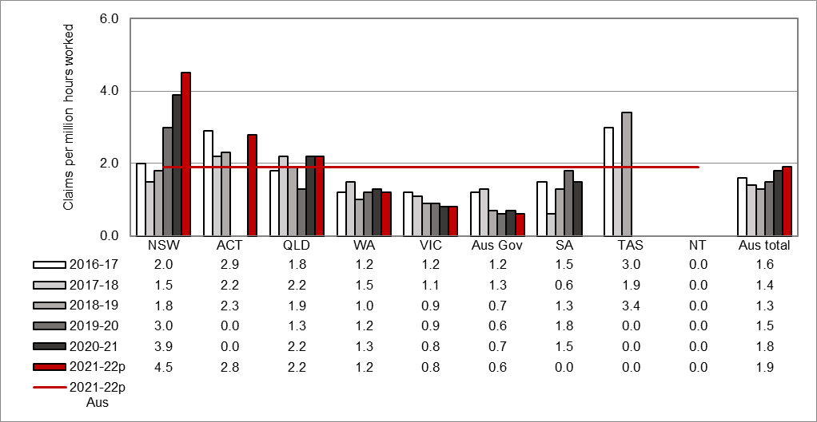

n.p.

n.p.

n.p.

n.p.

n.p.

n.p.

n.p.

n.p.

n.p.

n.p.

n.p.

n.p.

Some values for the Australian Capital Territory, South Australia, Tasmania, and the Northern Territory have been suppressed.

# Financial and insurance services

### Frequency rates of serious claims for Financial and insurance services by jurisdiction (previously indicator 11k)

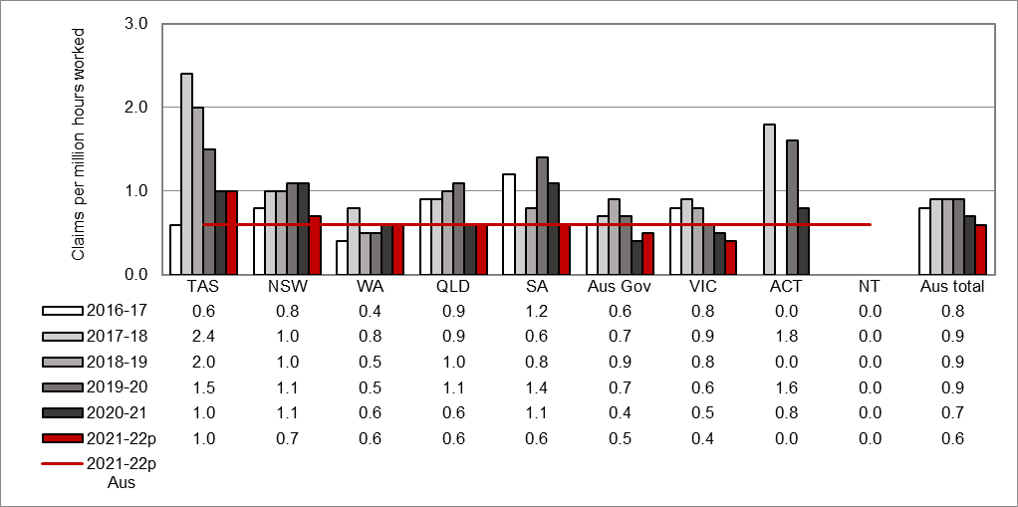

n.p.

1.8

n.p.

1.6

0.8

n.p.

n.p.

n.p.

n.p.

n.p.

n.p.

n.p.

Some values for the Australian Capital Territory and the Northern Territory have been suppressed.

# Rental, hiring and real estate services

### Frequency rates of serious claims for Rental, hiring and real estate services by jurisdiction (previously indicator 11l)

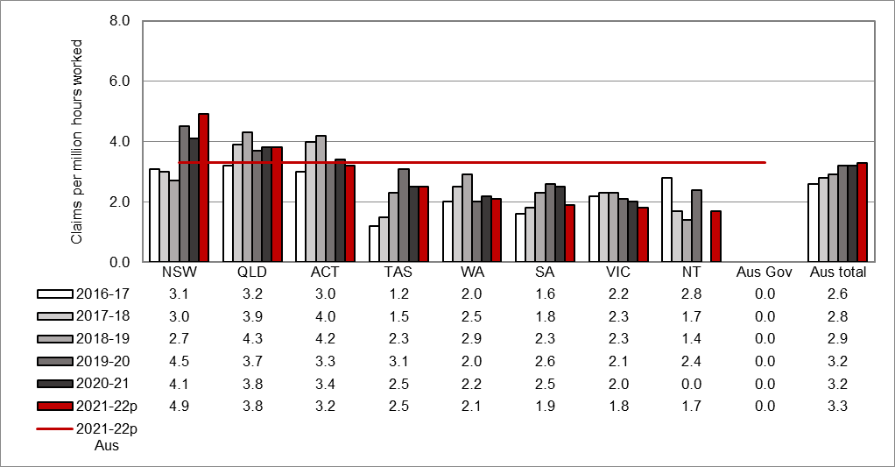

n.p.

n.p.

n.p.

n.p.

n.p.

n.p.

n.p.

Some values for the Northern Territory and the Australian Government have been suppressed.

ACT – includes workers’ compensation scheme data from the ACT government sector and ACT private sector.

# Professional, scientific and technical services

### Frequency rates of serious claims for Professional, scientific and technical services by jurisdiction (previously indicator 11m)

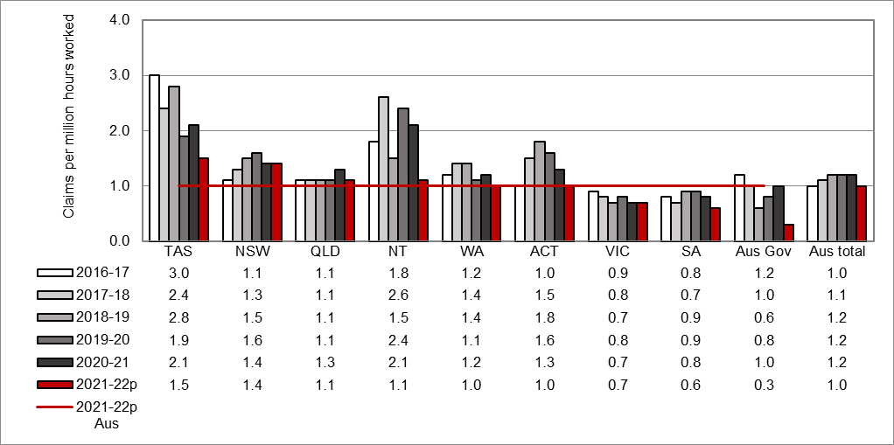

ACT – includes workers’ compensation scheme data from the ACT government sector and ACT private sector.

# Administrative and support services

### Frequency rates of serious claims for Administrative and support services by jurisdiction (previously indicator 11n)

ACT – includes workers’ compensation scheme data from the ACT government sector and ACT private sector.

The changes in frequency rates between 2021-22p and the previous years is partially due to improvements implemented to the estimates of the working population by Safe Work Australia.

# Public administration and safety

### Frequency rates of serious claims for Public administration and safety by jurisdiction (previously indicator 11o)

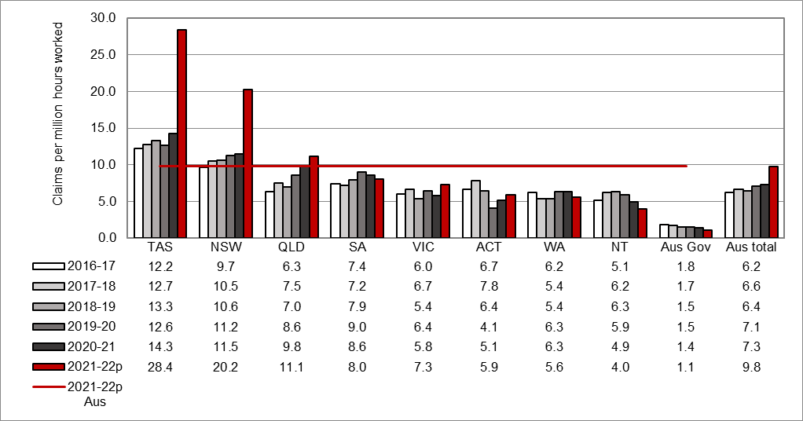

ACT – includes workers’ compensation scheme data from the ACT government sector and ACT private sector.

The changes in frequency rates between 2021-22p and the previous years is partially due to improvements implemented to the estimates of the working population by Safe Work Australia.

# Education and training

### Frequency rates of serious claims for Education and training by jurisdiction (previously indicator 11p)

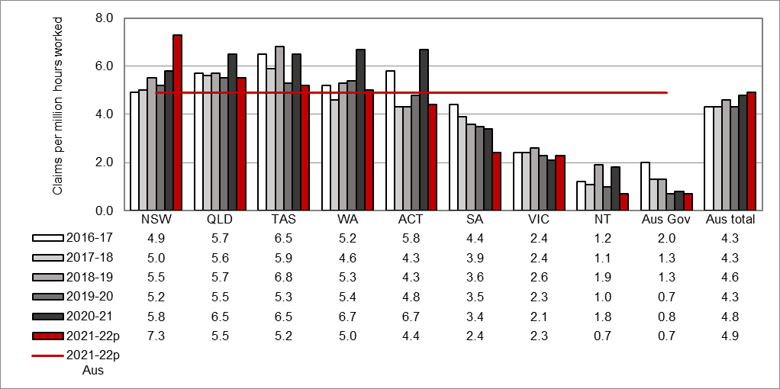

ACT – includes workers’ compensation scheme data from the ACT government sector and ACT private sector.

# Health care and social assistance

### Frequency rates of serious claims for Health care and social assistance by jurisdiction (previously indicator 11q)

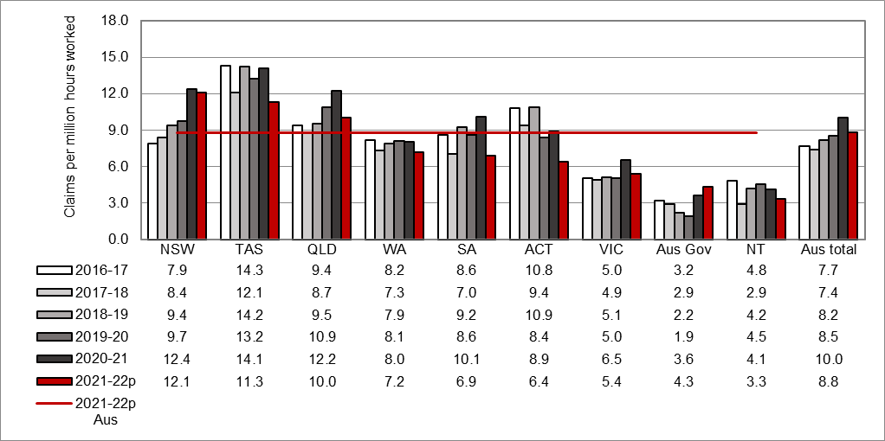

ACT – includes workers’ compensation scheme data from the ACT government sector and ACT private sector.

# Arts and recreation services

### Frequency rates of serious claims for Arts and recreation services by jurisdiction (previously indicator 11r)

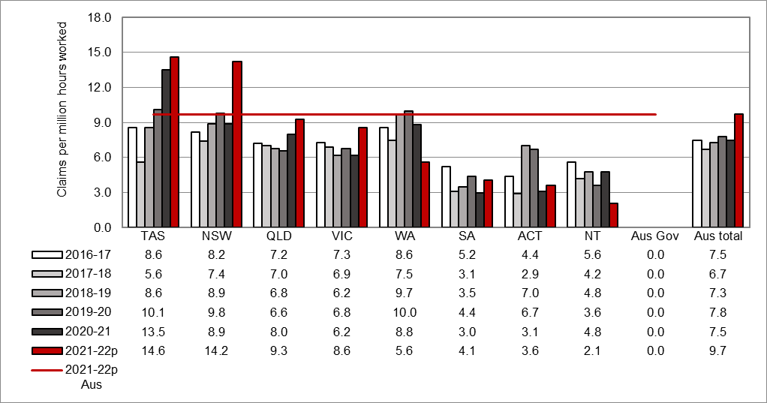

n.p.

n.p.

n.p.

n.p.

n.p.

n.p.

Aus Gov – values for the Australian Government have been suppressed.

ACT – includes workers’ compensation scheme data from the ACT government sector and ACT private sector.

# Other services

### Frequency rates of serious claims for Other services by jurisdiction (previously indicator 11s)

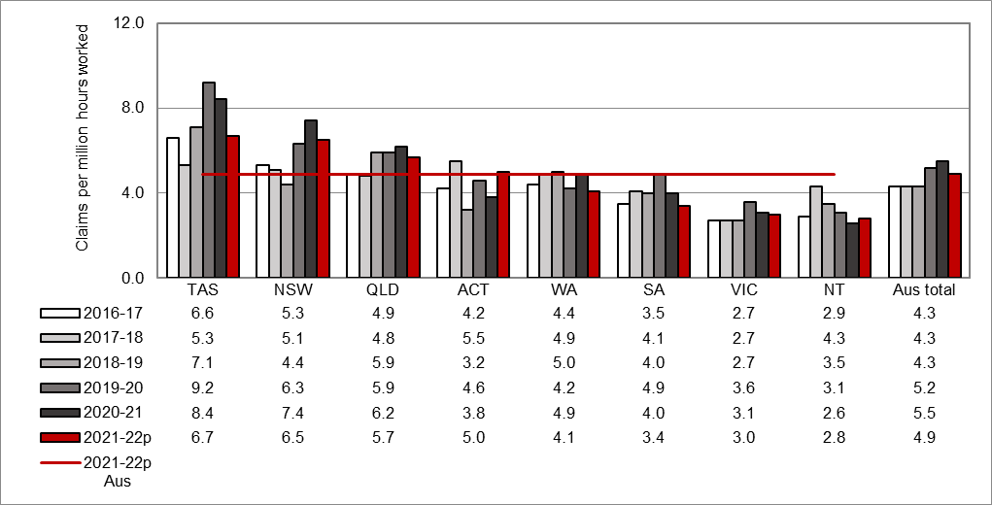

ACT – includes workers’ compensation scheme data from the ACT government sector and ACT private sector.

Appendix 1 - Further information

Glossary

*Definition of injury and disease*

Occupational injuries are defined as all employment-related injuries that are the result of a single traumatic event, occurring while a person is on duty or during a recess period at the workplace, and where there was a short or non-existent latency period.

Occupational diseases are defined as all employment-related diseases that result from repeated or long-term exposure to an agent(s) or event(s), or that are the result of a single event resulting in a disease (for example, the development of hepatitis following a single exposure to the infection). The data in this report do not cover all cases of occupational injury and diseases as workers’ compensation generally covers employees only (not contractors and self-employed workers). The incidence and frequency rates shown in this report for all industries are calculated using a denominator that has been adjusted to exclude self-employed persons.

The data in this report has been classified using the Type of Occurrence Classification System (TOOCS). More information on the TOOCS can be found on the [interactive data website](https://data.safeworkaustralia.gov.au/about-our-datasets/type-occurrence-classification-system-toocs-3rd-edition).

*Exclusions*

The following have been excluded from the data in this report:

* occupational injuries and diseases resulting in absences from work of less than   
  one working week,
* police in Western Australia and military personnel within the Defence force,
* cases not claimed as workers’ compensation or not acknowledged as being  
  work‑related, and
* claims for compensation to the Dust Diseases Authority of New South Wales.

*National Data Set for Compensation-based Statistics*

The data presented in this report are extracted from the National Data Set for Compensation-based Statistics (NDS), which is compiled annually from claims made under state, territory and Commonwealth workers’ compensation Acts. The New Zealand Accident Compensation Corporation (ACC) also collects data in accordance with the NDS. Further information about the NDS can be found on the [interactive data website](https://data.safeworkaustralia.gov.au/about-our-datasets/workers-compensation-data).

*Serious claim*

A serious claim is a workers’ compensation claim for an incapacity that results in a total absence from work of one working week or more. Claims excluded from this definition include those arising from a work-related fatality or a journey to or from work or during a recess period. One working week is defined as lost when the number of hours lost is greater than or equal to the number of hours usually worked per week.

*Traumatic Injury Fatalities*

This edition sources information from the Traumatic Injury Fatalities (TIF) collection. This collection sources data from workers’ compensation data, fatality notifications to the various WHS authorities and information in the National Coronial Information System (NCIS). Further information about the TIF collection can be found on the [interactive data website](https://data.safeworkaustralia.gov.au/about-our-datasets/work-related-fatalities-data).

Time series and adjustment of scheme data

The estimates of the number of employees and their hours worked for Australia are supplied by the Australian Bureau of Statistics and these denominator data are based on the Labour Force Survey, the Survey of Employment and Earnings and data provided by Comcare and the Australian Capital Territory Government. Further adjustments are performed using data from the Census. These data are matched to the scope of the claims data but may not be exact, particularly in the smaller jurisdictions, due to the number of employees being derived from a survey of the population rather than a census.

The New Zealand employment data used has been sourced from the New Zealand census information.

Incidence and frequency rates, especially for the most recent years, are expected to rise as the number of accepted claims increases, as more claims are lodged and finalised. This may involve additional claims being accepted or shorter-term claims with temporary incapacity incurring additional time lost and subsequently matching the definition of a serious claim: one that involves one or more working weeks of time lost.

Claims data shown in this report for 2021–22 are preliminary and likely to change. Therefore, these data items are likely to be understated and a comparison of 2020–21 data with those of previous years should be undertaken with caution.

A range of factors can affect the analysis of trends over time, including changes to jurisdictions’ legislative and administrative arrangements. Further details of these changes should be sought from the jurisdictions. Any commentary relating to these comparisons should be interpreted carefully.

More information on adjustments made to jurisdictions’ data can be found in the Explanatory notes: National data set for compensation-based statistics for Safe Work Australia on the [interactive data website](https://data.safeworkaustralia.gov.au/about-our-datasets/workers-compensation-data).