Disclaimer

Safe Work Australia is an Australian Government statutory agency established in 2009. Safe Work Australia includes Members from the Commonwealth, and each state and territory, Members representing the interests of workers and Members representing the interests of employers.

Safe Work Australia works with the Commonwealth, state and territory governments to improve work health and safety and workers’ compensation arrangements. Safe Work Australia is a national policy body, not a regulator of work health and safety. The Commonwealth, states and territories have responsibility for regulating and enforcing work health and safety laws in their jurisdiction.

**ISSN 2209-9158**

Creative Commons

With the exception of the Safe Work Australia logo, this copyright work is licensed under a Creative Commons Attribution 4.0 International licence. To view a copy of this licence, visit creativecommons.org/licenses. In essence, you are free to copy, communicate and adapt the work, even commercially, as long as you attribute the work to Safe Work Australia and abide by the other licence terms.

Contact information

Safe Work Australia | <mailto:info@swa.gov.au> | [www.swa.gov.au](http://www.swa.gov.au)

Comparative Performance Monitoring (CPM) 25th edition indicators

The CPM comprises of 5 sections that measure Work Health and Safety and Workers’ Compensation performance. The bolded indicators are included in this section.

**Work Health and Safety Performance**

* Incidence rates of serious injury and disease claims by jurisdiction
* Frequency rates of serious injury claims by jurisdiction
* Incidence rates of long term (12 weeks or more compensation) injury and disease claims by jurisdiction
* Frequency rates of long term (12 weeks or more compensation) injury and disease claims by jurisdiction
* Self-insured claims: number and proportion of serious claims by jurisdiction
* Serious claims: Percentage involving selected periods of compensation
* Traumatic injury worker fatalities: number and rate of incidents not on a public road, by state of death
* Compensated fatalities involving occupational diseases by jurisdiction
* Proportion of serious claims by mechanism of incident
* Incidence rates of serious claims by industry

**Work Health and Safety Compliance and Enforcement Activities**

* Work health and safety intervention activity by jurisdiction
* Work health and safety inspectorate activity by jurisdiction
* Work health and safety notices and enforceable undertakings by jurisdiction
* Work health and safety legal proceedings and fines by jurisdiction

**Workers’ Compensation Premiums**

* **Standardised average premium rates (including insured and self-insured sectors) by jurisdiction**
* **Australian average premium rates by industry**

**Workers’ Compensation Funding Ratio**

* Standardised ratio of assets to net outstanding claim liabilities for centrally funded schemes
* Standardised ratio of assets to net outstanding claim liabilities for privately underwritten schemes

**Workers’ Compensation Disputes**

* Proportion of claims with dispute
* Percentage of disputes resolved within selected time periods (cumulative)

Contents

Foreword 5

1. Workers’ compensation premiums 6

1.1 Standardised average premium rates by jurisdiction 6

Standardised average premium rates (including insured and self-insured sectors) by jurisdiction 7

1.2 Standardised average premium rates by industry 8

Australian average premium rates by industry 8

Standardised premium rates for Agriculture, forestry and fishing by jurisdiction 9

Standardised premium rates for Mining by jurisdiction 9

Standardised premium rates for Manufacturing by jurisdiction 10

Standardised premium rates for Electricity, gas, water and waste services by jurisdiction 10

Standardised premium rates for Construction by jurisdiction 11

Standardised premium rates for Wholesale trade by jurisdiction 11

Standardised premium rates for Retail trade by jurisdiction 12

Standardised premium rates for Accommodation and food services by jurisdiction 12

Standardised premium rates for Transport, postal and warehousing by jurisdiction 13

Standardised premium rates for Information, media and telecommunications by jurisdiction 13

Standardised premium rates for Financial and insurance services by jurisdiction 14

Standardised premium rates for Rental, hiring and real estate services by jurisdiction 14

Standardised premium rates for Professional, scientific and technical services by jurisdiction 15

Standardised premium rates for Administrative and support services by jurisdiction 15

Standardised premium rates for Public administration and safety by jurisdiction 16

Standardised premium rates for Education and training by jurisdiction 16

Standardised premium rates for Healthcare and social assistance by jurisdiction 17

Standardised premium rates for Arts and recreation services by jurisdiction 17

Standardised premium rates for Other services by jurisdiction 18

Appendix 1 — Explanatory notes for premium rates and entitlements 19

Foreword

This is the 25th edition of the Comparative Performance Monitoring (CPM) report which provides trend analyses about work health and safety (WHS) and workers’ compensation schemes operating in Australia and New Zealand.

This report has been compiled and coordinated by Safe Work Australia with assistance from representatives of all WHS and workers’ compensation authorities in Australia and New Zealand. Through a partnership of governments, employers and employees, Safe Work Australia leads the development of national policy to improve WHS and workers’ compensation arrangements across Australia.

The report is presented in the following sections:

* *Work health and safety performance* – provides an overview of WHS performance across Australia and New Zealand through analysing trends in serious claim rates and work-related fatalities across jurisdictions.
* *Work health and safety compliance and enforcement activities* – includes a jurisdictional comparison of workplace interventions, inspectorate activity, safety notices, enforceable undertakings, legal proceedings and fines.
* *Workers’ compensation premiums -* includes a national and jurisdictional overview of the standardised average premium rates by industry in the past 5 years (this section).
* *Workers’ compensation funding ratios –* compares the differences in scheme funding arrangements.
* *Workers’ compensation disputes* – includes information about disputes against an insurer’s decision or decisions relating to compensation.

Previous editions of the CPM report also included data on Workers’ Compensation expenditure (under the *Workers’ compensation funding – assets, liabilities and expenditure* section) and scenarios that illustrated the differences in entitlement levels across jurisdictions (under the *Entitlements under workers’ compensation* section). This information will be moved to the [*Comparison of workers’ compensation arrangements in Australia and New Zealand*](https://www.safeworkaustralia.gov.au/workers-compensation/comparing-workers-compensation-australia) which provides information biennially about workers’ compensation arrangements and the differences between schemes in Australia and New Zealand.

*About the data*

Comparisons of CPM measures/outcomes across the jurisdictions workers’ compensation schemes should be made with caution due to the differences in design, coverage, definitions and processes. Readers may find the [*Comparison of workers’ compensation arrangements in Australia and New Zealand*](https://www.safeworkaustralia.gov.au/workers-compensation/comparing-workers-compensation-australia)useful in comparing the differences in key aspects of each scheme. Additionally, data in this publication may differ from jurisdictional annual reports due to the use of different definitions and the application of adjustment factors to aid in the comparability of data.

The CPM does not currently include information or data from other industry-specific regulators that have responsibilities with respect to WHS and workers’ compensation. These include national industry-based regulators with compliance and enforcement roles such as the National Heavy Vehicle Regulator, the National Rail Safety Regulator and the National Offshore Petroleum Safety and Environmental Management Authority, and other agencies with responsibility for industry‑specific compensation claims. Further information on these regulators can be found on their respective websites.

In this report ‘Australian Government’ is used for indicators relating to WHS and workers’ compensation matters under the Australian Government jurisdiction, while ‘Comcare’ is used for the indicators relating to premium rates and disputes.

1. Workers’ compensation premiums

Workers’ compensation is a compulsory form of insurance for all employers in Australia. It provides protection to employees if they suffer a work-related injury or illness. Workers’ compensation premiums are paid by employers for this insurance, with the premium generally determined based on the amount of wages paid, as well as the industry and claim history of the employer.

The premium rates in this section are for policies that provided coverage during the financial years 2017‑18 to 2021-22. The premium rates reported are ‘earned premium’. Earned premium is defined as the amount allocated for cover in a financial year from premiums collected during the previous and current financial years, while written premium is defined as the amount of premium recorded for a policy at the time it is issued. The premiums reported are allocated for defined periods of risk, irrespective of when they were actually paid, enabling rates to be compared for each financial year. Goods and Services Tax charged on premiums is not included in the reported rates as most Australian employers recoup part or all this tax through input tax credits.

Standardised average premium rates by jurisdiction

*About average premium rates*

Premium rates published also vary to those published by the jurisdictions as adjustments are made to the data to enable jurisdictional comparisons. To increase comparability, adjustments have been applied to this indicator including:

* the use of Australian and New Zealand Standard Industrial Classification (ANZSIC) 2006 instead of ANZSIC 1993,
* the exclusion of provision for coverage of journey claims,
* the inclusion of self-insurers,
* the inclusion of superannuation as part of remuneration, and
* the standardisation of non-compensable excesses imposed by each scheme.

The effect of each of these adjustments is shown in *Appendix 1 – Table 2: Effect of adjustment factors on premium rates in 2021-22*.

Information about jurisdictional workers’ compensation arrangements is available from the [*Comparison of Workers’ Compensation Arrangements in Australia and New Zealand*](https://www.safeworkaustralia.gov.au/workers-compensation/comparing-workers-compensation-australia) publication that can be found on the [Safe Work Australia](https://www.safeworkaustralia.gov.au) website.

Standardised average premium rates (including insured and self-insured sectors) by jurisdiction (previously indicator 13)

ACT Private – only includes data from the Australian Capital Territory private sector.

Standardised average premium rates by industry

Australian average premium rates by industry (previously indicator 14)

Standardised average premium rates by industry and jurisdiction

Presented below is a comparison of standardised average premium rates across the Australian jurisdictions for each of the 19 industry groups. Not all jurisdictions are included under each industry, as some industries will not be relevant for certain jurisdictions, particularly Comcare (Australian Government).

# Agriculture, forestry and fishing

Standardised premium rates for Agriculture, forestry and fishing by jurisdiction (previously indicator 14a)

Comcare – the 2017-18 premium rate for Comcare is unavailable.

ACT Private – only includes data from the Australian Capital Territory private sector.

# Mining

Standardised premium rates for Mining by jurisdiction (previously indicator 14b)

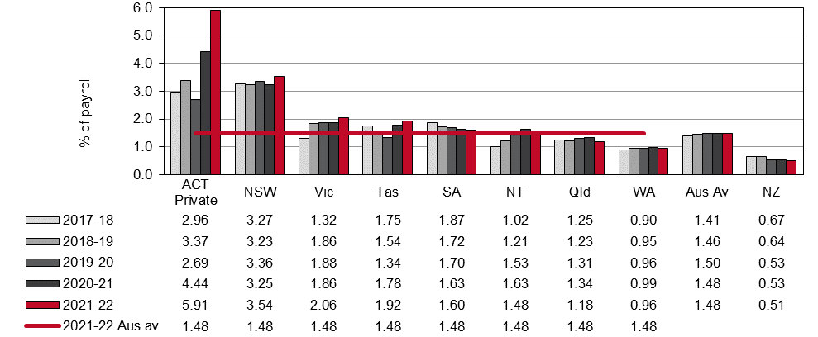

ACT Private – only includes data from the Australian Capital Territory private sector.

# Manufacturing

Standardised premium rates for Manufacturing by jurisdiction (previously indicator 14c)

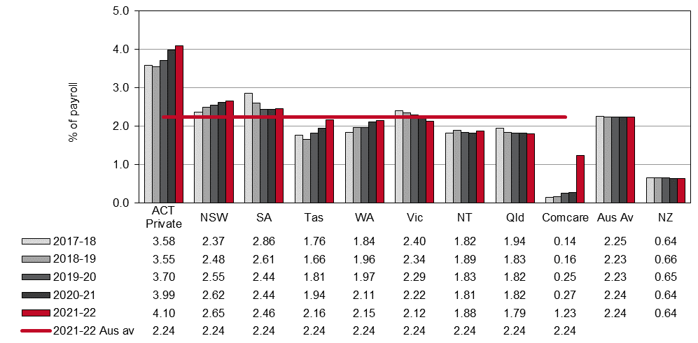

ACT Private – only includes data from the Australian Capital Territory private sector.

# Electricity, gas, water and waste services

Standardised premium rates for Electricity, gas, water and waste services by jurisdiction (previously indicator 14d)

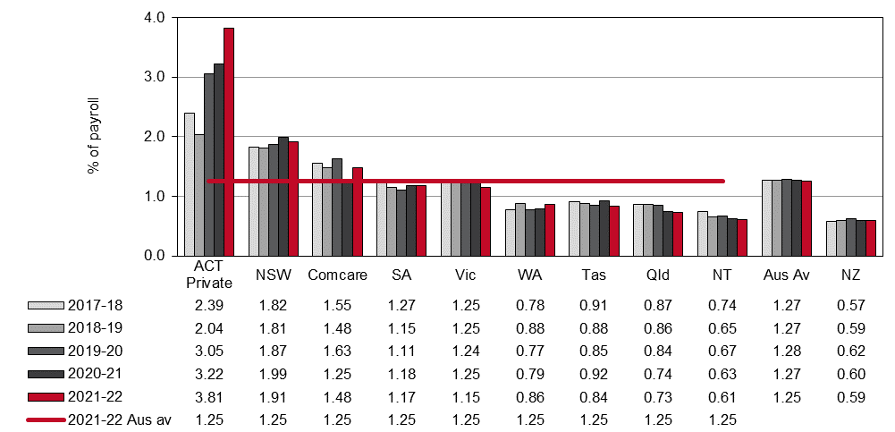

ACT Private – only includes data from the Australian Capital Territory private sector.

# Construction

Standardised premium rates for Construction by jurisdiction (previously indicator 14e)

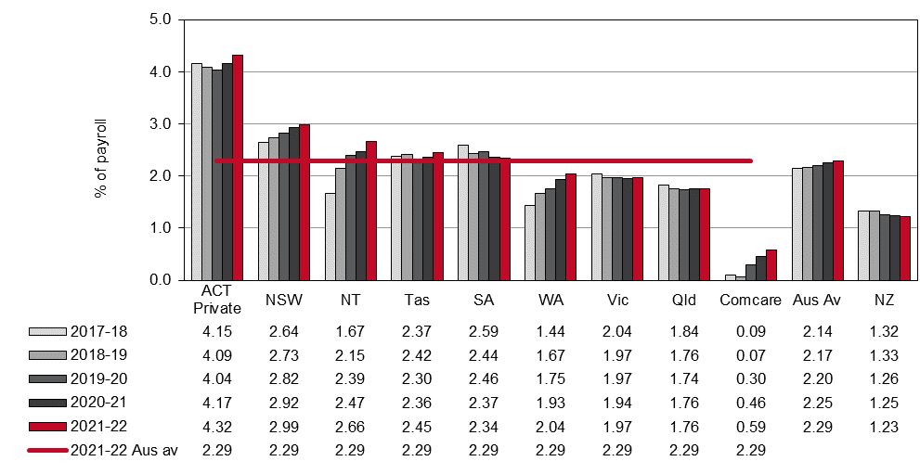

ACT Private – only includes data from the Australian Capital Territory private sector.

# Wholesale trade

Standardised premium rates for Wholesale trade by jurisdiction (previously indicator 14f)

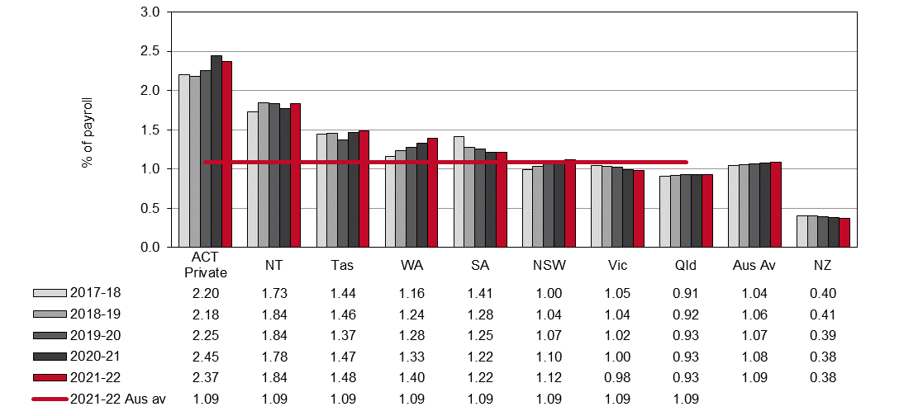

ACT Private – only includes data from the Australian Capital Territory private sector.

# Retail trade

Standardised premium rates for Retail trade by jurisdiction (previously indicator 14g)

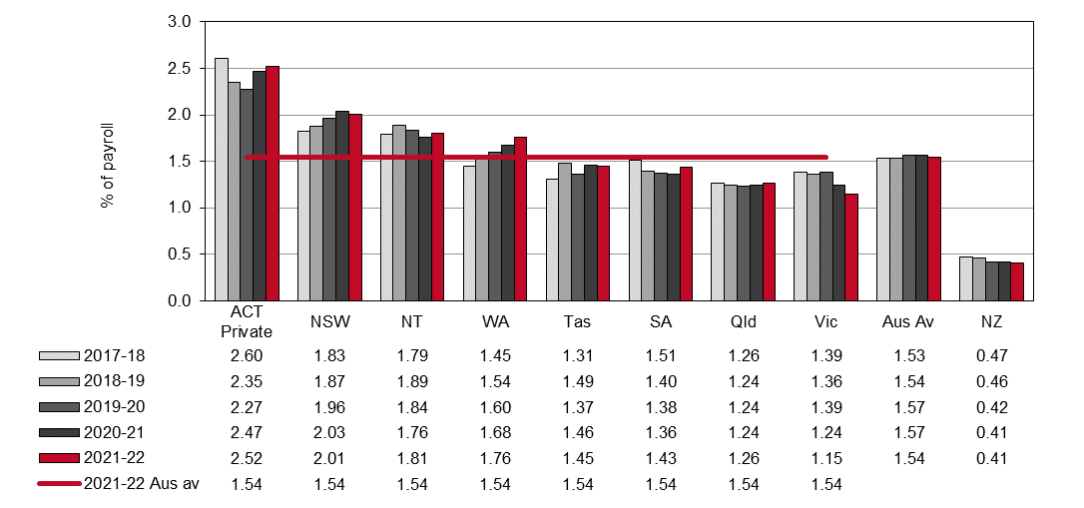

ACT Private – only includes data from the Australian Capital Territory private sector.

# Accommodation and food services

Standardised premium rates for Accommodation and food services by jurisdiction (previously indicator 14h)

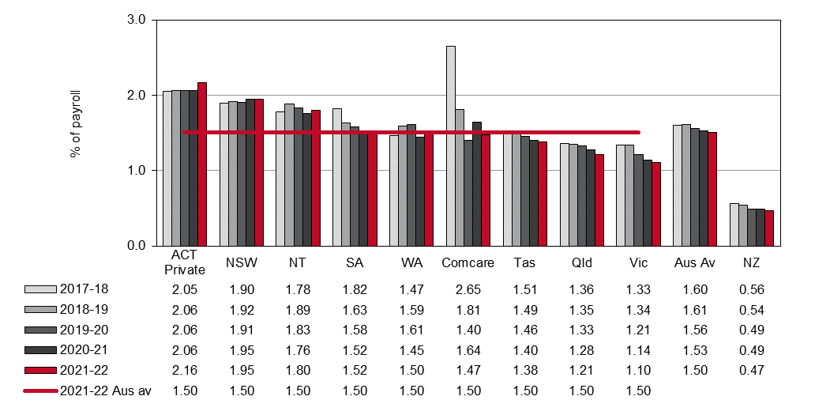

ACT Private – only includes data from the Australian Capital Territory private sector.

# Transport, postal and warehousing

Standardised premium rates for Transport, postal and warehousing by jurisdiction (previously indicator 14i)

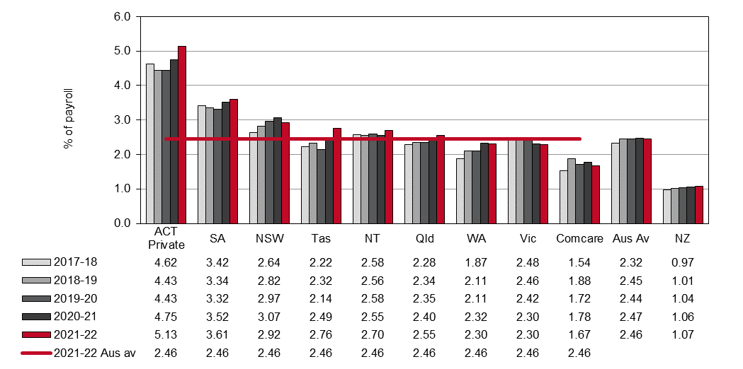

ACT Private – only includes data from the Australian Capital Territory private sector.

# Information, media and telecommunications

Standardised premium rates for Information, media and telecommunications by jurisdiction (previously indicator 14j)

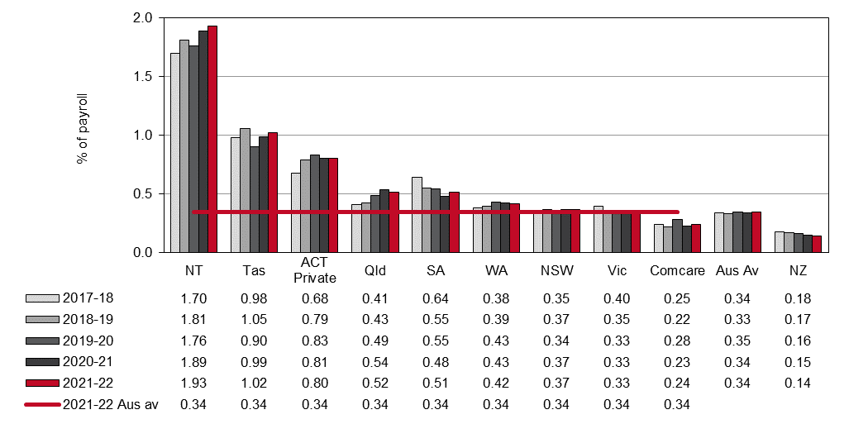

ACT Private – only includes data from the Australian Capital Territory private sector.

# Financial and insurance services

Standardised premium rates for Financial and insurance services by jurisdiction (previously indicator 14k)

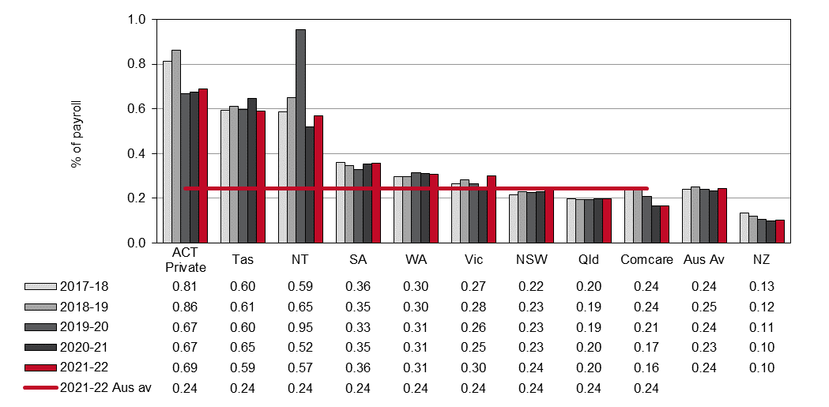

ACT Private – only includes data from the Australian Capital Territory private sector.

# Rental, hiring and real estate services

Standardised premium rates for Rental, hiring and real estate services by jurisdiction (previously indicator 14l)

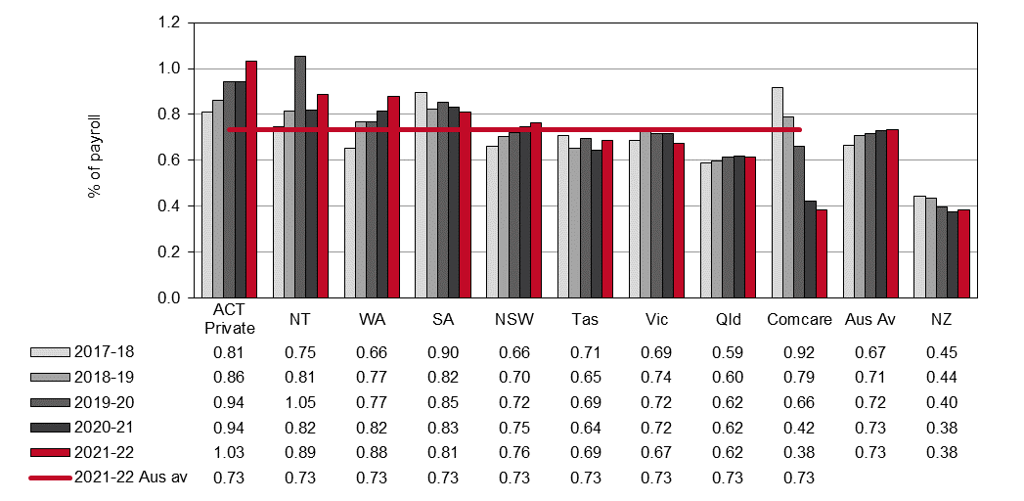

ACT Private – only includes data from the Australian Capital Territory private sector.

# Professional, scientific, and technical services

Standardised premium rates for Professional, scientific and technical services by jurisdiction (previously indicator 14m)

ACT Private – only includes data from the Australian Capital Territory private sector.

# Administrative and Support services

Standardised premium rates for Administrative and support services by jurisdiction (previously indicator 14n)

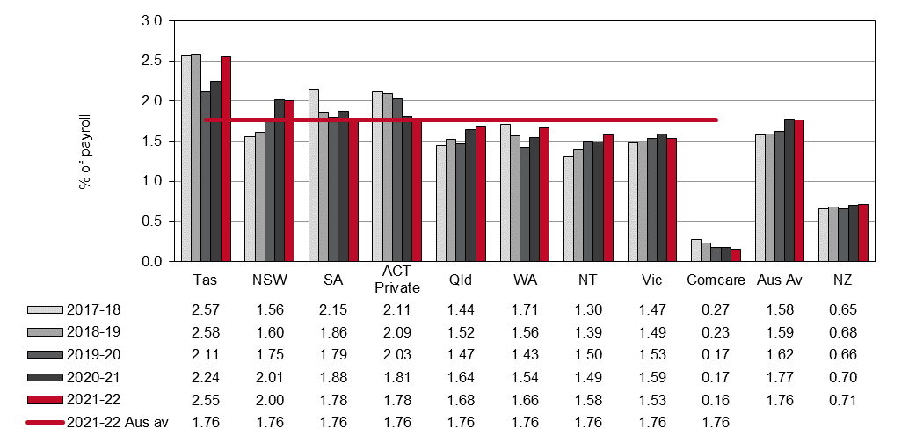

ACT Private – only includes data from the Australian Capital Territory private sector.

# Public administration and safety

Standardised premium rates for Public administration and safety by jurisdiction (previously indicator 14o)

ACT Private – only includes data from the Australian Capital Territory private sector.

# Education and training

Standardised premium rates for Education and training by jurisdiction (previously indicator 14p)

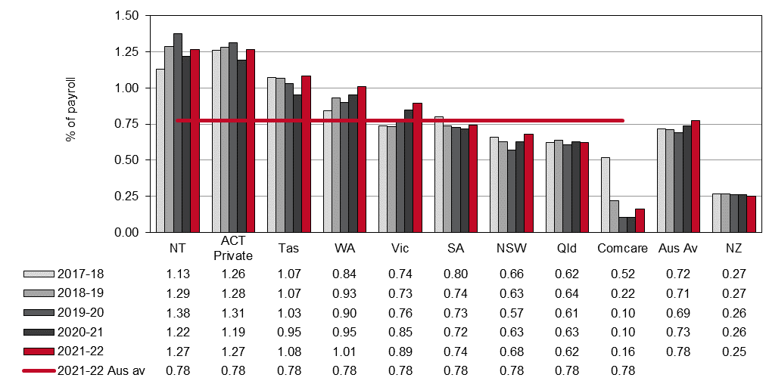

ACT Private – only includes data from the Australian Capital Territory private sector.

# Health care and social assistance

Standardised premium rates for Healthcare and social assistance by jurisdiction (previously Indicator 14q)

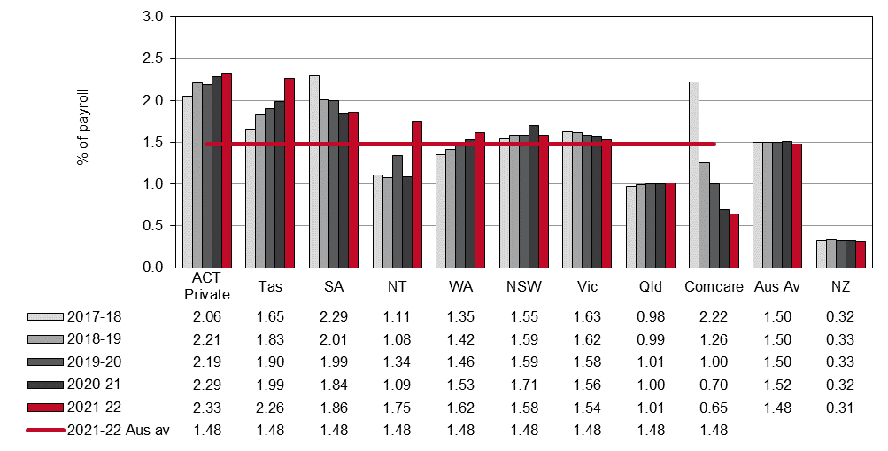

ACT Private – only includes data from the Australian Capital Territory private sector.

# Arts and recreation services

Standardised premium rates for Arts and recreation services by jurisdiction (previously Indicator 14r)

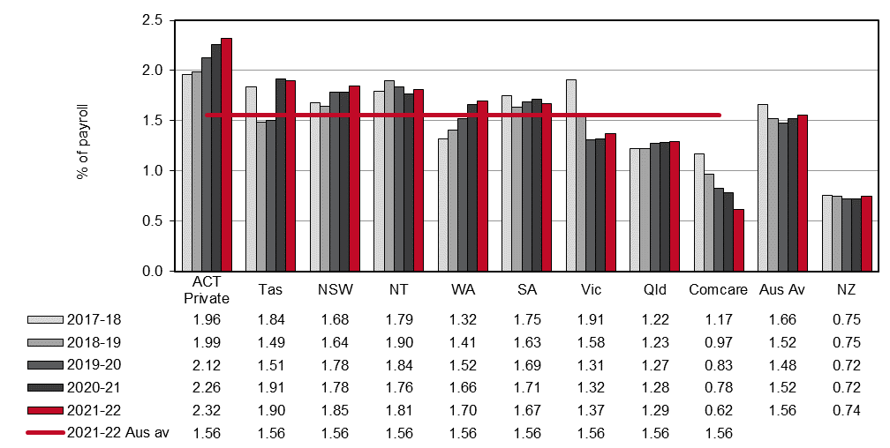

ACT Private – only includes data from the Australian Capital Territory private sector.

# Other services

Standardised premium rates for Other services by jurisdiction (previously indicator 14s)

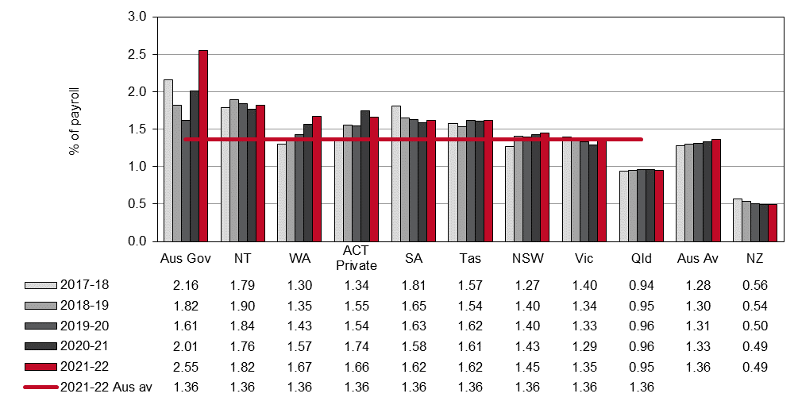

ACT Private – only includes data from the Australian Capital Territory private sector.

Appendix 1 — Explanatory notes for premium rates and entitlements

Issues affecting the comparability of premium rates across the schemes include:

* differences in benefits and coverage for certain types of injuries, in particular the coverage of the journey to and from work
* differences in claims management arrangements
* variations in the funding arrangements for delivery of WHS services, with some jurisdictions providing degrees of cross-subsidisation
* differences in the definitions of wages for premium setting purposes, including whether superannuation contribution is part of wages
* different scheme excess deductibles (note that wage under-declaration has not been accounted for as it is considered to have a similar prevalence in each jurisdiction)
* different levels of self-insurance
* different industry mixes
* differences in premium calculation methodology, and
* different actuarial assumptions used in the calculation of premium rates.

## Premiums in the self-insured sector

Most jurisdictions allow large employers to self-insure their workers’ compensation if they prove that they can manage the associated financial and other risks. Jurisdictions with a large proportion of employees under self-insurance arrangements include New South Wales, South Australia, Tasmania and Comcare. Significantly fewer self-insurers operate in Victoria, Queensland, Western Australia and the Australian Capital Territory Private Scheme. A number of methodologies are employed in this report to obtain an estimate of the amount of premium that self-insurers would pay.

## Employer excess factors

Some schemes have non-compensable excesses where the employer pays the first five or 10 days compensation and/or meets medical expenses to a maximum amount. To improve comparability of premium rates a common deductible for the first five days of compensation with no medical costs has been applied. The factors applied to the insured sector data in each jurisdiction are shown in Appendix 1 – Table 1. Adjustment factors have also been applied to the self-insured sector to make the data consistent with the common deductible of the first five days compensation with no medical costs.

## Journey factors

Queensland and the Australian Capital Territory Private Scheme provide some level of coverage for journey claims. Hence, an estimated amount equal to the cost of providing this coverage has been removed from the premium rates of the jurisdictions that provide this type of coverage. The factors applied are shown in Appendix 1 – Table 1. In New Zealand, journey claims are covered by a different scheme.

Appendix 1 – Table 1: Premium rate adjustment factors (%)

| **Jurisdiction** | **Employer excess factors** | | | **Journey** |
| --- | --- | --- | --- | --- |
| **Insured sector** | | **Self-insured** |
| **Time lost excess** | **Medical expenses** | **Time lost excess** |
| New South Wales | -2.1 | n/a | -3.5 | n/a |
| Victoria | 2.0 | 0.8 | -3.7 | n/a |
| Queensland | n/a | n/a | n/a | -6.8 |
| Western Australia | -3.3 | n/a | n/a | n/a |
| South Australia | -2.5 | n/a | -3.8 | n/a |
| Tasmania | -2.8 | n/a | -2.5 | n/a |
| Northern Territory | -1.8 | n/a | n/a | n/a |
| Australian Capital Territory (Private) | -2.2 | n/a | n/a | -6.8 |
| Comcare | -2.0 | n/a | -4.5 | n/a |
| New Zealand | n/a | n/a | n/a | -6.8 |

## Effect of adjustment factors on premium rates

Appendix 1 – Table 2 presents average premium rates with various adjustments to assist comparability. Each column in this table represents progressively adjusted premium rates as follows:

Column 1 – These data are average premium rates for insured employers only, calculated using the definition of remuneration as used by that jurisdiction, i.e. superannuation included where applicable. GST was excluded in all cases. Rates are applicable to the employer and medical excesses that apply in each jurisdiction and should not be compared.

Column 2 – These rates are average premium rates for the insured sector adjusted to include superannuation in the definition of remuneration. Estimates of superannuation were applied to Western Australia, Tasmania and the Northern Territory. All other jurisdictions were able to provide appropriate data. Data for New Zealand were also adjusted to include superannuation.

Column 3 – These rates are the average premium rates for each jurisdiction including both the insured and self-insured sectors before any adjustment factors are applied.

Column 4 – These rates adjust the rates in column 3 to account for the different employer excesses that apply in each jurisdiction. The adjustment made to the data from the self-insured sector may be different to the adjustment applied to the premium paying sector due to the assumption that a nil employer excess applies to the self-insured sector.

Column 5 – These rates further adjust the rates in column 4 to remove a component comparable to the cost of providing workers’ compensation coverage for journeys to and from work. These adjustments apply to Queensland and the Australian Capital Territory Private Scheme and New Zealand where the coverage for these types of claims is included in the workers’ compensation system.

Appendix 1 – Table 2: Effect of adjustment factors on premium rates in 2021–22

| **Jurisdiction** | **Average premium rates for premium paying sector (%)** | | **Total(a) average premium rate**  **(%)** | **Total(a) average premium rate adjusted for employer excess (%)** | **Total(a) average premium rate adjusted for employer excess and journey claims (%)** |
| --- | --- | --- | --- | --- | --- |
|  | **Unadjusted** | **Adjusted to include superannuation** |
|  | **1** | **2** | **3** | **4** | **5** |
| NSW(b) | 1.36 | 1.36 | 1.49 | 1.45 | 1.45 |
| Vic | 1.31 | 1.31 | 1.27 | 1.31 | 1.31 |
| Qld(c) | 1.17 | 1.17 | 1.24 | 1.24 | 1.15 |
| WA | 1.65 | 1.49 | 1.50 | 1.45 | 1.45 |
| SA | 1.66 | 1.66 | 1.64 | 1.60 | 1.60 |
| Tas | 1.99 | 1.81 | 1.98 | 1.92 | 1.92 |
| NT | 2.27 | 2.06 | 1.31 | 1.29 | 1.29 |
| ACT Private | 1.76 | 1.76 | 1.77 | 1.73 | 1.62 |
| Comcare | 0.69 | 0.69 | 0.73 | 0.70 | 0.70 |
| **Australia** | **1.34** | **1.34** | **1.37** | **1.36** | **1.34** |
| NZ | 0.73 | 0.66 | 0.57 | 0.57 | 0.53 |

(a) Total of adjusted premium for insured sector plus calculated premium for self-insured sector.

(b) The NSW average premium rates also include the dust diseases levy which is not part of the New South Wales scheme but is payable by employers in that State.

(c) Queensland includes stamp duty levied at a rate of 5% of the premium including GST.