Disclaimer

Safe Work Australia is an Australian Government statutory agency established in 2009. Safe Work Australia includes Members from the Commonwealth, and each state and territory, Members representing the interests of workers and Members representing the interests of employers.

Safe Work Australia works with the Commonwealth, state and territory governments to improve work health and safety and workers’ compensation arrangements. Safe Work Australia is a national policy body, not a regulator of work health and safety. The Commonwealth, states and territories have responsibility for regulating and enforcing work health and safety laws in their jurisdiction.

**ISSN 2209-9158**

Creative Commons

With the exception of the Safe Work Australia logo, this copyright work is licensed under a Creative Commons Attribution 4.0 International licence. To view a copy of this licence, visit creativecommons.org/licenses. In essence, you are free to copy, communicate and adapt the work, even commercially, as long as you attribute the work to Safe Work Australia and abide by the other licence terms.

Contact information

Safe Work Australia | <mailto:info@swa.gov.au> | [www.swa.gov.au](http://www.swa.gov.au)

Comparative Performance Monitoring (CPM) 25th edition indicators

The CPM comprises of 5 sections that measure Work Health and Safety and Workers’ Compensation performance. The bolded indicators are included in this section.

**Work Health and Safety Performance**

* Incidence rates of serious injury and disease claims by jurisdiction
* Frequency rates of serious injury claims by jurisdiction
* Incidence rates of long term (12 weeks or more compensation) injury and disease claims by jurisdiction
* Frequency rates of long term (12 weeks or more compensation) injury and disease claims by jurisdiction
* Self-insured claims: number and proportion of serious claims by jurisdiction
* Serious claims: Percentage involving selected periods of compensation
* Traumatic injury worker fatalities: number and rate of incidents not on a public road, by state of death
* Compensated fatalities involving occupational diseases by jurisdiction
* Proportion of serious claims by mechanism of incident
* Incidence rates of serious claims by industry

**Work Health and Safety Compliance and Enforcement Activities**

* Work health and safety intervention activity by jurisdiction
* Work health and safety inspectorate activity by jurisdiction
* Work health and safety notices and enforceable undertakings by jurisdiction
* Work health and safety legal proceedings and fines by jurisdiction

**Workers’ Compensation Premiums**

* Standardised average premium rates (including insured and self-insured sectors) by jurisdiction
* Australian average premium rates by industry

**Workers’ Compensation Funding Ratios**

* **Standardised ratio of assets to net outstanding claim liabilities for centrally funded schemes**
* **Standardised ratio of assets to net outstanding claim liabilities for privately underwritten schemes**

**Workers’ Compensation Disputes**

* Proportion of claims with dispute
* Percentage of disputes resolved within selected time periods (cumulative)

Contents

Foreword 5

1. Introduction 6

1.1 Assets to liabilities ratio 6

Standardised ratio of assets to net outstanding claim liabilities for centrally funded schemes 7

Standardised ratio of assets to net outstanding claim liabilities for privately underwritten schemes 7

Appendix 1 – Assets to liabilities ratio (funding ratio) definitions 8

Foreword

This is the 25th edition of the Comparative Performance Monitoring (CPM) report which provides trend analyses about work health and safety (WHS) and workers’ compensation schemes operating in Australia and New Zealand.

This report has been compiled and coordinated by Safe Work Australia with assistance from representatives of all WHS and workers’ compensation authorities in Australia and New Zealand. Through a partnership of governments, employers and employees, Safe Work Australia leads the development of national policy to improve WHS and workers’ compensation arrangements across Australia.

The report is presented in the following sections:

* *Work health and safety performance* – provides an overview of WHS performance across Australia and New Zealand through analysing trends in serious claim rates and work-related fatalities across jurisdictions.
* *Work health and safety compliance and enforcement activities* – includes a jurisdictional comparison of workplace interventions, inspectorate activity, safety notices, enforceable undertakings, legal proceedings and fines.
* *Workers’ compensation premiums -* includes a national and jurisdictional overview of the standardised average premium rates by industry in the past 5 years.
* *Workers’ compensation funding ratios –* compares the differences in scheme funding arrangements (this section).
* *Workers’ compensation disputes* – includes information about disputes against an insurer’s decision or decisions relating to compensation.

Previous editions of the CPM report also included data on Workers’ Compensation expenditure (under the *Workers’ compensation funding – assets, liabilities and expenditure* section) and scenarios that illustrated the differences in entitlement levels across jurisdictions (under the *Entitlements under workers’ compensation* section). This information will be moved to the [*Comparison of workers’ compensation arrangements in Australia and New Zealand*](https://www.safeworkaustralia.gov.au/workers-compensation/comparing-workers-compensation-australia)which provides information biennially about workers’ compensation arrangements and the differences between schemes in Australia and New Zealand.

*About the data*

Comparisons of CPM measures/outcomes across the jurisdictions workers’ compensation schemes should be made with caution due to the differences in design, coverage, definitions and processes. Readers may find the [*Comparison of workers’ compensation arrangements in Australia and New Zealand*](https://www.safeworkaustralia.gov.au/workers-compensation/comparing-workers-compensation-australia) useful in comparing the differences in key aspects of each scheme. Additionally, data in this publication may differ from jurisdictional annual reports due to the use of different definitions and the application of adjustment factors to aid in the comparability of data.

The CPM does not currently include information or data from other industry-specific regulators that have responsibilities with respect to WHS and workers’ compensation. These include national industry-based regulators with compliance and enforcement roles such as the National Heavy Vehicle Regulator, the National Rail Safety Regulator and the National Offshore Petroleum Safety and Environmental Management Authority, and other agencies with responsibility for industry‑specific compensation claims. Further information on these regulators can be found on their respective websites.

In this report ‘Australian Government’ is used for indicators relating to WHS and workers’ compensation matters under the Australian Government jurisdiction, while ‘Comcare’ is used for the indicators relating to premium rates and disputes.

1. Introduction

There are significant differences in funding arrangements for the various workers’ compensation schemes around Australia.

In centrally funded schemes (New South Wales, Victoria, Queensland, South Australia, the Australian Government and New Zealand), a single public insurer — a government agency, performs most, if not all of a workers’ compensation insurer’s functions. Central insurers are responsible for underwriting their scheme.

In privately underwritten schemes (Western Australia, Tasmania, the Northern Territory, the Australian Capital Territory and Seacare), most, if not all insurer functions are provided by the private sector through approved insurance companies and self-insuring employers who meet the appropriate prudential and other prerequisites. This includes underwriting.

These differences in funding arrangements should be considered when reviewing this section. More information about the definitions and inclusions for assets to liabilities ratios and scheme expenditure is available in *Appendix 1 – Assets to liabilities ratio (funding ratio) definitions* at the end of the section.

Assets to liabilities ratio

This section reports the standardised ratio of assets to net outstanding claim liabilities (funding ratio) for each jurisdiction over the past five years (2017-18 to 2021-22).

This indicator is a measure of the adequacy of the scheme to meet future claim payments. Ratios above 100% indicate that the scheme has more than sufficient assets to meet its predicted future liabilities. Conversely, low ratios could be an indication of the need for a scheme to increase its premium rates to ensure that assets are available for future claim payments. Funding ratio trends should therefore be considered in conjunction with the premium rates reported in the *Workers’ compensation premiums* section of the Comparison Performance Monitoring report.

Self-insurers are employers who are allowed to manage and pay for their employees’ claims for work-related injuries and disease, rather than paying premiums to insurers to take on these responsibilities. They are required to lodge financial guarantees to provide security for workers’ compensation entitlements. Self‑insurers are excluded from the funding ratio measures as the workers’ compensation assets and liabilities are not quarantined from the rest of the self‑insurer’s business.

Insurers in privately underwritten schemes are governed by the Australian Prudential Regulatory Authority’s prudential regulatory requirements to make sure that enough funds are available to cover all liabilities. The funding ratio measure for privately underwritten schemes does not capture the true extent of the private schemes’ abilities to meet future claim payments and has been shown on a separate graph to those for the centrally funded schemes.

**Centrally funded schemes**

Standardised ratio of assets to net outstanding claim liabilities for centrally funded schemes (previously indicator 18)

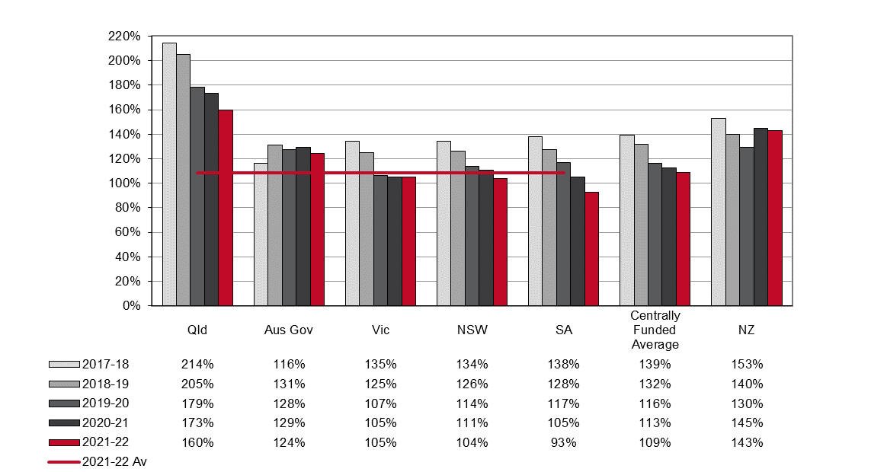

**Privately Underwritten Schemes**

Seacare and the Australian Capital Territory schemes are privately underwritten, but no data is currently available for this Indicator.

Standardised ratio of assets to net outstanding claim liabilities for privately underwritten schemes (previously indicator 19)

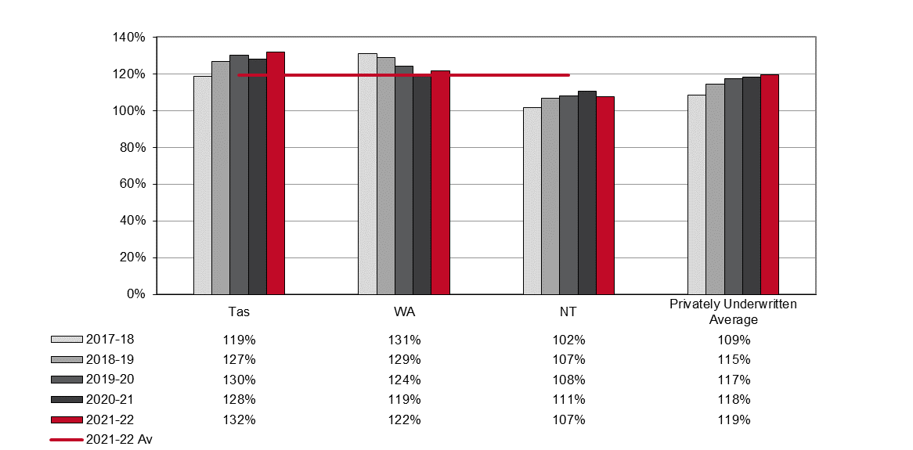

Appendix 1 – Assets to liabilities ratio (funding ratio) definitions

Different measures of assets to liabilities can arise from different economic and actuarial assumptions in valuing liabilities as well as differences in the definitions of:

* assets and net assets, and
* liabilities, such as allowance in some schemes for prudential margins, and allowance for different levels of claim handling expenses.

Different definitions of net assets have been addressed in this publication by applying a consistent definition. For centrally funded schemes, net assets are equal to the total current and non-current assets of the scheme minus the outstanding claim recoveries as at the end of the reference financial year. For privately underwritten schemes, assets are considered to be the insurers’ overall balance sheet claims provisions.

A consistent definition of net outstanding claim liabilities has also been adopted, but there are still some differences between jurisdictions in the measurement of net outstanding claim liabilities. These relate to the different assumptions for claim handling expenses by jurisdictions for which adjustments have not been applied.

Net outstanding claim liabilities for centrally funded schemes are equal to the total current and non-current liabilities of the scheme minus outstanding claim recoveries as at the end of the reference financial year. For privately underwritten schemes, liabilities are taken as the central estimate of outstanding claims for the scheme (excluding the self-insured sector) as at the end of the reference financial year.

For jurisdictions with a separate fund dedicated to workers’ compensation (centrally funded schemes), the assets set aside for future liabilities can be easily identified from their annual reports. Centrally funded schemes operate in Victoria, Queensland, South Australia, the Australian Government and New Zealand.

For jurisdictions where workers’ compensation is underwritten by insurance companies (privately underwritten schemes), assets are set aside to meet all insurance liabilities, but the insurance companies do not identify reserves specifically for workers’ compensation liabilities. For these schemes net assets are considered to be the balance sheet provisions made by the insurers at the end of each financial year. Privately underwritten schemes operate in Western Australia, Tasmania, the Northern Territory, the Australian Capital Territory and Seacare.

The New South Wales scheme is a managed fund, combining some of the features of centrally funded schemes and privately underwritten schemes.

**Prudential margins**

Many jurisdictions add prudential margins to their estimates of outstanding claims liabilities to increase the probability of maintaining sufficient assets to meet the liabilities estimate. This is done in recognition that there are inherent uncertainties in the actuarial assumptions underlying the value of outstanding liabilities. The addition of a prudential margin will lower the assets to liabilities ratio for that jurisdiction. As some jurisdictions do not have prudential margins, these margins have been removed from the estimates to enhance comparability. For jurisdictions that use prudential margins in determining their liabilities there will be a greater discrepancy between the ratios shown in this report and those shown in their annual reports.