**Safe Work Australia – Data insights**

# **Snapshot: WHS outcomes for apprentices and trainees**

July 2023 | Our Data. Your Stories.

**Apprenticeships and traineeships are types of formal training arrangements that combine work with study for a qualification in a trade or occupation.**

**In Australia, apprentices and trainees are:**

[1]



**93%**

Mostly young, under 30 years old



**62.5%**

Mostly male



**23.7%**

Work in the construction industry

Over the five years to 2020-21p[2], there were 11,490 serious workers’ compensation claims for apprentices and trainees. These are not insignificant injuries. Serious workers’ compensation claims are those that result in 5 or more days lost from work. Over the four year period from 2016-17 to 2020-21, the number of serious claims for apprentices and trainees rose by 41% from 1,684 to 2,375 despite the number of apprentices and trainees in training increasing only 13%. The vast majority of serious claims for apprentices and trainees were for Technicians and trades workers (87.3%, compared to 16.8% for non-apprentices and trainees). Of these, Construction trades workers had the highest number of serious claims, followed by Automotive and engineering trades workers and Electrotechnology and telecommunications trades workers.

Together, the Construction, Manufacturing and Other services industries accounted for more than two-thirds of all serious workers’ compensation claims for apprentices and trainees. Half (49.9%) of these claims were for workers in the Construction industry alone, a much higher proportion of serious workers’ compensation claims than occurred in the Construction industry for the general working population (11.8%).

The data presented in this snapshot will focus on **work, health and safety outcomes for apprentices and trainees under 30 in the Construction and Manufacturing industries**, as it is in these industries that the majority of work-related injuries or illnesses are occurring.

# **What kinds of work-related injuries and diseases do apprentices and trainees experience?**



**1 in 3**

**serious claims** were for Wounds, lacerations, amputations and internal organ damage.

Of these claims, the vast majority (80.3%) were for Lacerations or open wounds not involving traumatic amputation. Traumatic joint/ligament and muscle/tendon injury (28.7%) and Fractures (13.7%) accounted for the next highest number of claims.

## Construction industry

For both male and female apprentices and trainees in the Construction industry, the highest percentage of serious claims were for Wounds, lacerations, amputations and internal organ damage (41.7% and 26.0% respectively). This was a much higher proportion of serious claims than was seen in non-apprentices and trainees (32.5% and 21.5% for male and female employees, respectively). Lacerations or open wounds not involving traumatic amputation accounted for the highest proportion of these claims in both sexes (84.9% for males and 67.9% for females). Female apprentices and trainees were also slightly more likely to experience Traumatic joint/ligament and muscle/tendon injuries than non-apprentices and trainees.

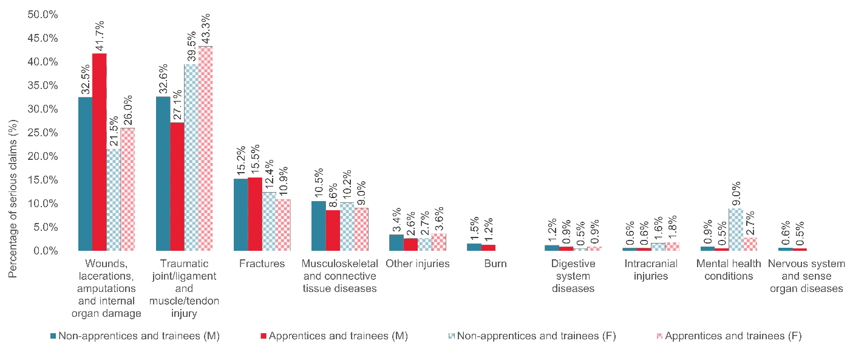

**Figure 1:** Percentage of serious claims by top 10 nature of injury/disease and sex in Construction, apprentices and trainees and non-apprentices and trainees under 30 (2016-17 to 2020-21p).

## Manufacturing industry

The highest proportion of serious claims for both male (45.0%) and female (27.6%) apprentices and trainees in the Manufacturing industry was also for Wounds, lacerations, amputations and internal organ damage. This was slightly greater than the proportion of claims for Wounds, lacerations, amputations and internal organ damage seen in non-apprentices and trainees in this industry (35.2% and 21.2% for male and female employees, respectively). For both male (76.5%) and female (47.4%) apprentices and trainees, Wounds, lacerations, amputations and internal organ damage claims were mostly accounted for by Laceration or open wounds not involving traumatic amputation.

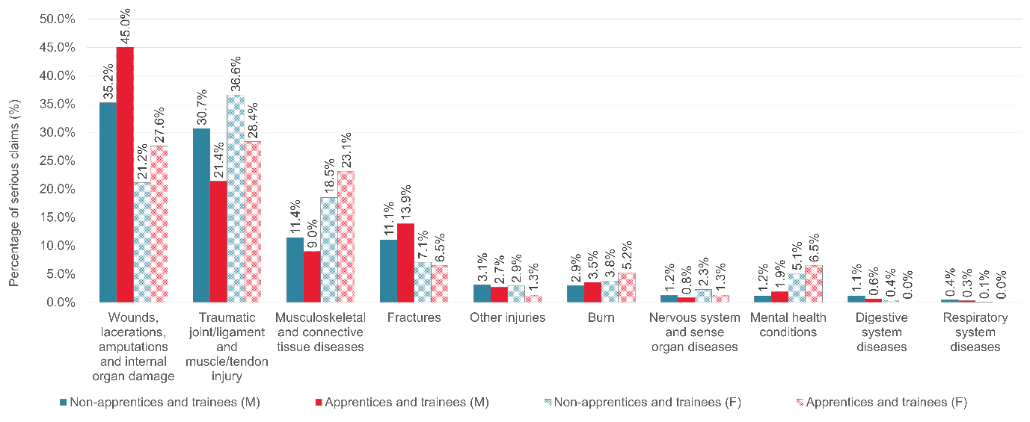

**Figure 2:** Percentage of serious claims by top 10 nature of injury/disease and sex in Manufacturing, apprentices and trainees and non-apprentices and trainees under 30 (2016-17 to 2020-21p).

Compared to non-apprentices and trainees, male and female apprentices and trainees in the Manufacturing industry were also slightly more likely to experience Burns and Mental health conditions. Female apprentices were also more likely to experience Musculoskeletal and connective tissue diseases.

# **What are the most common causes of work-related injury and disease in apprentices and trainees?**



**9 in 10**

**serious claims** were caused by Being hit by moving objects, Falls, trips and slips of a person, Body stressing; and Hitting objects with a part of the body.

Notably just 1.4% of serious claims in apprentices and trainees were caused by Mental stress, far lower than the 8.4% of serious claims that mental stress accounted for in all other workers and in contrast to the high proportion of apprentices and trainees who observed bullying in the workplace (21.2% of completers and 35.2% of non-completers observed bullying in the workplace in 2019[3]). There are several factors that may lead to this discrepancy, including apprentices and trainees being unaware of their rights at work, leaving their training due to poor or unsafe working conditions instead of lodging a workers’ compensation claim, trouble with the boss or colleagues[4] or hubris.

## Construction industry

Both male (29.3%) and female (33.3%) apprentices and trainees in the Construction industry were most likely to have a serious claim for Falls, trips and slips of a person. This was a slightly higher proportion than was seen in the non-apprentice and trainee population (26.6% and 28.5% for male and female workers, respectively). Apprentices and trainees were also more likely than non-apprentices and trainees to experience Being hit by moving objects and Hitting objects with a part of the body. However, they were less likely than non-apprentices and trainees to experience Body stressing.

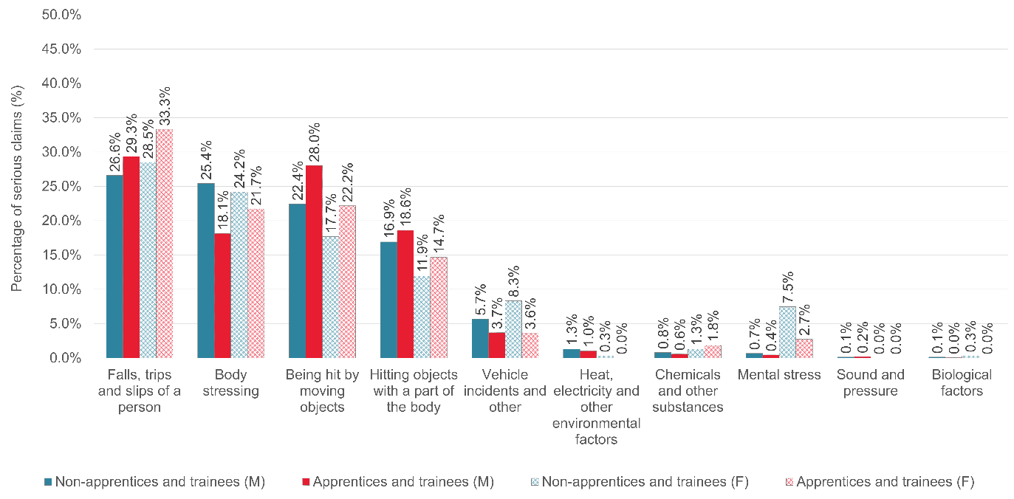

**Figure 3:** Percentage of serious claims by mechanism of incident and sex in Construction, apprentices and trainees and non-apprentices and trainees under 30 (2016-17 to 2020-21p).

### Insight:



**Male** apprentices and trainees were more likely to be injured by Machinery and (mainly) fixed plant, particularly Cutting, slicing and sawing machinery; Non-powered handtools, appliances and equipment, particularly Ladders, Mobile ramps and stairways and scaffolding; and Powered equipment, tools and appliances, mostly Workshop and worksite tools and equipment.



**Female** apprentices and trainees were more likely to be injured by Non-powered handtools, appliances and equipment, particularly Ladders, Mobile ramps and stairways and scaffolding; and Powered equipment, tools and appliances, mostly Workshop and worksite tools and equipment.

## Manufacturing industry

In the Manufacturing industry, both male (37.5%) and female (28.9%) apprentices and trainees were most likely to have a serious claim for Being hit by moving objects. This was a higher proportion than was seen in the general population (30.1% and 20.0% for male and female employees, respectively). Male apprentices and trainees were also more likely than non-apprentices and trainees to experience Hitting objects with a part of the body, while female apprentices and trainees were more likely to experience Being hit by moving objects; Falls, trips and slips of a person; and Mental stress.

Similarly to the Construction industry, both male and female apprentices and trainees in Manufacturing were less likely to experience Body stressing than non-apprentices and trainees.

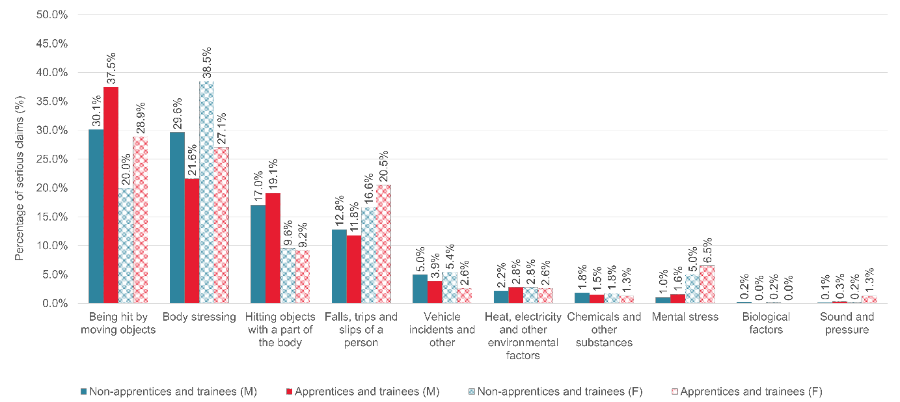

**Figure 4:** Percentage of serious claims by mechanism of incident and sex in Manufacturing, apprentices and trainees and non-apprentices and trainees under 30 (2016-17 to 2020-21p).

### Insight:



**Male** apprentices and trainees, compared to other manufacturing workers, were more likely to be injured by Machinery and (mainly) fixed plant, particularly, Cutting, slicing and sawing machinery. They were also more likely to be injured by Powered equipment, tools and appliances, mostly Workshop and worksite tools and equipment.



**Female** apprentices were more likely to have a serious claim caused by Machinery and (mainly) fixed plant, including both Cutting, slicing and sawing machinery and Crushing, pressing and rolling machinery.

# Explanatory notes

### Safe Work Australia compiles national workers’ compensation statistics using data obtained from workers’ compensation authorities in each state, territory and the Commonwealth government. These data are collated into the National Data Set for Compensation-based Statistics (NDS), which is Safe Work Australia’s primary source of information on work-related injuries and diseases. Information on apprenticeship/trainee status is collected in the NDS for all jurisdictions except the Northern Territory.

### This report uses serious claims to examine the experience of apprentices and trainees in Australia. A serious claim is defined as an accepted, non-fatal, non-journey workers’ compensation claim that resulted in time lost of one working week or more.

### References

Bednarz A, “Understanding the non-completion of apprentices, NCVER Research Report”, 2014. https://www.ncver.edu.au/research-and-statistics/publications/all-publications/understanding-the-non-completion-of-apprentices.

NCVER, “Apprentice and trainee experience and destinations, 2019. https://www.ncver.edu.au/__data/assets/pdf_file/0037/8379181/Apprentice_and_trainee_experience_and_destinations_2019.pdf.

NCVER, “Apprentice and Trainee Outcomes”, 2021. https://www.ncver.edu.au/research-and-statistics/collections/student-outcomes/apprentice-and-trainee-outcomes.

1. NCVER, “Apprentice and Trainee Outcomes”, 2021. https://www.ncver.edu.au/research-and-statistics/collections/student-outcomes/apprentice-and-trainee-outcomes.
2. 2020-21 data are preliminary (denoted by ‘p’) and are likely to rise as future revisions occur.
3. NCVER, “Apprentice and trainee experience and destinations, 2019. https://www.ncver.edu.au/__data/assets/pdf_file/0037/8379181/Apprentice_and_trainee_experience_and_destinations_2019.pdf.
4. Alice Bednarz, “Understanding the non-completion of apprentices, NCVER Research Report”, 2014. https://www.ncver.edu.au/research-and-statistics/publications/all-publications/understanding-the-non-completion-of-apprentices.